Friedrich-Alexander-Universität Erlangen-Nürnberg

Department Werkstoffwissenschaften

**Lehrstuhl für Werkstoffwissenschaften (Biomaterialien)**

Qi Fan

Matrikelnummer 22773798

Development and Characterization on the Mineralisation of amorphous calcium phosphate and amorphous calcium carbonate in *Aspergillus niger* mycelium and cellulose nanocrystals matrix

# Masterarbeit im Studiengang Werkstoffe in der Medizin

Betreuender Hochschullehrer:

Prof. Dr. Aldo R. Boccaccini

Weitere<r> betreuende<r> Hochschullehrer:

Jun.-Prof. Linus Stegbauer, Technische Universität Bergakademie Freiberg

M.Sc. Nina Oehlsen, Technische Universität Bergakademie Freiberg

Technischer Betreuer:

Karsten Meißner Dipl.-Ing. (FH)

September, 2024

Friedrich-Alexander-Universität Erlangen-Nürnberg

Department Materials Science and Engineering

**Institute for Biomaterials**

Qi Fan

22773798

Development and Characterization on the Mineralisation of amorphous calcium phosphate and amorphous calcium carbonate in *Aspergillus niger* mycelium and cellulose nanocrystals matrix

# Master Thesis in Studiengang Werkstoffe in der Medizin

Academic Supervisor:

Prof. Dr. Aldo R. Boccaccini

Additional academic supervisors:

Linus Stegbauer, Technische Universität Bergakademie Freiberg

Nina Oehlsen, Technische Universität Bergakademie Freiberg

Technical Supervisor:

Karsten Meißner Dipl.-Ing. (FH)

September, 2024

**Eidesstattliche Erklärung bei Abschlussarbeiten**

Ich versichere, dass ich die vorliegende Arbeit <Titel der Arbeit> ohne fremde Hilfe und ohne Benutzung anderer als der angegebenen Quellen und Hilfsmittel angefertigt habe, dass die Arbeit in gleicher oder ähnlicher Form noch keiner anderen Prüfungsbehörde vorgelegen hat und von dieser als Teil einer Prüfungsleistung angenommen wurde. Alle Ausführungen, die wörtlich oder sinngemäß übernommen wurden, sind als solche unter Angabe der Quelle gekennzeichnet.

Ort, Datum, eigenhändige Unterschrift

**Affidavit for final thesis**

I affirm that I have prepared this thesis <title of thesis> without outside help and without using sources or materials other than the ones listed, that the thesis has neither been submitted in the same or similar form to any other examination authority nor that it has been accepted by them as part of an examination performance. All statements that have been taken over verbatim or in spirit are marked as such and their source is indicated.

Place, date, handwritten signature

# Abstract

The aim of this thesis was to investigate the effects of disperser and heat treatment on the mechanical properties of *Aspergillus niger* mycelium and to develop a composite material based on the mineralization of *A. niger* mycelium and cellulose nanocrystal. For the first purpose, mycelium samples with different mycelium content in suspensions, different duration of disperser treatment and different duration of heat treatment were prepared and characterized. The composition of the materials was analyzed with spectroscopic methods (FTIR). Nanoindentation measurements and compression test were performed to assess the mechanical properties of the samples. Then *A. niger* mycelium was mineralized by insitu synthesis and precursor synthesis. As well as CNC as matrix was mineralized by precursor synthesis method. The composition of the mineralized mycelium and CNC composites was analyzed with PXRD and Raman spectroscopy. Nanoindentation measurements were performed to assess the mechanical properties of the composites.

The mycelium suspensions of different concentrations were subjected to different disperser treatments and aging treatments. The samples were cast from the suspensions and subjected to different heat treatments after drying. Scanning electron microscopy images show that the mean diameter of the mycelial structure without disperser treatment is 146 ± 42 µm. After 1 min of disperser treatment, the mean diameter is 152 ± 45 µm. However, the pellet-structure of the mycelium in the sample treated with the disperser for 25 min was dispersed and could not be distinguished. The mechanical properties of the samples made with the aging treated 10.3 wt.% mycelium suspension and with 18 h-heat treatment were the highest. The indentation modulus and Martens hardness of the samples reached 3.58 ± 0.06 GPa and 138 ± 3.3 N/mm2, respectively. The mechanical properties of the samples made with 7.4 wt.% and 10.3 wt.% mycelium suspension without aging treatment reached the maximum value after 2 h-heat treatment. The mechanical properties of the samples made with mycelium suspension after aging treatment reached the maximum value after 18 hours of heat treatment. In addition to heat treatment, the use of a disperser can also improve the indentation modulus of the sample.

In situ synthesis is achieved by adding two solutions containing calcium and phosphate ions respectively to precipitate calcium phosphate. When two solutions were added to mineralize the sample at the same time. The insitu precipitation of calcium phosphate in a mycelium matrix resulted in DCPD. The electron microscope photograph shows that the calcium phosphate has a multi-angular structure. When 10% weight percent of CaP was integrated to the mycelium matrix, the indentation modulus and Martens hardness of the sample were significantly improved to 3.51 ± 0.11 GPa and 132 ± 10.14 N/mm2. However, as the degree of mineralization continues to increase, the mechanical properties of the samples decrease. When calcium solution is added first, then phosphoric acid solution is added after drying and grinding, the calcium phosphate phase formed is OCP. PXRD results show that undissolved calcium acetate and ammonium phosphate (solute) are also present in the sample. The mechanical properties of samples produced by changing the order of solution addition decreased to significantly as the degree of mineralization increased. The indentation modulus of samples incorporating 50 wt.% CaP in which solution calcium was added first, decreases from 2.9 ± 1.27 GPa to 0.65 ± 0.09 GPa. Martens hardness also decreases from 137 ± 18.3 N/mm2 to the 25 ± 3.2 N/mm2. The indentation modulus of samples incorporating 50 wt.% CaP in which solution phosphate was added first, decreases from 3.16 ± 0.21 GPa to 1.54 ± 0.22 GPa. Martens hardness decreases from the 99.4 ± 10.7 N/mm2 to the 36.5 ± 8.3 N/mm2.

Mechanical characterization of the mycelium composites prepared with previously synthesized nano-CaP displayed an maximum hardness and indentation modulus in 10.wt% minerals. The indentation modulus of mycelium (1.98 ± 0.40 GPa) increased to 3.24 ± 0.43 GPa for the composite with 10 %-degree mineralization. PXRD results show that the calcium phosphate phase in it is HAP.

The CNC matrix was mineralized using a pre-synthesized nanocluster suspension of calcium phosphate and calcium carbonate (precursor synthesis). Raman spectra show that the calcium carbonate and calcium phosphate phases formed in mineralized CNC matrix are calcite and HAP, respectively. The indentation modulus and Martens hardness of the CNC and calcium phosphate composites reached the maximum value 5.80 ± 0.28 GPa in comparing with CNC (2.33 ± 0.21 GPa), when 50 wt.% CaP was integrated. The Martens hardness was increased from 121.18 ± 11 N/mm2 (CNC) to 138.5 ± 7.6 N/mm2. The indentation modulus and Martens hardness of the CNC and calcium phosphate composites reached the maximum value 5.80 ± 0.28 GPa in comparing with CNC (2.33 ± 0.21 GPa), when 50 wt.% CaP was integrated. The CNC and calcium carbonate composite samples have the maximum indentation modulus and Martens hardness at 75 wt.% CaC. The samples with other mineralization degree did not show any improvement in mechanical properties.

# Zusammenfassung

Ziel dieser Arbeit war es, die Auswirkungen von Dispergierer und Wärmebehandlung auf die mechanischen Eigenschaften des Myzels von *Aspergillus niger* zu untersuchen und ein Verbundmaterial auf der mineralisierten Matrix von Myzel von und Cellulose-Nanokristallen zu entwickeln. Zu diesem Zweck wurden Myzelproben mit unterschiedlichem Myzelgehalt in Suspensionen, unterschiedlicher Dauer der Dispergiererbehandlung und unterschiedlicher Dauer der Wärmebehandlung hergestellt und charakterisiert. Die Materialien wurde mit spektroskopischen Methoden (FTIR) analysiert. Zur Auswertung der mechanischen Eigenschaften der Proben wurden Nanoindentierung und Kompressionstests durchgeführt. Anschließend wurde das Myzel durch Insitu-Synthese und Vorläufersynthese mineralisiert. CNC als Matrix wurde ebenfalls durch die Methode der Vorläufersynthese mineralisiert. Die Zusammensetzung der mineralisierten Myzel- und CNC-Verbundstoffe wurde mit PXRD- und Raman-Spektroskopie analysiert. Zur Auswertung der mechanischen Eigenschaften der Verbundstoffe wurden Nanoindentationsmessungen durchgeführt.

Die Myzelsuspensionen mit unterschiedlicher Konzentrationen wurden verschiedenen Dispergiererbehandlungen und Alterungsbehandlungen unterzogen. Die Proben wurden aus den Suspensionen erzeugt und nach dem Trocknen verschiedenen Wärmebehandlungen unterzogen. REM zeigt, dass der mittlere Durchmesser der Myzelstruktur ohne Dispergiererbehandlung 146 ± 42 µm beträgt. Nach 1min-Dispergierbehandlung beträgt der mittlere Durchmesser 152 ± 45 µm. Die Pellet-struktur des Myzels in der 25 Minuten mit dem Dispergierer behandelten Probe war jedoch dispergiert und konnte nicht unterschieden werden. Die mechanischen Eigenschaften der Proben, die mit der gealterten 10,3 Gew.-% Myzelsuspension und mit 18 h-Wärmebehandlung hergestellt wurden, waren am höchsten. Der Eindringmodul und die Martenshärte der Proben erreichten 3,58 ± 0,06 GPa bzw. 138 ± 3,3 N/mm2. Die mechanischen Eigenschaften der Proben, die mit 7,4 Gew.-% und 10,3 Gew.-% Myzelsuspension ohne Alterungsbehandlung hergestellt wurden, erreichten den Höchstwert nach 2 h-Wärmebehandlung. Die mechanischen Eigenschaften der Proben, die mit Myzelsuspension nach Alterungsbehandlung hergestellt wurden, erreichten den Höchstwert nach 18 h-Wärmebehandlung. Zusätzlich zur Wärmebehandlung kann auch die Verwendung eines Dispergierers den Eindringmodul der Probe verbessern.

Die In-situ-Synthese wird durch Zugabe von zwei Lösungen erreicht, die jeweils Calcium- und Phosphationen enthalten, um Calciumphosphat auszufällen. Wenn zwei Lösungen hinzugefügt wurden, wurde die Probe gleichzeitig mineralisiert. Die Insitu-Präzipitation von Calciumphosphat in einer Myzelmatrix führte zu DCPD. Die Elektronenmikroskopaufnahme zeigt, dass das Calciumphosphat eine mehreckige Struktur aufweist. Als 10 % Gewichtsanteil CaP in die Myzelmatrix integriert wurden, verbesserten sich der Eindringmodul und die Martenshärte der Probe deutlich auf 3,51 ± 0,11 GPa und 132 ± 10,14 N/mm2. Mit zunehmendem Mineralisierungsgrad verschlechtern sich jedoch die mechanischen Eigenschaften der Proben. Wenn zuerst eine Calciumlösung und dann nach dem Trocknen und Mahlen eine Phosphorsäure-lösung hinzugefügt wird, entsteht die Calciumphosphatphase OCP. PXRD-Ergebnisse zeigen, dass in der Probe auch ungelöstes Calciumacetat und Ammoniumphosphat (gelöster Stoff) vorhanden sind. Die mechanischen Eigenschaften von Proben, die durch Änderung der Reihenfolge der Lösungszugabe hergestellt wurden, nahmen mit zunehmendem Mineralisierungsgrad deutlich ab. Der Eindringmodul von Proben mit 50 % Gewichtsanteil CaP, denen zuerst die Calciumlösung hinzugefügt wurde, sinkt von 2,9 ± 1,27 GPa auf 0,65 ± 0,09 GPa. Die Martenshärte sinkt ebenfalls von 137 ± 18,3 N/mm2 auf 25 ± 3,2 N/mm2. Der Eindringmodul von Proben mit 50 Gew.-% CaP, denen zuerst Phosphatlösung zugesetzt wurde, sinkt von 3,16 ± 0,21 GPa auf 1,54 ± 0,22 GPa. Die Martenshärte sinkt von 99,4 ± 10,7 N/mm2 auf 36,5 ± 8,3 N/mm2. Die mechanische Charakterisierung der mit zuvor synthetisiertem Nano-CaP hergestellten Myzel-Komposite zeigte eine maximale Härte und einen maximalen Eindringmodul bei 10 Gew.-% Mineralien. Der Eindringmodul des Myzels (1,98 ± 0,40 GPa) stieg für das Komposit mit 10 %-Grad-Mineralisierung auf 3,24 ± 0,43 GPa. PXRD-Ergebnisse zeigen, dass die darin enthaltene Calciumphosphatphase HAP ist.

Die CNC-Matrix wurde mit einer vorsynthetisierten Nanocluster-Suspension von Calciumphosphat und Calciumcarbonat (Vorläufersynthese) mineralisiert. Raman-Spektren zeigen, dass die in der mineralisierten CNC-Matrix gebildeten Calciumcarbonat- und Calciumphosphatphasen Kalzit bzw. HAP sind. Der Eindringmodul und die Martenshärte der CNC- und Kalziumphosphat-Komposite erreichten den Maximalwert von 5,80 ± 0,28 GPa im Vergleich mit CNC (2,33 ± 0,21 GPa), wenn 50 Gewichtsprozent CaP integriert wurden. Die Martenshärte stieg von 121,18 ± 11 N/mm² (CNC) auf 138,5 ± 7,6 N/mm². Der Eindringmodul und die Martenshärte der CNC- und Kalziumphosphat-Komposite erreichten den Maximalwert von 5,80 ± 0,28 GPa im Vergleich mit CNC (2,33 ± 0,21 GPa), wenn 50 Gewichtsprozent CaP integriert wurden. Die CNC- und Kalziumkarbonat-Kompositproben weisen bei 75 Gewichtsprozent CaC den maximalen Eindringmodul und die maximale Martenshärte auf. Die Proben mit anderen Mineralisierungsgraden zeigten keine Verbesserung der mechanischen Eigenschaften.

Contents

Abstract III

Zusammenfassung IV

**1.** **Introduction** - 1 -

**2.** **Theoretical Background** - 2 -

**2.1 Biomineralization** - 2 -

**2.2 Bio-composite Material** - 3 -

**2.3 Rule of mixtures (ROM)** - 4 -

**2.4 Classification of calcium phosphate** - 6 -

Amorphous of calcium phosphates - 6 -

Synthesis methods of amorphous calcium phosphates - 8 -

**2.5 Classification of calcium carbonate** - 10 -

Amorphous calcium carbonate - 11 -

Synthesis methods of amorphous calcium carbonates - 11 -

**2.6 *Aspergillus Niger*** - 12 -

**2.7 Cellulose nanocrystals** - 14 -

**2.8 Nanoindentation** - 16 -

**3.** **Materials and methods** - 19 -

**3.1** **Materials** - 19 -

**3.2** **Preparation of pure A. niger mycelium samples without mineralization.** - 22 -

3.2.1. Calculation of *A. niger* mycelium weight percentage in suspension. - 23 -

3.2.2. Preparation of *A. niger* mycelium suspension with varying parameters. - 24 -

3.2.3. Manufacturing of *A. niger* mycelium samples for nanoindentation. - 26 -

3.2.5. Production of pure *A. niger* mycelium plate samples for compression test. - 28 -

**3.3 Preparation of A. niger mycelium samples with mineralization.** - 28 -

3.3.1 *Insitu* synthesis of amorphous calcium phosphate in A. niger mycelium matrix. - 28 -

3.3.2 Precursor synthesis of amorphous calcium phosphate in A. niger mycelium matrix. - 32 -

**3.4 Preparation of calcium phosphate and calcium carbonate mineralized composite materials in CNC matrix using precursor synthesis.** - 34 -

3.4.1 Preparation of mineralized composites with different CaP content in CNC matrix using precursor synthesis - 34 -

3.4.2 Preparation of mineralized composites with different calcium carbonate content using precursor synthesis - 36 -

3.5 Samples preparation for characterization - 37 -

3.5.1 Preparation of samples for PXRD and FTIR - 37 -

**3.6 Characterization** - 38 -

3.6.1 Thickness measurement - 38 -

3.6.2 Nanoindentation - 38 -

3.6.3 Compression testing - 38 -

3.6.4 Microscopic analysis - 38 -

3.6.5 Spectroscopy and diffraction analysis - 39 -

**3.7 Statistics** - 40 -

**4.** **Results and discussion** - 41 -

**4.1 Characterization of pure *A. niger* mycelium samples.** - 41 -

4.1.1 Characterization of morphology and surface of pure *A. niger* mycelium samples - 41 -

4.1.2 Mechanical characterization of the mycelium samples - 43 -

4.1.3 FTIR Spectroscopy of pure A. niger mycelium samples - 54 -

**4.2 Characterization of composite materials based on *A. niger* mycelium with mineralization**- 58 -

4.2.1 Characterization of morphology and surface of *A. niger* mycelium composite materials - 58 -

4.2.2 Characterization of calcium phosphate phase in *A. niger* mycelium composite materials - 61 -

4.2.3 Mechanical properties of *A. niger* mycelium composite materials - 63 -

**4.3 Characterization of composite materials based on CNC with mineralization** - 65 -

4.3.1 Characterization of morphology of the CNC composite material - 65 -

4.3.2 Characterization of calcium phosphate phases contained in the CaP-CNC composite material - 70 -

Mechanical properties calcium phosphate mineralized CNC composite material - 72 -

**5.** **Conclusion** - 74 -

**6.** **Reference** - 76 -

Appendix - 86 -

# **Introduction**

Through biomineralization organisms in nature achieve mineralized materials with more uniform and denser structure with sufficient mechanical properties. For example, the elastic modulus and tensile yield stress of bones made of hydroxyapatite and collagen can reach 18,2 ± 1,88 MPa and 71.6 ± 10.2 MPa respectively [1]. At the same time, artificially synthesized composite materials often require complex synthesis methods and high synthesis temperatures, along with high costs. Therefore, one can look at mineralization as a tool that could be used to develop high-performance materials. It can be used as inspiration to design new processing routes that operate under mild conditions of temperature, pressure, and solvent type [2].

Whether in the industrial sector or in nature, there are a variety of composite materials. Among these composite materials, the combination of organic and inorganic substances occupies a significant position. Many substances in nature, such as calcium phosphate (in bones, tooths) and calcium carbonate (in shells), exists not only in crystal phase, but also in amorphous structure. The most important point is that this amorphous structure can provide highly isotropic mechanical properties different from the crystalline phase as a precursor of crystalls. In this thesis, inspired by biomineralization, we are trying to mineralize *Aspergillus niger* mycelium and cellulose nanocrystals which were used as matrix materials with one or two minerals, namely amorphous calcium phosphate and amorphous calcium carbonate.

*A. niger* mycelium is a complex material due to its diverse composition. It is often used in industry because it can efficiently produce citric acid through the TCA cycle. Further, we will also study the complex matrix material of *A. niger* mycelium because of its interesting structure.

Keywords: composite materials, biomineralization, *Aspergillus niger*, cellulose nanocrystals, amorphous calcium phosphate, amorphous calcium carbonate

# **Theoretical Background**

## **2.1 Biomineralization**

The definition of biomineralization was given as early as 1989: biomineralization describes the process of mineralization in biological settings, where an organic matrix or soluble biomolecules, along with biologically induced local environments, assist in the crystallization of minerals and regulate their shape and nucleation sites [3]. Essentially, biomineralization involves organic substances such as small molecules, peptides, proteins, and nucleic acids, which control the formation of inorganic minerals. This process enables living organisms to interact with internal mineral ions, forming mineralized tissues that contribute to biological support, protection, and metabolic regulation [4].

The process of biomineralization is achieved through two main mechanisms: biological induction and biological control. Bio-induced mineralization refers to the process by which organisms promote the formation of minerals by changing the chemical conditions of their local environment. This process is usually achieved through chemical reactions in the extracellular environment. For example, physiological activities such as metabolism and respiration cause changes in the physical and chemical environment around cells. This type of mineralization is not controlled by specific tissues, cells, or biological factors, thus forming minerals with different crystal orientations and a lack of unique morphology. On the other hand, bio-controlled mineralization involves more complex mechanisms, in which organisms precisely regulate the morphology, structure and distribution of minerals through a series of highly controlled biochemical reactions. The resulting biominerals contain organic matter, with consistent crystal shape and arrangement and uniform dimension [5].

A biomaterial is a material that is engineered to interact with a biological system to achieve a medical purpose, which can be either therapeutic (treating, enhancing, repairing or replacing tissue function in the body) or diagnostic. Biomineralization, in turn, fundamentally involves biological processes and factors in the development of biomaterials [6,7]. This natural phenomenon allows organic compounds and inorganic minerals to combine to form structural biomaterials that can withstand a variety of multidimensional stress conditions well [8]. Therefore, because of the role of biomineralization a variety of biomaterials with highly complex structures and functions exist in nature. These materials exhibit remarkable performance at the microscopic cell or molecular level, as well as at the macroscopic organ and biological levels Mollusk shells, fish scales, arthropod exoskeletons, mammalian bones, and sponge spicules are examples of such natural composites that exhibit such a remarkably rich and isotropic combination of mechanical properties and functions [9,10]. As a teacher of mankind, nature has provided us with another new way to create composite materials: to develop biomineralized materials suitable for us by learning and imitating biomineralization.

Biomineralization has important applications in many fields. For example, in medicine, the principles of biomineralization are used to develop biocompatible materials that can be used for bone and tooth repairs. In industry, biomineralization is used for environmental remediation, such as the use of mineralizing microorganisms to treat heavy metal pollution. In addition, by mimicking the biomineralization process in nature, scientists are also able to develop new functional materials with excellent mechanical properties and biocompatibility.

## **2.2 Bio-composite Material**

Nowadays countless composite materials are used in human society. These materials can be classified into ceramic-based, metal-based and polymer-based composite materials according to the matrix [11]. Most composite materials have many disadvantages such as complex production processes, high synthesis temperatures, high costs, and non-degradability [12]. To meet the needs of modern social development and the concept of sustainable development, biopolymer composite materials combined with inorganic materials in polymer-based composite materials are becoming increasingly important [13].

Biomineralization has greatly promoted the development of bio-composites and inspired us to learn this new idea to develop new materials. In this thesis, we developed new bio-composites by mineralizing amorphous calcium phosphate (ACP) and amorphous calcium carbonate (ACC) onto *Aspergillus niger* mycelium and cellulose nanocrystal matrices. We learned from biomineralization to synthesize and process these two minerals at room temperature and mild chemical environments [14][15] in aqueous suspension.

*A. niger* is a filamentous fungus. The mycelium composed of its hyphae extracted from industrial waste is a complex bio-based material with certain mechanical properties and flexibility after drying [16]. Cellulose nanocrystals (CNC) are highly crystalline, rod-like nanoparticles. They are usually covered by negatively charged groups and colloidally stable in water [17,18]. The use of *A. niger* mycelium and CNC as matrix materials not only provides good biocompatibility, but also improves the loading and distribution uniformity of minerals through its natural porous structure and high specific surface area [12]. The study of such composite materials not only enriches the theory of materials science, but also shows great potential in practical applications. In the future, by further exploring the combination mechanism of organic and inorganic substances, we are expected to develop more new composite materials with excellent performance to meet the needs of different industries.

## **2.3 Rule of mixtures (ROM)**

Because the various physical and chemical properties of composite materials are usually determined by their individual components, the rule of mixtures is used to predict and calculate these properties [19]. Theoretically, materials described by the mixing rule have the following characteristics [20,21,22]:

* Uniform distribution of the component
* No chemical reaction between the component and matrix materials
* Uniform distribution of stress or strain: For the Voigt model, it is assumed that the strain is uniform in all components; that is, all materials experience the same strain. For the Reuss model, it is assumed that the stress is uniform in all components; that is, all materials are subjected to the same stress.
* There are no interface defects or detachment to ensure that stress and strain can be effectively transmitted.

In general, there are two models, namely, an upper boundary obtained according to the Voigt model and a lower boundary obtained according to the Reuss model [23,24]. Figure 1 depicts the stress and strain scenarios corresponding to the Voigt model (a) and the Reuss model (b) [23,24]:

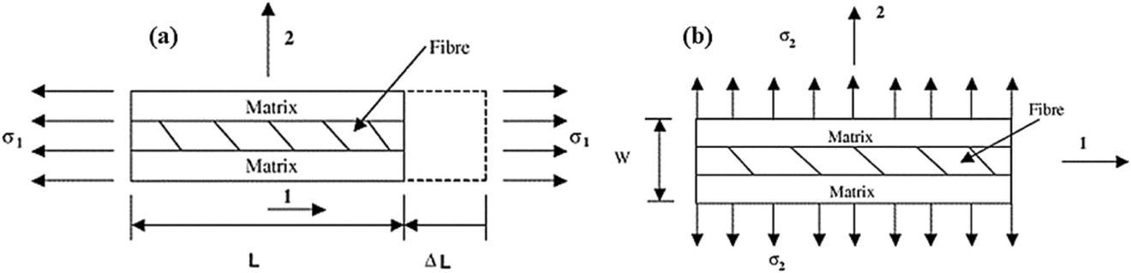

Figure 1. Schematic diagram of the stresses in the matrix and reinforcement phase in (a) direction 1 and (b) direction 2.

The Voigt model describes the modulus of composite materials under uniform strain [25]. When a composite material is subjected to transverse stress, the strains of the matrix and the reinforcement phase (fiber) are the same, and its equivalent elastic modulus(E↔) is obtained by the following formula [26]:

$$E_{↔}=E_{F}V_{F}+E_{M}V_{M}$$

Where EF, EM, VF and VM are the modulus and volume fraction of the reinforcement phase(fiber) and matrix materials respectively.

The Reuss model describes the modulus of a composite material under uniform stress [26]. When a composite material is subjected to longitudinal stress, the stress in the matrix and the reinforcement phase (fiber) is the same, and its equivalent elastic modulus(E↕) is obtained by the following formula [27]:

$$E_{↕}=\frac{E_{F}E_{M}}{V_{M}E_{F}+V_{F}E_{M}}$$

Through the mixing rule, we can obtain a graph (Figure 2) with the volume fraction of the reinforcement phase as the horizontal axis and Young's modulus of the composite material as the vertical axis [22]. The performance of the composite material lies between the two boundaries.

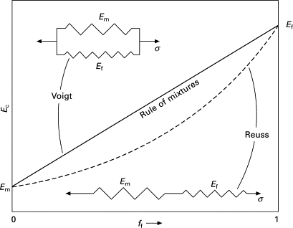

Figure 2: Schematic diagram of rule of mixture [37][38]

In nature, various biomaterials formed by biomineralization, such as nacre and enamel have a Young's modulus that is far higher than that of the upper boundary [27,28]. At the same time, in industry, the performance of synthetic composite materials is often lower than the lower boundary. While we marvel at the ingenuity of nature, we are also committed to creating a composite material that can meet the mixing rule; that is, its modulus is between the two models or even close to the upper boundary.

## **2.4 Classification of calcium phosphate**

Calcium orthophosphates are widely and abundantly found in nature and living organisms. Therefore, they are compounds of particular interest in many scientific fields such as geology, chemistry, biology, and medicine [29]. The calcium orthophosphate phase has received considerable attention owing to its biological importance. The first systematic studies were conducted by Cameron and *et al.* [30,31,32,33] and Bassett [34,35,36,37] in the early 20th century. Both researchers studied individual phases of various calcium orthophosphates. Table 1 summarizes biologically significant and common phases of calcium phosphates.

Table 1. Summary of biologically significant and common phases of calcium phosphates [38].

|  |  |  |  |
| --- | --- | --- | --- |
| Calcium phosphate phase | Abbreviation | Chemical formula | Ca/P  molar ratio |
| Dicalcium phosphate anhydrous | DCPA, monetite | CaHPO4 | 1.0 |
| Dicalcium phosphate dihydrate | DCPD, brushite | CaHPO4 x 2H2O | 1.0 |
| Hydroxyapatite | HAP | Ca5(PO4)3(OH) | 1.67 |
| Octacalcium phosphate | OCP | Ca8H2(PO4)6 | 1.33 |
| Tricalcium phosphate | TCP | Ca3(PO4)2 | 1.5 |
| Amorphous calcium phosphate | ACP | CaxHy(PO4)z·nH2O, n = 3–4.5; 15%–20% H2O | 1.2 – 2.2 |

Calcium phosphates are all white solids (unless doped with colored ions); most calcium phosphates are slightly soluble in water, some are extremely insoluble in water, but all are soluble in acid [39]. In nature, calcium orthophosphates are often found as de-posits such as apatites or phosphorites. In mammals, biologically formed CaPO4 is the major component of calcified tissue [40].

### Amorphous of calcium phosphates

Amorphous calcium phosphate (ACP) with chemical formula CaxHy(PO4)z·nH2O (n = 3–4.5), does not exhibit long-range order compared to other crystalline calcium phosphates, which makes it unique among all forms of calcium phosphate [41]. Its X-ray diffraction patterns are broad and diffuse with a maximum at 25° 2θ [42]. ACP observed by electron microscopy usually consists of small spherical particles and the particle size is approximately 40-100 nm [43]. At the same time, the microstructure of calcium phosphate crystals is a polyhedron with more edges and corners [44].

This amorphous structure, high hydration degree, and presence of defects make ACP highly reactive with body fluids, leading to rapid reprecipitation of apatite, which is an important reason why ACP has better osteoconductivity than hydroxyapatite[45,46], i.e. acts as a scaffold for the formation of extracellular bone matrix by osteoblasts and stimulates cell adhesion and proliferation. In addition, ACP also has better biodegradability than tricalcium phosphate in vivo [46]. It is also considered to be the precursor of the final crystalline hydroxyapatite, and is involved in the development of bones and teeth [41]. Due to their preferred kinetics, octacalcium phosphate (OCP) and ACP are usually formed first during the reaction and recrystallize to form hydroxyapatite in a further step.

This property also makes it very promising for applications in dentistry, orthopedics, and various medical fields. On the other hand, it is also unstable or metastable, and this uncontrolled instability is the reason why ACP has not been widely used in applications. In contrast, in the presence of other ions or certain cellular environments, ACP can be kinetically stabilized and persist for extended periods of time [46]. For example, the presence of Mg2+, F-, carbonate, pyrophosphate, diphosphate, polyphosphorylated metabolites, or nucleotides can stabilize ACP rather than convert it to hydroxyapatite other crystalline forms [47,48].

Furthermore, such amorphous structures and non-crystalline characteristics also provide ACP with isotropic mechanical properties and are expected to be used in structural materials. These amorphous structures are already used in nature. Amorphous metallic salt such as amorphous calcium carbonate (ACC) and amorphous calcium phosphate (ACP) fundamentally support the growth of biological skeleton. For example, the top of the carapace of *Calappa granulata* contains up to 43 % ACC [49]. Besides that, amorphous structures account for ~20 % of the approximately 60 different inorganic compounds or minerals formed by living organisms [49]. If the current industry can also make good use of it, we will obtain another class of excellent materials that can overcome the various shortcomings of traditional crystal materials.

### Synthesis methods of amorphous calcium phosphates

In this thesis two main methods for generating ACP were used: one method employs the coprecipitation in aqueous medium and the other a synthesis of an oligomeric precursor in ethanol medium.

Calcium chloride and diammonium hydrogen phosphate [(NH4)2HPO4] are used as sources of calcium and phosphate ions, respectively, in aqueous media. After the two solutions were mixed, the pH of the mixed solution increased due to the disappearance of the acidic solute, and ACP, as an intermediate of thermodynamically stable hydroxyapatite, was immediately precipitated due to supersaturation. During the contact and reaction of the two solutions, other crystalline phases of calcium phosphate may be generated at any time and mixed with ACP because of the reduction in solubility. Figure 3 shows the solubility of some phases of calcium phosphate that may result [49]. The solubility of various calcium phosphates decreases from acidic to alkaline environments, and DCPD and DCPA are the first to be generated in acidic environments.



Figure 3: Solubility isotherms of various calcium phosphate phases in the system Ca (OH)2-H3PO4-H2O at 37 °C.

This method mimics the way in which cells in organisms transport ions or molecules to the locations where mineralization occurs. At the same time, it is simple, and fast and can occur directly in the biopolymer matrix, therefore we call it insitu synthesis.

Another method involves the synthesis of ACP in ethanol. The group of Tang *et al.* successfully synthesized calcium phosphate ion clusters (CPICs) using triethylamine (TEA) as effective stabilizer [50,51]. They slowly added an ethanol solution containing phosphoric acid (H3PO4 to a solution containing calcium chloride dihydrate (CaCl2·2H2O) and TEA while stirring. This mixture of the two solutions produced CPICs in large quantities. Figure 4 shows the production process and characterization [50]. The stabilizer TEA acts as a capping agent during the synthesis process (Figure 4F). It binds calcium phosphate molecules to prevent further bonding with other calcium phosphate molecules. Compared with other organic additives used in previous studies (especially polymers) [52,53], TEA is a small molecule that is highly volatile. It can be removed by subsequent centrifugal washing with ethanol; to obtain pure inorganic ACP.

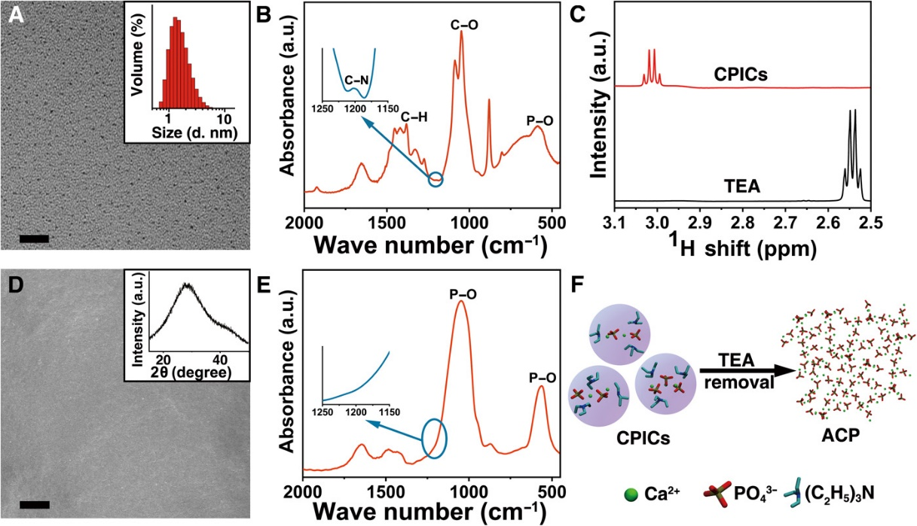

Figure4. (**A**) TEM image of CPICs and DLS size distributions of the CPICs in ethanol solution. (**B**) FTIR spectra of the gel-like CPICs.(**C**)1H NMR spectra of TEA and CPICs. (**D**) SEM image and X-ray diffraction (XRD) of bulk ACP. (**E**) FTIR spectra of bulk ACP materials. (**F**) Schematic of ACP formation using CPICs when TEA as the stabilizer was removed [50].

Transmission electron microscopy (TEM) in Figure 4A shows that the average diameter of the ion clusters is 1.5 ± 0.3 nm, and dynamic light scattering (DLS) measurements confirm that their size is 1.6 ± 0.6 nm. The FTIR spectrum in Figure 4B shows that TEA and CPICs interact with each other, because the stretching vibration of C-N normally appears at 1200 cm−1 in ethanol, whereas this peak shifts to 1203 cm−1 when TEA is present in CPICs. Moreover, no particles, grain boundaries or borders can be observed in the scanning electron microscopy (SEM) image in Figure 1D, indicating that the material exhibits structural continuity [50].

This method mimics the in vivo process, where macromolecules are synthesized in advance and then transported directly by the cell to the site where demineralization occurs. We refer to this method as precursor synthesis.

## **2.5 Classification of calcium carbonate**

Calcium carbonate is the calcium salt of carbonate, a compound of calcium, carbon, and oxygen, with the chemical formula CaCO3. Calcium carbonate is one of the most widespread compounds found in sedimentary rocks. It occurs mainly in the form of the mineral calcite which, with a share of around five percent, is one of the most common minerals in the earth's crust [54]. Calcite is also one of the main components of massive limestone and matrix rock. Other variants of calcium carbonate include the minerals aragonite and vaterite. Aragonite is mostly found in mineral deposits in seawater because the magnesium in seawater favors the formation of aragonite [55]. Compared to the first two, vaterite is rare in nature. Calcium carbonate has crystalline polymorphs, and the three introduced are its anhydrates. There are also two hydrates: monohydrocalcite and ikaite. The former is not common but is often associated with other calcium and magnesium carbonate minerals [56]. Ikaite is more unstable; it exists only in a metastable state, and once the water leaves the freezing point, it quickly dehydrates and decomposes [57]. These two forms are also called pseudomorphs of calcium carbonate. The last form is amorphous calcium carbonate (ACC). All six variants are colorless and odorless solids in pure form. The following table lists the polymorphs and pseudo-polymorphs of these six calcium carbonates [57].

Table 2. Overview of the polymorphs and pseudopolymorphs of these six calcium carbonates

|  |  |  |
| --- | --- | --- |
| Calcium cabonate phase | Chemical formula | stability |
| Calcite | CaCO3 | Stable |
| Aragonite | CaCO3 | Stable above 70 °C |
| Vaterite | CaCO3 | metastable below 10 °C |
| Monohydrocalcite | CaCO3·H2O | Water release from 60–80 °C |
| Ikaite | CaCO3·6H2O | Stable below 0 °C |
| Amorphous calcium cabonate | CaCO3 | unstable when dehydrated |

### Amorphous calcium carbonate

ACC has been confirmed to be the precursor of crystalline calcium carbonate [58]. It has amorphous structural features and is unstable. However, ACC has high solid solubility [59], high plasticity, and toughness [60,61]., it exhibits high biocompatibility and biodegradability. Therefore, ACC is a research focus in medicine, biology, chemistry, and materials science.

ACC has a wide range of applications. In the field of drug delivery, calcium-based materials such as ACC can transport contrast agents, which can enhance imaging effects, and Ca2+ ions can also interfere with treatment [62]. In the aerospace field, it can be used as a therapeutic agent to improve muscle atrophy and osteopenia in astronauts [63]. In the field of materials science, ACC can be used as an important material to improve the design and synthesis of nanomaterials [64].

### Synthesis methods of amorphous calcium carbonates

Due to the instability of ACC, many methods have been tried to generate a stable amorphous phase, but the results have not been ideal. For example, the cloesed configuration of batch-mixed Na2CO3 and CaCl2 solutions causes the solution composition to change significantly during the synthesis process [65]. Another method for example, was to diffuse (NH4)2CO3 into the CaCl2 solution to increase the supersaturation and induce ACC formation, but a very small amount of ACC was generated [66]. Inspired by polymer materials made from cross-linked monomers and oligomers, Tang *et al.* developed a method to synthesize ACC using TEA as a stabilizer [67]. Ionic oligomers of calcium carbonate were generated by bubbling CO2 into an ethanolic solution containing calcium chloride dihydrate and TEA. The principle is the same as that of the ACP synthesis method mentioned above, and TEA is used as a capping agent to stabilize the precursor (Figure 5a). Specifically, TEA can form hydrogen bonds with protonated carbonates through its tertiary amine group (Figure 5b) and prevent the oligomers from polymerizing [67].

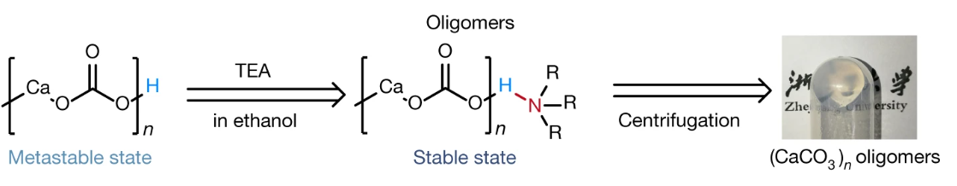

c

b

a

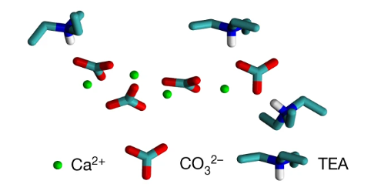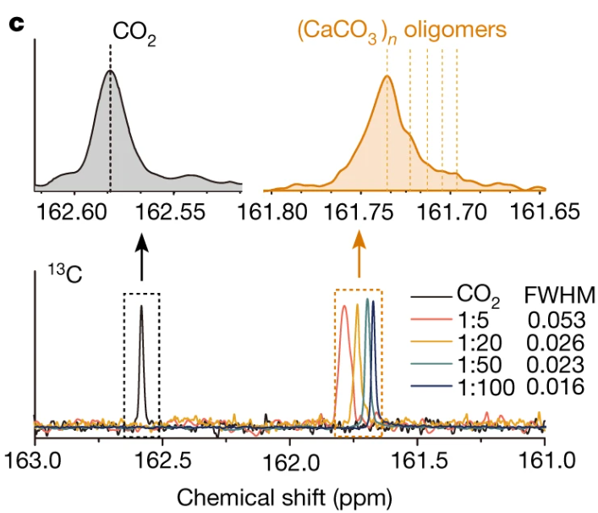

Figure 5. (a) schematic of the capping agent TEA and reaction conditions for producing (CaCO3) n oligomers and gel-like (CaCO3) n oligomers. (b) hydrogen bonds formed with protonated carbonates through tertiary amine group. (c) Liquid-state 13C NMR spectra of CO2 or the carbonates of (CaCO3) n oligomers [67].

Liquid-state nuclear magnetic resonance (NMR) spectroscopy (Figure 5c) confirmed the formation of oligomers. FTIR spectroscopy showed that both TEA and ethanol evaporated during the drying of the oligomer gel, as the absorbance at approximately 1,200 cm−1 and 880 cm−1 decreased. The oligomers also formed calcium carbonate, and the resulting phase was ACC [67].

## **2.6 *Aspergillus Niger***

Fungi are important eukaryotic organisms that include microorganisms such as yeasts and molds. They are among the most widely distributed organisms in nature [68]. *Aspergillus niger* is a filamentous fungus belonging to the family Mucoralean. It possesses fruiting bodies and can reproduce in the form of spores. They are airborne and widespread in soil throughout the world. It is also known to infect a variety of vegetables and fruits and is a common mold found in spoiled food.

The most basic structural unit of *Aspergillus niger* or other filamentous fungi are the filamentous cells called hyphae. Hyphae colonize the substrate through elongated filamentous cells and continue to grow until they eventually form a three-dimensional intertwined network called mycelium (Figure 6). Mycelium secretes enzymes that break down various substances into simpler components for absorption as nutrients [69].

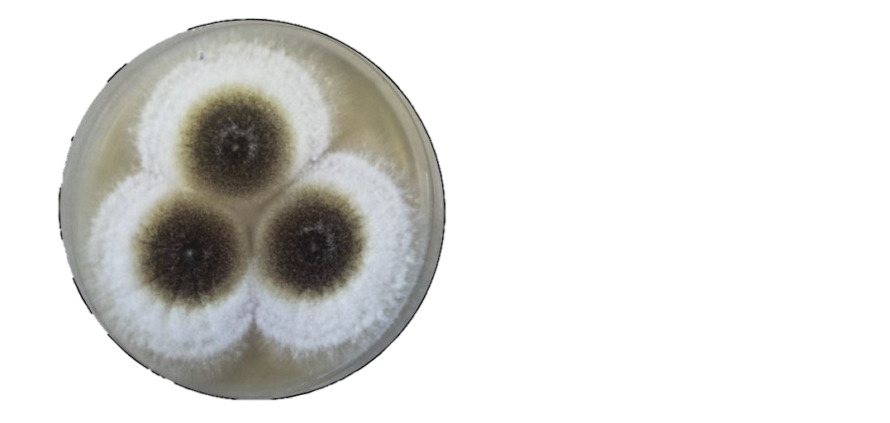 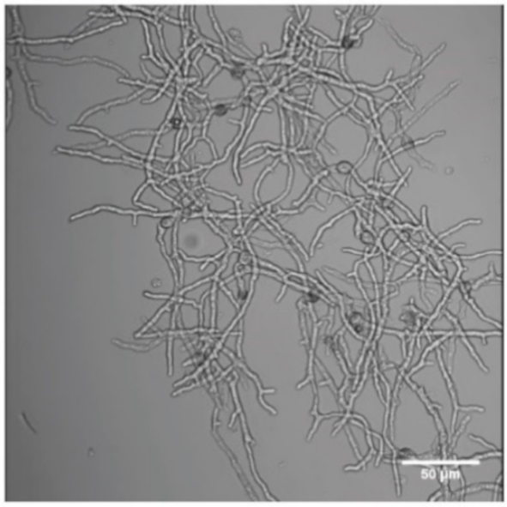

20mm

50µm

a

b

*Figure 6: a. The colonies of A. niger in the PDA (Potato Dextrose) agar Petri dishes with white, spreading mycelium and light yellow at the edge to black mycelium in the center [84] b. Hyphae of A. niger mycelium [69].*

Like other eukaryotic organisms, the hyphal cells of *A. niger* also possess cell walls and various organelles. The main components of the cell wall are structural polysaccharides such as chitin and chitosan (16%) [70,71,72]. In addition, β-glycan accounts for 48% of the cell wall. It also contains proteins (22.2%), starch (9.7%), minerals (1%) and α-glycan (0.6%) [70].

As a promising method of environmentally friendly waste management, the living *A. niger* mycelium also shows excellent biodegradability and can degrade plastic and packaging waste such as PE. Besides that, *A. niger* mycelium can secrete a variety of hydrolytic enzymes such as cellulase, protease and pectinase. These enzymes can effectively degrade complex organic substances such as plant cell walls, proteins and polysaccharides. [70].

In addition, *A. niger* is also often used in industrial fermentation processes to produce important chemical products such as enzymes such as amylase, protease and pectinase. Metabolites of *A. niger* such as citric acid are also produced biotechnologically from sugar. Citric acid is produced in the mitochondrial matrix in *A. niger* during the citric acid cycle. [73]. The *A. niger* mycelium which we used were waste products from the citric acid production of a company, Jungbunzlauer. Jungbunzlauer citric acid is produced by submerged fermentation (SmF), in which the microorganism *A. niger* converts sugar into citric acid. This process is called tricarboxylic acid cycle and takes place in the mitochondrial matrix [73].



*Figure7. Depiction of the TCA Cycle. PFK = phosphofructokinase, PC = pyruvate carboxylase, ACO = aconitase. [73].*

After this process, the produced citrate flows out of the mitochondria into the cytoplasm through carriers [73], and can be transported from the cytoplasm to the external medium through active transport systems [73,74]. Due to this characteristic, *A. niger* is often used in industry to produce citric acid and fructooligosaccharides (FOS) [75,76]. The final *A. niger* mycelium as our raw materials has pellet structure. It is formed by the aggregation of hyphae due to a specific process in the industrial production of citric acid.

## **2.7 Cellulose nanocrystals**

Paper, a vital component of daily life, consists mainly of cellulose. Cellulose is an unbranched polysaccharide. It is a linearly arranged macromolecule that usually consists of hundreds to tens of thousands of (β-1,4-glycosidically linked) β-D-glucose. The repeating unit of this polysaccharide is called cellobiose (Figure 8). Cellulose is found in the cell walls of plants and is their main component. Plant fibers are natural cellulose stores [77]. These fibers consist of a single cell. The cell walls of which contain cellulose fibers or microfibrils with a length of 1 to 50 mm and a diameter of 10 to 50 μm [77,78]. Cellulose fiber are the basic reinforcing units of the hierarchical structures found in various plants. Due to its high mechanical strength, high strength-to-weight ratio and high toughness, they are used as structural building materials.

a

b

β-1,4-glycosidic bond

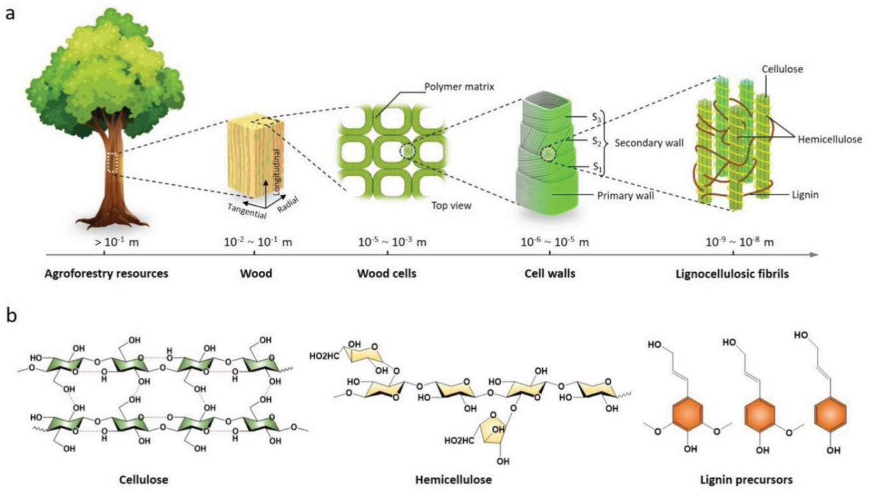

*Figure 8: The illustration of cellulose from plant cells [79]. a) Structural components of wood at different enlargements. b) structure of cellulose.*

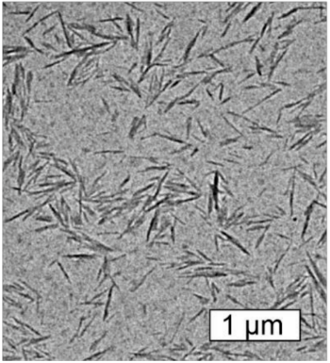

Figure 9.: Microstructure of CNC observed by TEM [80].

Nanocellulose is derived from cellulose and has defined nanoscale dimensions. It is generally divided into three categories: cellulose nanocrystals (CNC), cellulose nanofibers (CNF) and bacterial cellulose (BC). These three types of cellulose differ in their properties due to their raw material sources and processing methods [81].

CNCs are highly crystalline and have a characteristic needle-like shape with a width of 3–5 nm and a length of 50–500 nm (Figure 9). They are extracted from the crystalline regions of natural microfibers and obtained by acid hydrolysis to remove the non-crystalline regions and subsequent ultrasonic treatment. Typically, hydronium chloride or sulfuric acid is used as a strong acid to destroy the amorphous domains, leading to the formation of highly crystalline cellulose at nanoscale. Biologically extracted CNCs are amphiphilic materials with surface-exposed (hydrophilic sites) and hidden (hydrophobic sites) hydroxyl groups (-OH) [82]. Due to these physicochemical properties, CNCs are suitable for use as emulsifiers to stabilize emulsions. These hydroxyl groups of CNC (-OH) can also be surface modified through chemical reactions such as esterification, etherification and nitration. Surface modifications can not only change the hydrophilicity or hydrophobicity of CNCs, but also introduce other functional groups, making them more widely used in composite materials. CNCs have high thermal stability and their thermal decomposition temperature is usually above 210 °C [83]. Due to their highly crystalline structure, they have a low coefficient of thermal expansion when heated, which gives them better dimensional stability in high temperature environments. CNCs have unique optical properties, such as optical activity (change in the polarization plane of light) and selective light transmission. Due to their nanometer size and highly ordered structure, CNCs are able to scatter light and form structural colors through color changes, which enables them to be used in optical devices [84].

CNC also has good biocompatibility and biodegradability. They can be degraded by microorganisms in the environment and produce harmless products, which is why they are considered environmentally friendly materials. Its biocompatibility makes it suitable for potential applications in biomedical materials such as tissue engineering scaffolds and drug carriers.

## **2.8 Nanoindentation**

Nanoindentation is a powerful and effective non-destructive material testing method. The most classic and common application of nanoindentation is the determination of the hardness and elastic modulus of thin-layer materials. The low application force and penetration depth limit the interaction with the indented sample to a very small spatial volume effectively reducing the measurement error. At the same time, nanoindentation technology has mainly been developed for linear elastic, isotropic, and homogeneous materials. This makes the test method suitable for various samples in this thesis [85].

The simple principle is to press the tip of a diamond indenter of a known shape into the sample to be tested and measure the applied force and depth of indentation simultaneously [85]. The data obtained from these measurements are used to calculate various mechanical performance characteristics of the material. Commonly used indenters for nanoindentation include Berkovich-, spherical-, Vickers-, conical- and wedge-shaped indenters [86,87]. The indenter type of the instrument we used is a Vickers indenter. The shape and typical indentation morphology are shown in figure 10.a below. The Vickers indenter is usually made of diamond and has the shape of a regular tetrahedron, with each face being an equilateral triangle, and the angle between the four sides is 136 °.

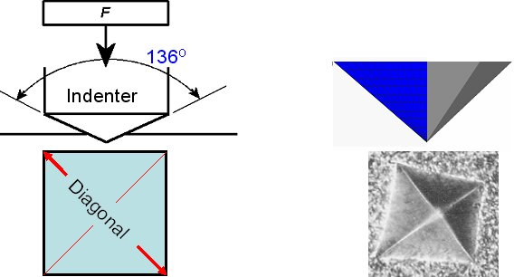

Figure 9. Schematic of Vickers indenter and an indentation left in ferrite [88].

The nanoindentation process consists of three parts [89] (Figure 10b). First, the indenter is pressed into the specimen with a defined force curve, while the applied force and the indentation depth are recorded. During this process, the specimen undergoes elastic deformation followed by plastic deformation. In the second stage, when the specified maximum force or maximum indentation depth is reached, the indenter is held at the maximum force to minimize the effects of creep and also study the creep behavior [90]. In the last stage, the indenter is slowly unloaded again with a defined force curve, while the data is recorded.

 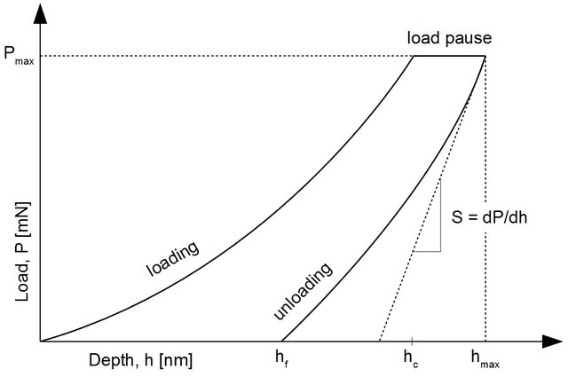

(b)

(a)

Figure 10. Schematic of nanoindentation testing. (a). penetration of indenter into the sample [91]. (b) the typical load–displacement curve consists of loading, load holding and unloading parts [92].

As early as 1965, Sneddon initially proposed a method to exploit the measured data and use them to roughly infer the elastic modulus of the material [93]. Based on this, Oliver and Pharr made several improvements and revisions [94], taking more important factors into consideration. With the development of nanoindentation technology, the Oliver and Pharr method has gradually become the standard method for modern nanoindentation analysis software [85]. The Oliver-Pharr method uses the following exponential function to fit the unloading curve and obtain thee important relationship between load P and displacement h in the unloading phase [95]:

$$P={B(h-h_{f})}^{n}$$

The slope of the load–displacement curve of the unloading section *S* which is also the elastic contact stiffness is obtained by derivation [85][95]:

$$S={\left(\frac{dP}{dh}\right)}_{h=h_{m}}=Bn{\left(h_{m}-h_{f}\right)}^{n-1}$$

where *hf* and *hm* are the residual indentation depth and the maximum load, respectively and *B* and *n* are fitting parameters. For calculating the contact area *Ac* which is the key value for hardness calculation, the contact depth *hc* (Figure 10.a) must also be calculated. The contact depth *hc* is calculated using the following formula [95]:

$$h_{c}=h-ε\frac{P}{S}$$

where the variable ε depends on the indenter tip. For a Vickers indenter, ε is 0.75 [96]. Then the contact area *Ac* is calculated using the following empirical formula and the angle θ = 68 °[95, 97]:

$$A_{c}=h_{c}\tan^{2}θ=25.504h_{c}^{2}$$

The hardness can then be calculated by dividing the maximum load by the contact area at this load [95]. The resulting hardness is called Martens hardness (HM) [98]:

$$H_{M}=\frac{P_{m}}{A_{c}}$$

The indentation modulus EIT (or the reduced elastic modulus) is calculated using the gradient (load P and depth h) of the unloading curve at the initial stage [95]:

$$E_{IT}=\frac{\sqrt{π} S}{2β\sqrt{A_{c}}}$$

Alternatively, a different approach to calculate the reduced elastic modulus can be seen in the following formula [95,96,98]:

$$\frac{1}{E_{IT}}=\frac{1-υ^{2}}{E}+\frac{1-υ_{i}^{2}}{E_{i}}$$

where *E* and *υ* are the Young's modulus and Poisson's ratio of the indenter, respectively, and *Ei* and *υi*represent the elastic modulus and Poisson's ratio of the tested sample, respectively.

In addition to the high requirements for sample preparation, for example the surface of the sample to be measured needs to be level and have low roughness. Nanoindentation technology also has restrictions on the setting of various parameters [99]. For the many experiments in this thesis, we measured thin samples with thicknesses ranging from 30 to 200 µm. For such samples, it is usually necessary to set a smaller penetration force or, better yet, to set the penetration depth to between 1/15 and 1/20 of the total sample thickness. This is to avoid the influence of the sample substrate (glass), which has a greater hardness and modulus than the sample. When the penetration depth is less than 1/15 of the film thickness, the influence of the substrate is negligible [100]. This will leave a fully developed plastic zone below the measuring area, which is important for hardness measurement. Only in this way can we ensure that the data obtained have a smaller variance and can accurately reflect the various mechanical properties of the material.

# **Materials and methods**

## **Materials**

In this thesis, a variety of chemical reagents, biological materials were used for the mineralization and the production of monolithic bodies and films. In addition to this there is a range of analytical software and characterization instruments for analysis of results. These are listed in detail below.

Table 3.1.: Chemicals with producer and specification used in this thesis.

|  |  |  |
| --- | --- | --- |
| Chemicals | Producer | Specification |
| Acetone | VWR Chemicals, Radnor (USA) | CAS: 67-64-1 |
| *Aspergillus Niger* | Jungbunzlauer Ag | mycelium content: 14.2 % |
| Calcium acetate monohydrate | Sigma-Aldrich, St. Louis (USA) | CAS: 5743-26-0  LOT: MKCN2612 |
| Calcium chloride dihydrate | Merck KGaA, Darmstadt (D) | CAS: 10043-52-4  LOT: K49688478 908 |
| Di-ammonium hydrogen phosphate | Merck KGaA, Darmstadt (D) | CAS: 7783-28-0  LOT: A1619507 036 |
| Ethanol absolute | Merck KGaA, Darmstadt (D) | CAS: 64-17-5 |
| Chemicals | **Producer** | **Specification** |
| Ethyl acetate | Sigma-Aldrich, St. Louis (USA) | CAS: 141-78-6  LOT: STBF4584V |
| Ortho-Phosphoric acid | Carl Roth GmbH & Co. KG, Karlsruhe (D) | CAS: 7664-38-2  LOT: 460302737 |
| Milli-Q H2O | Wasseraufbereitungssysteme  GMBH |  |
| Silica gel beads | Carl Roth GmbH & Co. KG, Karlsruhe (D) | 2-5 mm, white |
| Triethylamine | Sigma-Aldrich, St. Louis (USA) | CAS: 121-44-8  LOT: BCBB4983 |

Table 3.2.: Materials which are used in this thesis with producer and specification.

|  |  |  |
| --- | --- | --- |
| Materials | Producer | Specification |
| Adhesive tape | Emil Lux GmbH & Co. KG, Wermelskirchen (D) | expert, 252370 |
| Aluminum foil | Carl Roth GmbH & Co. KG, Karlsruhe (D) | 20 µm, L 150 m x 450 mm |
| Cannulas | B. Braun Melsungen AG, Melsungen (D) | 0.8 x 120 mm |
| Carbon tape  (double-sided) | Plano GmbH, Wetzlar (D) | Art.-No. G3939  8 mm x 20 mm |
| Centrifuge tubes | Beckman Coulter, Brea (USA) | Polypropylene |
| Clamps | Wolfcraft GmbH, Kempenich (D) | - |
| Crucibles | Shanghai Jing Yi Chemical Material Co., Ltd., Shanghai (CHN) | Aluminum |
| Eppendorf cup | Eppendorf AG, Hamburg (D) | 1.5 mL, 2 mL |
| Glass vial | Th. Geyer GmbH & Co. KG, Renningen (D) | 2 mL, 5 mL, 10 mL |
| Microscope slides | Gerhard Menzel GmbH, Braunschweig (D) | 76 x 26 x 1 mm |
| Speedmixer Becher | Fa.ars, Borken (D) | 12 mL |
| Petri dish | TH. Geyer GmbH & Co. KG, Renningen (D) | Polystyrol |
| Pipette tips | Eppendorf AG, Hamburg (D) | 0 – 100 µL, 0 – 1000 µL, 0 – 5 mL, 0 – 10 mL |
| Quartz glass plate | GVB GmbH, Herzogenrath (D) | - |
| Razor blade | Amazon, Seattle (USA) | - |
| Round neck flask | Schott AG, Mainz (D) | 250 mL, 500 mL |
| SEM stub | Plano GmbH, Wetzlar (D) | Art.-No. G301 |
| Silicon wafer | MEMC Electronic Materials |  |
| Silicone mat | RCT Reichelt Chemietechnik GmbH & Co, Heidelberg (D) | Thickness: 2 mm, 1 mm, 0.5 mm |
| Superglue | Conrad Electronic SE, Hir-schau (D) | Toolcraft Sekundenkleber Ropid 150 |
| Syringes | B. Braun Melsungen AG, Melsungen (D) | 20 mL, 50 mL |
| Zirconia beads | Bertin Instruments, Montigny-le-Bretonneux (FRA) | 6.8 mm |

Table 3.3.: equipment or instruments which is used in this thesis with producer and specification.

|  |  |  |
| --- | --- | --- |
| Equipment | Producer | Specification |
| Analysis scale | Mettler Toledo | PE3600/9 |
| Analysis precision scale | Sartorius AG Göttingen | BC BC 100 |
| Analysis precision scale | KERN & SOHN GmbH,  Germany | - |
| Centrifuge |  |  |
| Centrifuge |  |  |
| ATR-FTIR spectrometer | Bruker Corporation, Billerica,  Massachusetts, United States | Tensor II |
| Fume hood | Köttermann GmbH | 2-410 NL, 200014 |
| Incubator |  |  |
| Magnetic stirrer | Heidolph Instruments GmbH & Co. KG | MR 3001 K |
| Mortar | Haldenwanger GmbH, Waldkrai-burg (D) | - |
| Nano indenter | Helmut Fischer GmbH, Sindelfin-gen (D) | FISCHERSCOPE H100 Xyp |
| Oven | Memmert GmbH | UNB 100 ofen |
| pH meter | pH 95 | WTW |
| Raman spectrometer | Bruker Corporation, Billerica,  Massachusetts, United States | MultiRAM |
| Scanning electron microscope | Carl Zeiss GmbH, Oberkochen (D) | Evo15 |
| Sensor (temperature and humidity) | ecowitt, Shenzhen (CHN) | WH31A |
| Ultrasonic cleaner | Bandelin electronic GmbH & Co. KG, Berlin (D) | - |
| SpeedMixer® | Hausschild & Co. KG, Hamm (D) | - |
| Sputter coater | SDS 050 | BAL-TEC AG, Liechtenstein,  Germany |
| Syringe pump | Shanghai Angel electronic equipment Co. Ltd, Shanghai (CHN) | AJ-5803 |
| Syringe pump | New Era Pump Systems, Inc. | NE 300 |
| Thickness gauge |  |  |
| Thickness gauge |  |  |
| Turaxx | IKA-Werke GmbH & Co. KG | IKA 0593400 18 mm  IKA 1024200 8 mm |
| Equipment | **Producer** | **Specification** |
| Ultrapure water system | Merck KGaA | Wasseraufbereitungssysteme, Direct-Q® 3 |
| Vortexer® | Lab Logistic Group GmbH, Meckenheim (D) | Mixer Uzusio  VTX-3000L |
| X-ray diffractometer | Bruker Corporation, Billerica,  Massachusetts, United States | D8 Discover |

Tabel 3.4.: Materials which are used in this thesis with producer and specification.

|  |  |  |
| --- | --- | --- |
| Software | Producer | Application |
| Auto CAD | Autodesk | Modeling for 3D printing |
| ImageJ | Wayne Rasband, National In-stitute of Health, (USA) | Editing images |
| OPUS | Bruker Corporation, Billerica (USA) | FTIR measurements and analy-sis |
| Origin Pro | OriginLab Corporation, Northampton (USA) | Evaluation and presentation of measurements |
| Python 3.11 | Python Software Foundation, Guido van Rossum | Processing images, data analysis |
| Spyder IDE | Carlos Córdoba, Pierre Raybaut | Plugins for python |
| ToupView | ToupTek Photonics, Zhejiang (PRC) | Light microscope images |
| WIN-HCU® | Helmut Fischer GmbH & Co. KG, Sindelfingen (D) | Measurements on the nanoindenter |

### Disperser

In this paper, a disperser Turaxx was used to stir and break up the pellet-structure of the mycelium. On the one hand, when Turaxx rotates at high speed, it generates strong shear stress in the suspension to tear the pellet-structure of the mycelium. On the other hand, the rotation of Turaxx drives the mycelium particles to move at high speed. At this time, a large number of mycelium collides with each other and is ground or destroyed. Two sizes of dispersers were used. Turaxx IKA 0593400 has a blade with 18 mm diameter and IKA 1024200 has a blade with 8 mm diameter. The rotation speed is adjusted to 30000 rpm and an ice bath was set up duration the usage.

## **Preparation of pure A. niger mycelium samples without mineralization.**

In this section the preparation of pure *A. niger* mycelium samples is described. First mycelium suspension with a certain mycelial concentration is prepared. The suspension is treated to different degrees using a disperser called Turaxx (0 min, 1 min, 25 min). The suspension is then subjected to different aging treatments, i.e., evaporated into a suspension with a fixed mycelium concentration, placed in a mold and dried (7.4 wt.% - 20 wt.%). Finally, the dried samples are subjected to different degrees of heat treatment. Specifically, the preparation of the mycelium suspension is described in Sections 3.2.1-3.2.3. The preparation of mycelium samples for nanoindentation and compression tests is described in Sections 3.2.4-3.2.4. The heat treatment is described in detail in Section 3.2.4.2.

### **3.2.1. Calculation of *A. niger* mycelium weight percentage in suspension.**

The mycelium samples in this thesis had suspensions with two different weight percent of mycelium before being treated with the disperser Turaxx, namely 7.4 wt.% and 10.3 wt.%. The suspension containing 10.3 wt.% mycelium was treated with dispersers of different sizes. The samples treated with the small-sized disperser Turaxx were subjected to different aging treatments, that is, the suspension was allowed to evaporate water. Finally, 4 groups of different samples were obtained for mechanical property testing using nanoindentation. The fifth group of samples was used as the control group for compression experiments. Its preparation method was different from the previous four groups and will be described separately in Section 3.2.5. Before the experiment, the amount of water required to be added and evaporated for each group of mycelium samples needs to be calculated.

The weight percentage (wt. %) of mycelium in the suspension for the production of the samples was calculated with the following formula:

$${wt. \%}_{A. niger mycelium}=\left(\frac{m_{A. niger mycelium}}{m_{A. niger mycelium}+m_{H_{2}O}}\right)$$

The mycelium raw material we used was a suspension that had been frozen before use. The weight percentage of mycelium in the frozen suspension has been determined in previous work, i.e., 14.5 wt.% and 17.5 w.t%. The mass of mycelium in this suspension can be obtained by using the following formula:

$$m_{A. niger mycelium}=m_{A. niger mycelium suspention}*14.5 \%/17.5\%$$

The amount of water that needs to be added or evaporated for mycelium suspensions of different weight percentage (wt. % n) can be calculated according to the following formula:

$$m_{H_{2}O added/evaporated }=m_{A. niger mycelium suspension}×\left(\frac{14.5 \%/17.5\%}{{wt. \%}_{n}}-1\right)$$

Positive numbers indicate that water needs to be added, negative numbers indicate that water needs to be evaporated. The above formulas can be used to calculate the amount of water that needs to be added and evaporated to prepare different mycelium samples. Before preparing standardized samples, we conducted a series of preliminary experiments, through which we determined the amount of mycelium required for each sample and the appropriate water content. It can be found that the water content should not exceed 95%, otherwise the mycelium concentration in the suspension will be too low and the volume and density of the prepared sample will be too small after drying. The water content should not be lower than 25%, otherwise the suspension cannot be processed by the disperser Turaxx and the amount of water that needs to be evaporated is too large.

### **3.2.2. Preparation of *A. niger* mycelium suspension with varying parameters.**

#### 3.2.2.1 Preparation of different mycelium suspension

This section describes the procedure for the preparation of different mycelium suspensions with different parameters. The amounts of water used to prepare these different mycelium suspensions and the amount of water to be added or evaporated are listed in Table 3.5. Various values were calculated according to the formulas described in Section 3.2.1.

Table 3.5.: The parameters required to prepare different mycelium suspensions.

|  |  |  |  |  |  |  |  |  |
| --- | --- | --- | --- | --- | --- | --- | --- | --- |
| *Batch* | *Weight percent of mycelium in suspension to be processed [wt.%]* | *Amount of mycelium suspension raw material [g]* | *Amount of water to be added before treatment[g]* | *Amount of water to be evaporated after treatment [g]* | *Disperser size* | *Weight percent of mycelium in suspension after processing [wt.%]* | *Testing method* | *Mycelium content in raw material [wt.%]* |
| 1. 7.4 sTX | **7.4** | 10 | +10.1 | 0 | Small | **7.4** | *Nanoindentation* | *14.9* |
| 2. 10.3 sTX | **10.3** | 10 | +7.0 | 0 | Small | **10.3** | *Nanoindentation* | *17.5* |
| 3. 10.3 sTX aging | **10.3** | 10 | +7.0 | -8.3 | Small | **20** | *Nanoindentation* | *17.5* |
| 4. 10.3 bTX aging | **10.3** | 10 | +7.0 | -8.3 | Large | **20** | *Nanoindentation* | *17.5* |
| 5. 10.3 sTX aging | **10.3** | 279 | +195.0 | -230.0 | Small | **20** | *Compression test* | *17.5* |

The frozen mycelium suspension raw material was taken out from the freezer, and the standard freezing temperature is generally set at -19.5°C. An appropriate amount of material was taken out from the large block of frozen material with a hammer or a shovel and putted into a cup, and thawed with a high-speed blender called Speedmixer, at 3500 rpm for 2 minutes. This thawing step is repeated until there is no ice in the material.

For mycelium samples for the determination of mechanical properties by nanoindentation, three portions of mycelium suspension raw materials of 8 g for first batch 7.4 sTX and 10 g for batches 2-4 were prepared and placed in 30 mL glass bottle. According to the data in Table 3.5, a certain amount of water was added to different batches. Three portions of mycelium suspensions in each batch were treated with small or large Turaxx for 0 min, 1 min and 25 min, respectively. The steps of Turaxx treatment are described in detail in section 3.2.2.2. The mycelium suspension of the first and second batch, namely 7.4 sTX and 10.3 sTX, was not subjected to aging treatment. The mycelium suspension of the third and fourth batches, namely 10.3 sTX aging and 10.3 bTX aging, was subjected to aging treatment. The suspension was placed in a fume hood to evaporate a fixed amount of water according to table 3.5. Due to the limitation of bottleneck diameter, the aging treatment time is about 5 h.

For compression tests, totally 279 g of mycelial suspension were prepared. The suspension was then with Turaxx treated in the same manner as the previous suspensions. The mycelium suspension treated with Turaxx was then poured into a 1 L PP box and placed in a fume hood for aging, which took approximately 36 h.

#### 3.2.2.2. TURAXX treatment of A. niger mycelium suspension.

First, an ice bath was required to be prepared. About 6 ice cubes made using a 3×3×3 cm mold in a crystallizing dish with ø115 mm diameter. The glass bottle containing the mycelium suspension was then placed in the crystallizing dish. An appropriate amount of water was then added to the dish until the liquid level is slightly higher than the level of the mycelium suspension in the bottle. The whole process is shown in Figure 3.1.

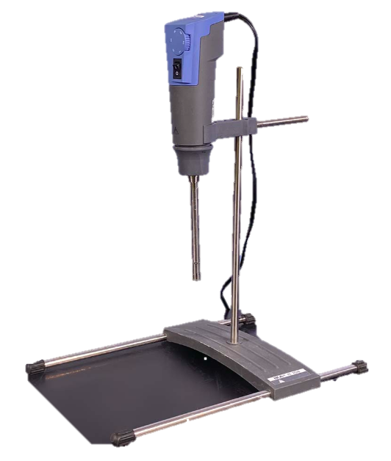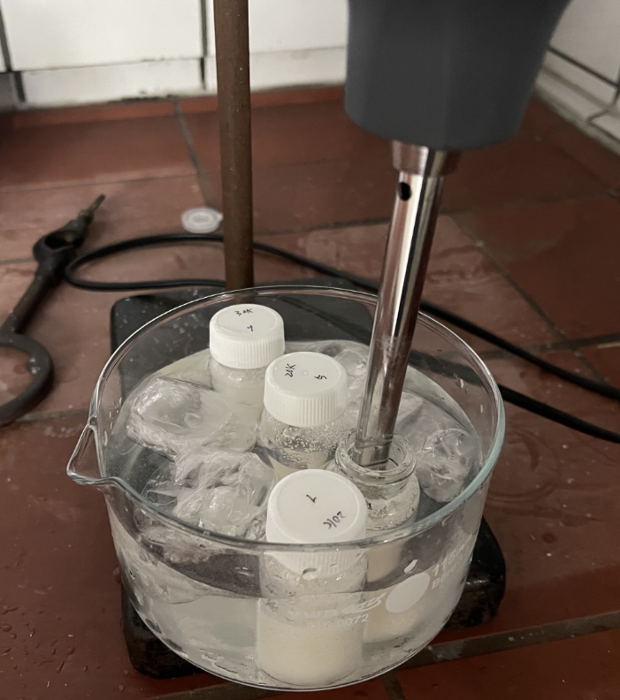

Ice bath

Blade

b

a

Figure 3.1.: a). Schematic diagram of Turaxx. b). Schematic diagram of Turaxx treatment operation in a ice bath.

During the disperser Turaxx treatment, the blade of Turaxx is inserted into the glass bottle containing the mycelium suspension, with the blade being 3 cm from the bottom. The required blade rotation speed was set to 3000 min-1. The suspensions were then treated with Turaxx for either 1 min or 25 min.

### **3.2.3. Manufacturing of *A. niger* mycelium samples for nanoindentation.**

#### 3.2.3.1. Casting of mycelium suspension with different parameters.

The silicone mold was cleaned thoroughly with detergent and ethanol in advance to prevent a part of the sample from sticking to the mold wall and causing the entire sample to tear. The prepared *A. niger* mycelium suspension according to section 3.2.2 was placed into the silicone mold using a spatula. There are two kinds of molds (figure 3.2), one is a cube with a side length of 1 cm, and the other is a slightly larger cube with a side length of 2 cm. And then they were pressed tightly using the special stamps printed using 3D printing technology. There are also two corresponding stamps, and the fotos are placed in the appendix. Then a spatula was used to scrape off any excess that has overflowed from the surface.

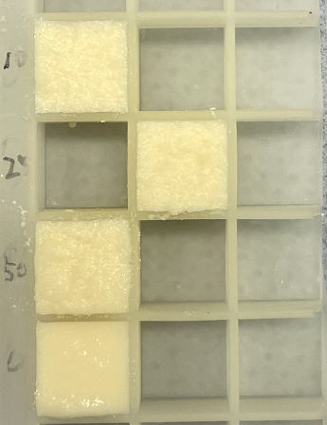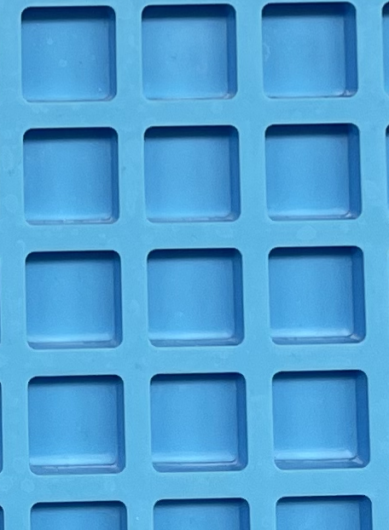

***2 cm***

***1 cm***

b

a

Figure 3.2.: Schematic diagram of two molds. a­). the mold with a cube of 1 cm in side length. b­). the mold with a cube of 2 cm in side length.

#### 3.2.3.2 Drying of mycelium suspension.

In the drying process, all samples were first placed in a fume hood to air dry for 72 hours (3 days). Subsequently, the three different mycelium samples for each batch according to section 3.2.2 and 3.2.3 (without or with TURAXX treatment for 1 or 25 min) were further divided into three groups for different heat treatment processes. Group ***c*** of the three groups was the control group, and the other two groups, ***a*** and ***b***, were subjected to different degrees of heat treatment, in order to study the effects of different heat treatments on the mechanical properties of the samples. The parameters for the heat treatment came from a research report by Eric Schulze from the University of Stuttgart. Table 3.7 lists the heat treatment processes we used in this thesis.

Table 3.7.: Different heat treatment for the samples.

|  |  |  |
| --- | --- | --- |
| ***Drying process*** | | |
| **Sample group** | **Air drying in fume hood** | **Heat treatment in drying oven** |
| ***a*** | 72h | 120℃ 2h |
| ***b*** | 72h | 120℃ 18h |
| ***c*** | 72h | 0h |

Groups ***a*** and ***b*** were placed into an oven at a pre-adjusted temperature for the heat treatment for the designated duration. Sample group ***c*** was subjected to further drying in the fume hood until a constant mass was obtained.

### **3.2.5. Production of pure *A. niger* mycelium plate samples for compression test.**

First, a piece of wool was warped around the mold which was 16.8 cm × 9 cm × 1 cm in size with a black frame. The mycelium suspension was prepared according to section 3.2.2.1 and then filled in the mold wrapped with wool. With a large spatula (e.g., cake spatula), mycelium in it was spread and flattened. And the excess material was removed. The mold was removed then by following the sides of the wool and the sample was placed on the sieve in order to move it. Cover it with the second piece of wool and the sieve. Leave in a fume hood for 22 hours, turning it every 6 hours. The sample needs airflow from above and below. Then place in an oven at 35 °C (still between the sieves). Turn it every 90 minutes for about 6 hours. Place in a press mold (3D printed white plate and its drawing is placed in Appendix) and press the mold together with clamps. Leave the mold in the oven for 2 nights and 1 day (38-39 hours). After the sample is completely dry, a cutting machine was used to cut it into cylindrical samples with a diameter of 9 mm and a thickness of 3 mm. A minimum of 18 pieces are required, with 6 pieces in each group. Each group was subjected to different heat treatments according to Table 3.7.

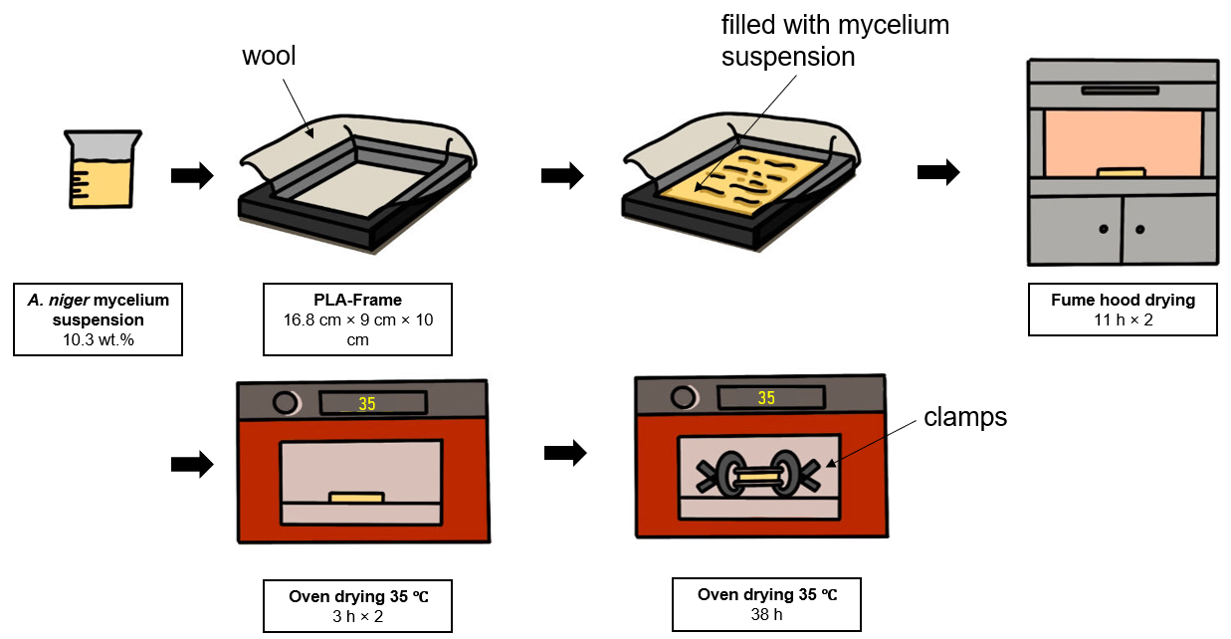

Figure 3.3.: Schematic diagram of production of mycelium plate samples.

## **3.3 Preparation of A. niger mycelium samples with mineralization.**

### **3.3.1 *Insitu* synthesis of amorphous calcium phosphate in A. niger mycelium matrix.**

This section describes the preparation of mineralized composites samples in A. niger mycelium matrix by *insitu* precipitation of calcium phosphate (CaP). Solutions A and B were added as calcium and phosphate sources to the prepared mycelium suspension according to three different schemes resulting in M-insitu-CaP composites with CaP concentrations ranging from 10 % to 50 % of the dry mycelium weight. This samples are referred to as M-insitu-CaP10 to M-insitu-CaP50. Table 3.8 gives an example of the calculation for the required volumes of solution calcium (A) and solution phosphate (B) when the mycelium suspension weight was 1.2 g. The preparation of solutions A and B is described in Section 3.3.1.1. The preparation of the mineralized composites is described in Section 3.3.1.2.

Table 3.8.: Amount of mineralization solution required for a 1200 mg, 14.5 wt.% A. niger mycelium suspension.

|  |  |  |  |  |
| --- | --- | --- | --- | --- |
| **A. niger mycelium: 1200 mg, 14.9 wt.% of mycelium** | | | | |
|  | **M-insitu-CaP 0** | **M-insitu-CaP 10** | **M-insitu-CaP 25** | **M-insitu-CaP 50** |
| Solution A (Ca2+) (1.5M) | 0 | 105.47 µL | 316.42 µL | 949.25 µL |
| Solution B (PO43-) (3.5M) | 0 | 30.13 µL | 90.40 µL | 271.21 µL |

In addition to the different schemes for adding mineralizing solution calcium (A) and solution phosphate (B) mentioned in Table 3.9, different mycelium raw materials, different drying methods and different mycelium suspension preparation methods were also used to produce A. niger mycelium composite materials. All other process methods are listed in the appendix. The samples produced by these methods will not be discussed and analyzed in this thesis. Three representative schemes are shown in Table 3.9. Their production methods are described in the section 3.3.1.2.

Table 3.9.: Three methods of adding solutions and the amounts and order of addition. From left to right is the order in which they are added or operated.

|  |  |  |  |  |
| --- | --- | --- | --- | --- |
| **A. niger mycelium: 1200 mg, 14.9 wt.% of mycelium** | | | | |
| **Batch** | **The order of addition or Operations is from left to right** | | | |
| ***Insitu*** | Sol A, Sol B |  |  | Mixing |
| ***ADB*** | Sol A | Drying (3 Days), grinding | DW, Sol B | Mixing |
| ***BDA*** | Sol B | Drying (3 Days), grinding | DW, Sol A | Mixing |

#### **3.3.1.1 Preparation and calculation of solution A and solution B.**

The solution A of calcium acetate monohydrate (Ca(OAc)2 x H2O) at a concentration of 1.5 M was used as the calcium source for the composites. Solution B, the phosphate source, was prepared by dissolving diammonium hydrogen phosphate powder (NH4)2HPO4) in distilled water. Due to solubility limitations, the concentration of solution B was 3.5 M. Table 3.10 lists the mass of the two substances and the mass of distilled water required to prepare exemplary volumes of the two solutions.

Table 3.10.: The formulas of solution A and solution B and the solubility of their respective solvents.

|  |  |  |  |  |
| --- | --- | --- | --- | --- |
|  | concentration | solubility | Amount of solvent | Amount of DW |
| Solution A | 1.5 M | 34.7 g/100 mL (20 °C) | 2642.7 mg | 10 mL |
| Solution B | 3.5 M | 58.8 g/100 mL (20 °C) | 2311.05 mg | 5 mL |

The synthesis of solution A requires first weighing 2642.7 mg of calcium acetate monohydrate particles, and then 10 mL of distilled water was poured into them in a falcontube. For solution B, 2311.05 mg of diammonium hydrogen phosphate powder are weight, and then 5 mL of distilled water was poured into them in a falcontube. Finally, the two tubes was heated in a 70°C ultrasonic water bath for approximately 3 h to fully dissolve the solute.

#### **3.3.1.2 Fabrication of mineralized mycelium composite materials using insitu synthesis.**

This section describes three different schemes which was listed in table 3.9 in detail.

##### Production of Batch insitu of *A. niger* mycelium composites

As the simplest production schemes of *insitu* precipitated calcium phosphate, this batch is called insitu. In this production method, solutions A and solution B are simultaneously added to the mycelium matrix. The total amount of solution added was different for mycelium matrices with different mineralization degrees. In order to make the weight percentage of mycelium in suspensions after adding solutions A and B the same, based on the M-insitu-CaP 50 sample with the most solution added, other samples need to add an appropriate amount of DW before mineralization.

4 portions of 1200 mg of mycelium suspension were weighted. Then 1220.46 µL of DW was added to the sample without mineralization treatment and named M-insitu-CaP 0. 1084.86 µL and 813.64 µL of DW was added to the mycelium suspension with a mineralization degree of 10% and 25%, respectively. Then, solutions A and B are added to the samples with mineralization degrees of 10%, 25% and 50% for mineralization treatment. The amounts of solution A and solution B required for the mineralization treatment of these four suspensions are given in Table 3.8. The contact between the two solutions will quickly cause the precipitation reaction of calcium phosphate. After adding the solution, the suspension was quickly mixed using a Speedmixer at 3500 rpm for 20 s.

Then a spatula was used to put the mixed suspension into the mold and the stamp was used to compact the sample. The mold was then shacked to release as many bubbles as possible, repeat this step several times. Finally, with a spatula the excess sample on the surface was scraped off and then the samples were placed in a fume hood to dry for 72 h (3 days).

##### Production of Batch ADB or BDA of A. niger mycelium composite material

In this method, solution A and solution B were added one after another, additionally with a drying process in the middle, so it is called AD(drying)B or BDA. First, four portions of 1200 mg of *A. niger* mycelium suspension were weighed. The mycelium suspension with a mineralization degree of 0 was not further treated and was named M-insitu-CaP 0. The amounts of solution A and solution B required for the mineralization treatment of these four suspensions are given in Table 3.10. And the add sequence is presented in Table 3.9. The four suspensions were mixed thoroughly using a Speedmixer in 3500 rpm and 20 s. The four mycelium suspensions were then spread on aluminum foil using a spatula and then placed in a fume hood to dry. After three days of thorough drying, the mixture of mycelium and solution A on the aluminum foil was removed. The dried mixture was ground into powder with a ceramic grinding mortar. Then 1969.87, 1909.5 and 1728.79 μL of DW was added to each of the four samples respectively and mixed well using a Speedmixer at 3500 rpm for 20 s. No solution B or A was added to sample M-insitu CaP 0. All samples were mixed thoroughly again using a Speedmixer at 3500 rpm for 20 s. The mixed suspensions were placed in a mold, compacted using a stamp, and shaken to release as many bubbles as possible. After repeating this step for several times, scrape off the excess sample on the surface with a spatula and place it in a fume hood to dry for 72 hours (3 days).

### **3.3.2 Precursor synthesis of amorphous calcium phosphate in A. niger mycelium matrix.**

This section describes the synthesis of ACP using a precursor synthesis method and its combination with an A. niger mycelium matrix to form a composite material. The precursor method produces an ethanol suspension of ACP.

#### 3.3.2.1 Preparation of calcium phosphate nanoclusters.

The synthesis of the calcium phosphate nanoclusters (nano-CaP) was carried out according to the group of Tang et al. [40]. Calcium phosphate nanoclusters are precipitated by mixing solution Ca with solution Phosphate. First, 1.0 g of calcium chloride dihydrate (CaCl2 x 2H2O) was weighted and dissolved in 90 mL of ethanol for approximately 1 min. After it is fully dissolved, it is introduced into a neck flask with a stirring bar, and 3.8 mL of triethylamine (TEA) is added, accompanied by continuous stirring at 300 rpm. The neck flask is sealed with a silicone plug. Then, 350 µL of ortho phosphoric acid (H3PO4) are dissolved in 10 mL of ethanol. Through the needle the solution was then to suck it into the syringe, which is solution Phosphate. The neck flask is fixed and the stirring speed is adjusted to 300 rpm. The syringe is fixed on the syringe pump, and its needle is inserted into the plug and deep into the neck flask. At the same time, the second needle was also inserted into the plug to ensure that the internal and external air pressures was balanced. The syringe diameter was entered into the computer of the syringe pump, and the injection speed is adjusted to 3.3 mL/h. Solution 2 will be slowly injected into solution 1 and form a milky suspension.

After about 3 hours of injection, more than 100 ml of calcium phosphate precipitate suspension was formed. The suspension was evenly divided into 4 centrifuge tubes and centrifuged at 7840 rpm for 10 minutes. After removing the supernatant, 15 mL of ethanol was injected into each of the 4 centrifuge tubes and resuspended by using a vortex mixer. The suspensions from two of the centrifuge tubes were added to the other two centrifuge tubes respectively, and the ethanol washing step was repeated twice. That is, a total of 3 ethanol washings were performed to wash away TEA. After the last wash, add 20 mL of ethanol to each of the two centrifuge tubes and resuspend them by shaking. Mix the suspensions in the two centrifuge tubes and pour a total of 40 mL into a glass bottle. Take 500 μL of the suspension, dry it, weigh it and determine the concentration. The concentration is approximately 17 mg/mL. Then put it in the refrigerator to freeze for storage. A schematic presentation of the experi-mental setup is given in Figure 3.4.

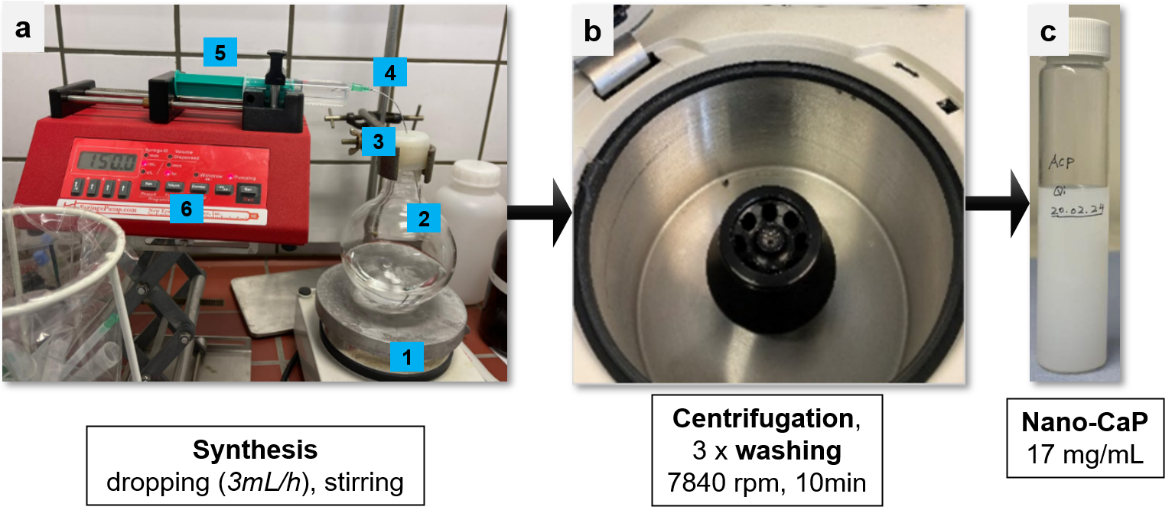

Figure 3.4.: Experimental setup for the synthesis of the calcium phosphate nanoclusters (nano-CaP). a) Setup with syringe pump (5, 6), cannulas (4), round neck flask (2) with plug (3) and magnetic stirrer (1). b) Centrifugation at 7840 rpm for 10 min. c) Storage of the nano-CaP suspension in a concentration of 17 mg/mL in a glass sample container.

#### **3.3.2.2 Fabrication of mineralized mycelium composite materials using precursor synthesis.**

The required amount of Nano-CaP was weighted to each to be mineralized mycelium composite and centrifuged. Then the supernatant was discarded. The amount required for each sample is listed in Table 3.11.

Table 3.11.: The amount of Nano-CaP suspenstions required for each mineralization level of the sample.

|  |  |  |  |  |
| --- | --- | --- | --- | --- |
| **A. niger mycelium: 1500 mg, 14.9 wt.% of mycelium** | | | | |
|  | M-insitu-CaP 0 | M-insitu-CaP 10 | M-insitu-CaP 25 | M-insitu-CaP 50 |
| Nano-CaP (17mg/mL) | 0 | 1.31 mL | 3.29 mL | 6.57 mL |

In the first step, 4 portions of 1500 mg of A. niger mycelium suspension raw materials were weighted. One portion was not added with Nano-CaP and was called M-Prec-CaP 0. Then 1.31, 3.29 and 6.57 mL of Nano-CaP centrifugal precipitate were added to the remaining 3 portions of mycelium suspension and mixed using a Speedmixer at 3500 rpm for 20s, named as M-Prec-CaP 10, M-Prec-CaP 25, M-Prec-CaP 50 respectively. The mixed suspension was placed in a mold, compacted with a stamp, and shaken to release as many bubbles as possible. After repeating several times, the excess sample on the surface was scraped off with a spatula and dried in a fume hood for 72 h (3 days).

## **3.4 Preparation of calcium phosphate and calcium carbonate mineralized composite materials in CNC matrix using precursor synthesis.**

This section describes the preparation of mineralized composite materials of calcium phosphate and calcium carbonate in CNC matrix. Calcium phosphate nanoclusters and calcium carbonate nanoclusters were pre-synthesized by a precursor synthesis method and then added to the CNC matrix after centrifugation. The preparation of CNC composites with different calcium phosphate mineralizations (20 wt.%, 33 wt.%, 50 wt.%, 66 wt.%, 75 wt.%) in two CNC matrix was described in Section 3.4.1. The preparation of two CNC composites with different mineralizations (20 wt.%, 33 wt.%, 50 wt.%, 66 wt.%, 75 wt.%) in two CNC matrix was described in section 3.4.2. The synthesis of calcium phosphate nanoclusters used in Section 3.4.1 has been described in Section 3.3.2.1 and will not be repeated in this section. The synthesis of calcium carbonate nanoclusters will be described in Section 3.4.2.1.

### **3.4.1 Preparation of mineralized composites with different CaP content in CNC matrix using precursor synthesis**

This section describes the process for preparing samples of two CNC suspensions (100 and 110) that were mineralized to 5 different degrees with calcium phosphate. The following table 3.12 lists the amounts of CNC suspension and nano-CaP required for this experiment. The added amount of calcium phosphate for composites consisting of 10 % to 75 % CaP of the dry CNC weight (named CNC-CaP0 to CNC-CaP75) is calculated according to the following formula and given by an example in Table 3.12.:

$$V_{Nano-CaP}=\frac{m_{CNC suspension}×c_{CNC}× χ\%}{c_{nano-CaP}}$$

Table 3.12.: The amounts of CNC suspension and nano-CaP required for five CNC-ACP composites with different mineralization degrees.

|  |  |  |  |  |  |
| --- | --- | --- | --- | --- | --- |
| **CNC suspension: weight percent of CNC 100/110 is 6.4%. Nano-CaP: concentration of suspension is 17mg/mL.** | | | | | |
| **Weight percent of CaP** | **20%** | **33%** | **50%** | **66%** | **75%** |
| CNC (100L, 110L) | 2 g | 2 g | 2 g | 2 g | 2 g |
| Nano-CaP | 1.51 mL | 2.51 mL | 3.76 mL | 5.02 mL | 5.65 mL |

In the first step, 2 g of each of the two CNC suspensions was weighed, and 5 portions were prepared. The needed amount of CaP for composites consisting of 10 % to 75 % CaP of the dry CNC weight (named CNC-CaP10 to CNC-CaP75) is listed in Table 3.12. 1.51 mL, 2.51 mL, 3.75 mL, 5.02 mL and 5.65 mL of the nano-CaP suspension were weighed in centrifugal tube and then centrifuged at 8000 rpm for 3 min and the supernatant was discarded. 1.51 mL suspension centrifugal precipitates were added to the CNC suspensions, named as CNC-CaP20 100/110. 2.51 mL and 3.75 mL suspension centrifugal precipitates were added to the CNC suspensions, named as CNC-CaP33 100/110 and CNC-CaP50 100/110. The remaining 5.02 mL and 5.65 mL suspension centrifugal precipitates were added to the two CNC suspensions, named as CNC-CaP66 100/110 and CNC-CaP75 100/110. Remaining CaP in the centrifugal tube was taken up with a smaller spatula. Finally, all samples were uniformly mixed by Speedmixer at 3500 rpm for 2 min.

#### Fabrication of calcium phosphate mineralized CNC composite materials

Firstly, microscope slides were subsequently cleaned with DW, acetone, DW, and isopropanol, and then dried. A utility knife was used to cut window molds from three types of 1mm thick red silicone mats. The center of the mold was a circle with a diameter of 2cm and a square frame. Two silicone molds were placed on microscope slides. These combinations were used as mold to hold the composite mixtures. For each mixture, a spatula was used to place the mixture into the window molds (see Figure 3.5). The mixture was placed in an incubator to dry. The incubator temperature was adjusted to 24°C and the relative humidity was adjusted to 70%.

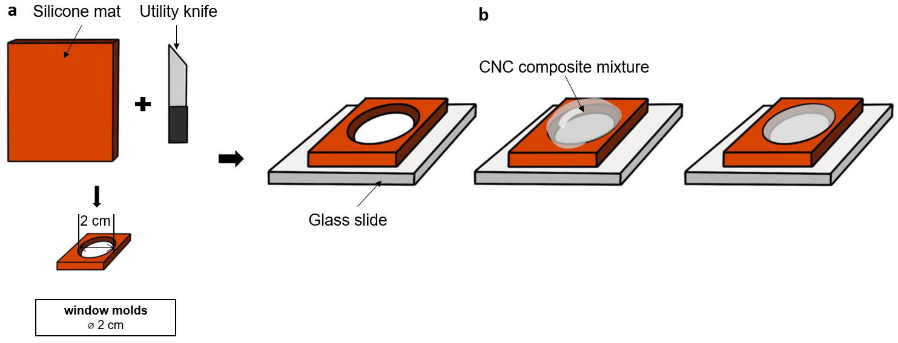

Figure 3.5.: Schematic diagram of CNC composite film production. a) The window mold is cutted out using a utility knife. b) The CNC-CaP mixture is poured into the mold and smoothed.

### **3.4.2 Preparation of mineralized composites with different calcium carbonate content using precursor synthesis**

In this section the process for preparing samples of two CNC suspensions (100 and 110) that were mineralized to 5 different degrees with calcium carbonate was described. The following table 3.13 lists the amounts of CNC suspension and nano-CaP required for this experiment.

#### 3.4.2.1 Preparation of calcium carbonate oligomer .

The synthesis of the calcium carbonate oligomer (CCO) was carried out according to the group of Tang et al. [82]. This calcium carbonate oligomer is synthesized by bubbling carbon dioxide into a solution containing calcium. First, weigh 0.6 g of calcium chloride dihydrate (CaCl2 x 2H2O) and then dissolve it in 100 mL of ethanol. After it is fully dissolved, it is introduced into a neck flask with a stirring bar, and 11.4 mL of triethylamine (TEA) is added. They are prepared into a mixed solution and accompanied by continuous stirring at 300 rpm. Then, 100 ml min−1 of carbon dioxide was bubbled into the mixed solution through a glass gas tube for 10 min. The solution turned milky white. The neck flask is sealed with a silicone plug and fixed. And the stirring speed of the stirring bar is adjusted to 300 rpm. Then the solution was stirred for 24 h until it became semi-transparent.

At last, more than 110 ml of CCO suspension was formed. The suspension was evenly divided into 4 centrifuge tubes and centrifuged at 7840 rpm for 10 minutes. After removing the supernatant, 15 mL of ethanol was injected into each of the 4 centrifuge tubes and resuspended by shaking with a vortex mixer. The suspensions from two of the centrifuge tubes were added to the other two centrifuge tubes respectively, and the ethanol washing step was repeated twice. That is, a total of 3 ethanol washings were performed to wash away TEA. After the last wash, add 15 mL ethanol to each of the two centrifuge tubes and resuspend them by shaking. Mix the suspensions in the two centrifuge tubes and pour a total of 30 mL into a glass bottle. 500 μL of the suspension should be taken, dried. And the net weight of the precipitate was weighted to determine the concentration. The general concentration is about 6 mg/mL. Then put it in the refrigerator to freeze for storage.

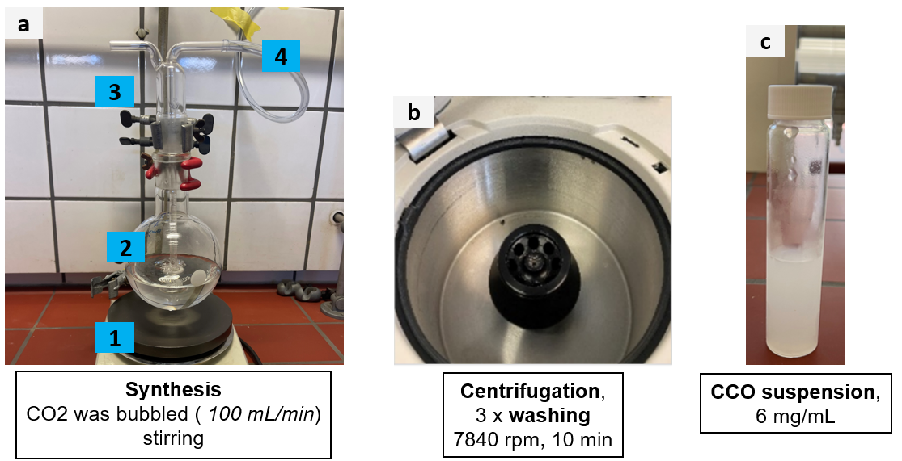

Figure 3.6.: Experimental setup for the synthesis of the calcium carbonate oligomer (CCO). a) Gas distributor (3, 4), round neck flask (2) and magnetic stirrer (1). b) Centrifugation at 7840 rpm for 10 min. c) Storage of the CCO suspension in a concentration of 6 mg/mL in a glass sample container.

#### 3.4.2.2 Fabrication of calcium carbonate mineralized CNC composite materials

This section describes the process for preparing samples of two CNC suspensions (100L and 110L) that were mineralized to 5 different degrees with calcium carbonate. The following table 3.15 lists the amounts of CNC suspension and CCO suspension required for this experiment.

Table 3.13.: The amounts of CNC suspension and CCO suspension required for five CNC-CaC composites with different mineralization degrees.

|  |  |  |  |  |  |
| --- | --- | --- | --- | --- | --- |
| **CNC suspension: weight percent of CNC is 6.4%. CCO: concentration of suspension is 6 mg/mL.** | | | | | |
| **Weight percent of CCO** | **20%** | **33%** | **50%** | **66%** | **75%** |
| CNC (100L, 110L) | 1 g | 1 g | 1 g | 1 g | 1 g |
| CCO suspension | 2.13 mL | 3.56 mL | 5.33 mL | 7.1 mL | 8 mL |

First, 1 g of each of the two CNC suspensions was weighed, and 5 portions were prepared. The needed amount of CaP for composites consisting of 10 % to 75 % CaC of the dry CNC weight (named CNC-CaC10 to CNC-CaC75) is listed in Table 3.13. The corresponding volume of the previously synthesized CCO solution was centrifuged for 3 min at 8 000 rpm and the supernatant was removed. The residual gel-like CCO was then transferred in the CNC suspensions with a spatula. Remaining CaP in the centrifugal tube was taken up with a smaller spatula. Then all samples were uniformly mixed by Speedmixer at 3500 rpm for 2 min.

Two 1 mm thick window molds were placed on clean microscope slides as described in Section 3.4.1 and in figure 3.5. Then a spatula was used to fill the mixture into the mold, compact it lightly, smooth the surface and scrape off the excess mixture on the surface. It was then placed in an incubator in order to dry for 72 hours. The incubator temperature and relative humidity was set to 24°C to 70% respectively.

### **3.5 Samples preparation for characterization**

### **3.5.1 Preparation of samples for PXRD and FTIR**

The CNC composite samples were required to be pulverized to perform PXRD and FTIR. samples were ground into fine powder using pestle and mortar (＜10 μm particle size). To avoid cross-contamination, the mortar has to be washed with water and ethanol after pulverizing a previous sample. The A. niger mycelium sample also needs to be pulverized for PXRD, and the preparation process is the same. But no requirement of pulverization for FTIR.

## **3.6 Characterization**

### **3.6.1 Thickness measurement**

The thickness of the films was measured with a thickness gauge (). The composite film was separated from the glass slide and placed in a thickness gauge for measurement. Three measuring points were taken on different spots and the mean value and standard deviation was calculated.

### **3.6.2 Nanoindentation**

Nanoindentation experiments were executed to determine the Martens hardness HM and the indentation elastic modulus (EIT) of the specimens, using a nanoindenter (FISCHERSCOPE H100 XYp, Helmut Fischer GmbH). The applied maximum of indentation depth was set to 1/15 of the film thickness for CNC composite samples. For mycelium smapes, the applied maximum indentation depth was set to 8 µm. When the maximum indentation depth was reached after a 20-second ramp, the force was maintained for 15 seconds before initiating the unloading phase. Each samples HM and EIT were determined through six measurements within a single cycle, providing an average value along with its standard deviation. A diamond Vickers indenter was used for all indentations. Indentation results were analyzed and calculated from the measured load-displacement curves with WINHCU ® software and a Python script, followed by further analysis and visualization using the Origin software.

### **3.6.3 Compression testing**

The thickness of the CNC composite film was measured by a thickness gauge. The composite film was separated from the glass slide and placed in a thickness gauge for measurement. Three measuring points were taken on different spots and the mean value and standard deviation was calculated.

### **3.6.4 Microscopic analysis**

#### 3.6.4.1 Light microscope

For the first evaluation of the structure changes of pellet-structure in mycelium suspensions, a light microscope was taken. Eyepieces with 10x and objective with 5x and 10x magnification were used.

#### 3.6.4.2 Scanning electron microscope

The investigation into the morphological and structural characteristics of the mycelium samples and CNC composite samples was done using a scanning electron microscope (SEM) (VEGA 3, Tescan). CNC Samples were either sectioned into smaller spices using a razor blade or fractured using a hammer. Subsequently, these pieces were attached to a SEM stub using carbon tape and cross section was always facing up. For each sample, a section of the surface and a cross-section were examined. To assure sample conductivity, a thin gold coating was applied to the sample's surface using a sputter coater (SCD 050, BAL-TEC AG) equipped with a gold target. This coating method used a 90-second sputter period and a current of 50 mA. The SEM pictures were taken with an electron acceleration of 20 kV. Each sample was imaged to capture both internal and external features.

#### 3.6.4.3 energy dispersive X-ray spectroscopy

The contents of CaC and CaP in CNC composite samples were analyzed using a scanning electron microscope (SEM) (VEGA 3, Tescan) combined with an EDX detector (Bruker Nano GmbH, XFlash Detector 610M). The samples were ground into powder and pressed onto a conductive tape on a sample tray. A thin carbon coating was applied to the sample surface using a sputter coater (SCD 050, BAL-TEC AG) equipped with a gold target. SEM images were taken at 20 kV electron acceleration. Three point measurements were performed for each sample. The three data were averaged and analyzed for the mass percentage of CaC and CaP.

### **3.6.5 Spectroscopy and diffraction analysis**

#### 3.6.5.1 Raman Spectroscopy

Characterization of the calcium phosphate phases and calcium carbonate phases in the composites films was done using a Raman spectrometer (Bruker MultiRAM). The laser used had a wave-length of 1064 nm. Resolution is 4 cm-1 and cathode material is Nd:YAG. 250mW defocus for CNC composite films. Measurement of powder sample (CaC and CaP) in aluminum crucible (same measurement parameters, focusing only). Measurement time is 200 scans Evaluation and peak analysis were run using the software Origin. For some data a baseline correction had to be carried out. All data were normalized before plotting.

#### 3.6.5.2 FTIR Spectroscopy

ATR-FTIR spectroscopy was carried out by placing the pulverized CNC composite samples or mycelium block samples on the diamond ATR crystal (VERTEX 70v, Bruker Corporation) and with a stamp the powder was pressed before measurements were performed. All measurements were done in absorption mode. The background measurement of 60 independent scans was performed before the measurements. Similarly, the main measurement for each sample included 60 scans with a measurement period of 45 seconds. The recorded data ranged from 400 cm-1 to 4000 cm-1, with a resolution of 0.5 cm-1. Ethanol was used to clean the ATR crystal and stamp after each measurement.

The analysis was run using the software OPUS during measurement and Origin for data plotting. For evaluation and comparison, the data were normalized based on the intensity values ​​of the specific peaks.

#### 3.6.5.3 Powder diffractometry

The prepared sample powders were used for PXRD. X-ray diffractometer is D8 Discover, Bruker with Cu-Kα radiation (λ = 1.5406 Å). Primary side is fixed aperture with 0.6mm aperture, 2.5°. The detector of primary is Lynx-Eye XE-T generator Soller in the secondary side is 5.6mm aperture, 2.5°. Its output is 40 kV/40 mA. The measurements were conducted in reflection mode with a flat sample preparation. The X-ray diffraction (XRD) scans were performed over a 2Theta range from 5° to 70°, using a step size of 0.0203° and a counting time of 0.5 seconds per step.

## **3.7 Statistics**

Statistical analysis of indentation modulus and hardness was done within the software Origin using a single-factor ANOVA analysis. At least six measuring points were considered for each sample. Mean value comparison was performed by the Bonferroni post-hoc test. The significance level was p < 0.05.

# **Results and discussion**

## **4.1 Characterization of pure *A. niger* mycelium samples.**

This section discusses the characterization of all samples made using only *A. niger* mycelium. The samples were grouped according to the initial concentration of the mycelium in the suspension, aging process and the duration of disperser treatment. There were four groups, namely one group of samples containing 7.4 % and two groups of samples containing 10.3 % mycelium in initial suspension and with different aging treatment. All these three groups were treated with a small disperser (sTX). The last group of samples containing 10.3 % mycelium in initial suspension using a big disperser (bTX) with aging treatment. First, the performance of the mechanical properties of the A. niger mycelium after drying was discussed. More specifically, the effects of the disperser, aging treatment and different heat treatment times on the mechanical properties of the mycelium samples were investigated. Then, the effects of different initial concentrations of mycelium suspension on the mechanical properties were discussed. Finally, the effects of heat treatment on the chemical composition of the A. niger mycelium were discussed. All mechanical property measurement data were subjected to single-factor Anova analysis to see whether there were significant differences between the data groups.

### **4.1.1 Characterization of morphology and surface of pure *A. niger* mycelium samples**

Figure 4.1 shows the SEM micrograph of the pure *A. niger* mycelium sample with 10.3 wt.% mycelium in suspension without aging treatment. For sample preparation, samples without grinding and polishing were selected. The figure shows the surface morphology of the sample after drying.

The surface of the sample without Turaxx treatment clearly shows the pellet-structure of mycelium. The mean diameter of these pellet-structure is counted as 146 ± 42 µm. In contrast, the pellet-structure of mycelium can also be identified on the surface of the sample with 1 min-Turaxx treatment. Their mean diameter is 152 ± 45 µm. However, due to the effect of Turaxx, the pellets were torn up moderately, and small pellets mycelium or hyphae filled the gaps between large pellets. Therefore, it can be clearly seen that the boundaries between the particle structures seem to be fused together, and the boundaries are not as clear as those of samples without Turaxx treatment. Due to the fusion of the interface, the size of the particles is enlarged, and there are also smaller particle structures that are torn up. Therefore, the statistical average and standard deviation are higher than those of samples without Turaxx treatment. After 25 minutes of Turaxx treatment, the pellet-structure in the sample can no longer be clearly identified. The surface of the sample is like the surface of solidified magma. This shows that after sufficient Turaxx treatment, the pellet-structure is completely destroyed. Pellet-structure size statistics become infeasible. By comparing the samples without heat treatment and the samples after heat treatment, the microscopic morphology of the samples did not change. However, it can be found that the sample shrinks significantly. According to statistics, after 2h and 18h ​heat treatment, the volume shrinkage of the sample is 4.7 ± 0.5 % and 3.9 ± 0. 3 % respectively. The same variation can be obtained by statistically analyzing the size changes of the pellet-structures. After 2 h and 18 h of heat treatment, the mean diameter of pellet-structure in the samples without Turaxx treatment changed to 121 ± 42 and 134 ± 35 µm, respectively. For the sample with 1 min-Turaxx treatment, the dimension of pellet-structure changed to 131 ± 37 mmafter 18 h-heat treatment.

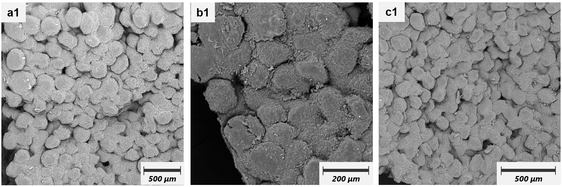

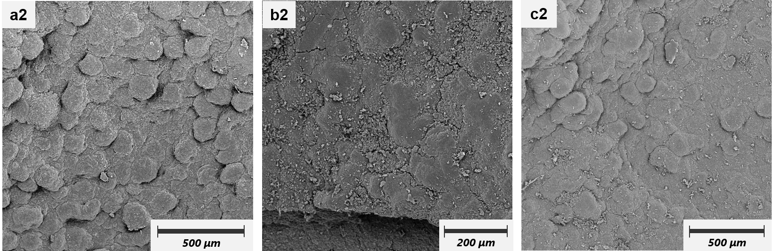

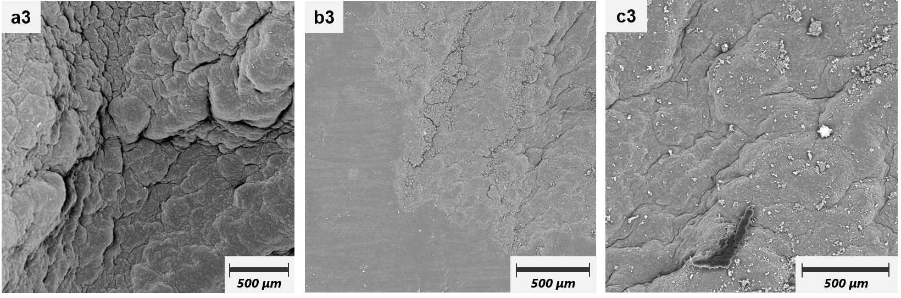

Figure 4.1.: SEM micrographs of the surface of batch 10.3 wt.% mycelium samples. 1=Samples without Turaxx treatment. 2=Samples with 1 min-Turaxx treatment. 3=Samples with 25min-Turaxx treatment. a=without Heat treatment. b=120℃ 2h-heat treatment. c=120℃ 18h-heat treatment.

### **4.1.2 Mechanical characterization of the mycelium samples**

#### 4.1.2.1 Mechanical characterization using nanoindentation

Mechanical characterization was done by nanoindentation measurements. The sample was ground with 320P-4000P sandpaper without water to achieve a horizontal sample surface. The Martens hardness (HM) and elastic modulus or indentation modulus (EIT), calculated from the Nano-indenter software, are plotted for each sample. Significant differences were tested using a single-factor ANOVA with Bonferroni (p < 0.05).

This section discusses the changes in indentation modulus and hardness of 7.4 wt.%, 10.3 wt.%, and 10.3 wt.% with aging samples in initial suspension after heat treatment for different time (0 h, 2 h, 18 h), and sets up a control experiment to compare the two different dispersers (Turaxx). Turaxx is generally used for mixing solutions, which are thoroughly stirred by means of a high-speed rotating cutter head. In this thesis, we used it to disrupt the original pellet structure of mycelium. Turaxx works in two ways. On the one hand, the cutter head rotates at high speed to generate huge shear stresses to tear the pellet-structural mycelium apar. On the other hand, the suspension is driven to rotate very fast by the high-speed rotation of the cutter head, in which the mycelium particles are constantly colliding with other particles and being grinded. Through these two aspects Turaxx changes the pellet structure of mycelium into smaller pieces of mycelium or dispersed hyphae.

In the batch 7.4 wt.%-sTX, it’s mechanical properties can be viewed in figure 4.2. The samples without Turaxx-treatment showed a trend of first increasing and then decreasing with the increase of heat treatment time. To be precise, the Young's modulus of the samples with a 2 h-heat treatment was significantly increased to 2.93 ± 0.06 GPa compares to the samples in room temperature with 2.31 ± 0.14 GPa. However, as the heat treatment time increases to 18 h, the Young's modulus of the samples has decreased slightly to 2.77 ± 0.16 GPa. In contrast to the change trend of indentation modulus, the Martens hardness of the samples did not change significantly under the two heat treatment times. The data shows the Martens hardness of the samples after 2 h- and 18 h-​​heat treatment is 118 ± 2.5 N/mm2 and 116.68 ± 8.42 N/mm2. They are no difference but higher than the samples in room temperature which has 93.0 ± 4.9 N/mm2 for Martens hardness. The sample with 25 min-Turaxx treatment has a similar changing trend to the samples without Turaxx-treatment. Its indentation modulus first increases significantly from 2.44 ± 0.07 GPa to 2.81 ± 0.1 GPa after 2 h-heat treatment and then decreases significantly to 2.57 ± 0.15 GPa when the heat treatment time is increased to 18 h. The hardness follows the same trend, it firstly increased from 94.5 ± 2.96 N/mm2 at room temperature to 113 ± 3.72 N/mm2 after 2h of heat treatment, and then decreased to 104 ± 5.88 N/mm2 when the heat treatment time was increased to 18 h. The indentation modulus of samples treated with 1 min of Turaxx is 2.29 ± 0.11 GPa at room temperature and increases with heat treatment time to 2.46 ± 0.03 GPa and then 2.62 ± 0.09 GPa. The Martens hardness of these samples follow the trend of most group of samples, i.e., it increases from 91.7 ± 2.04 N/mm2 at room temperature and then increases to 110 ± 2.05 N/mm2 after 2h of heat treatment, but decreases to 101 ± 4.59 N/mm2 after increasing the heat treatment time to 18h.

Comparing the three groups of samples at the same temperature, the samples with 25 min-Turaxx treatment at room temperature have a higher indentation modulus than the samples with 1 min-Turaxx treatment and without Turaxx treatment, but there is no significant difference in their Martens hardness. Among the samples with 2 h-heat treatment, the highest indentation modulus and Martens hardness is observed in the samples without Turaxx treatment. The lowest indentation modulus is observed in the samples with 1-min Turaxx treatment, and their Martens hardness is the same as that of the sample with 25-min Turaxx treatment and both of them are lower than that of the samples without Turaxx treatment. In the samples with 18 h-heat treatment, the indentation modulus and Martens hardness of the samples with Turaxx treatment are lower than those of the samples without Turaxx treatment.

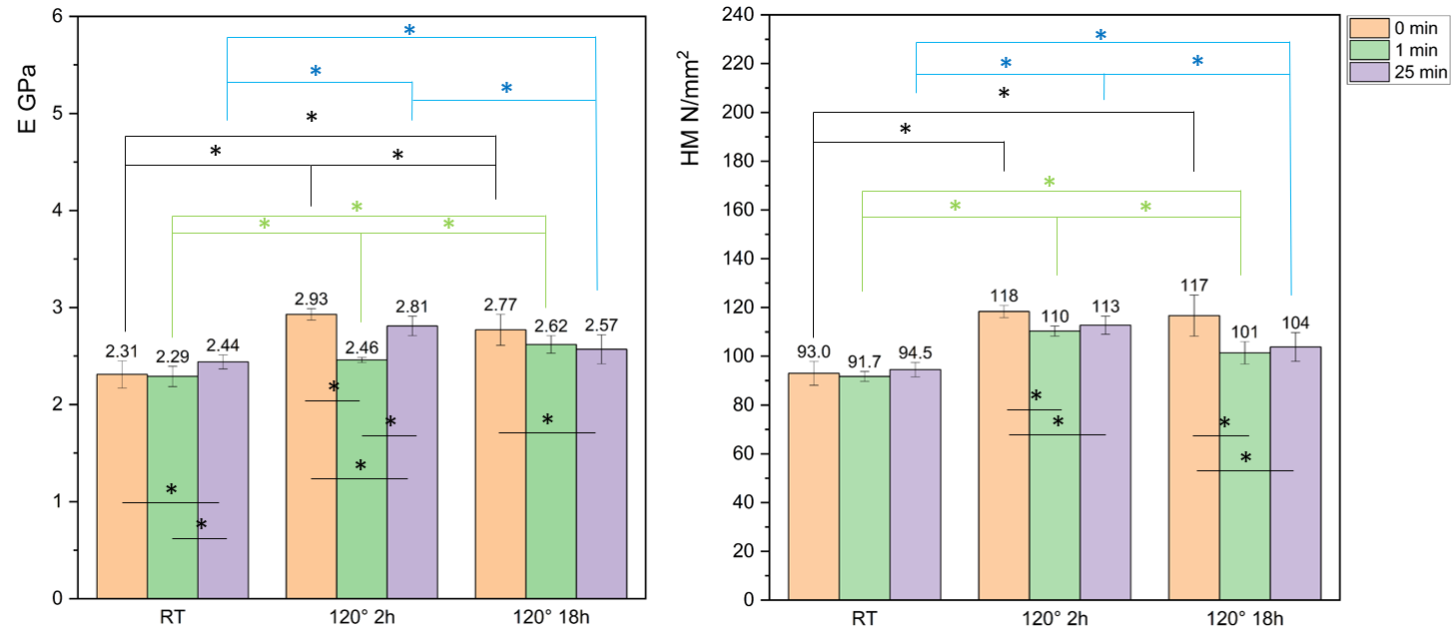

Figure 4.2.: Indentation modulus and Martens hardness of the batch 7.4 wt.%-sTX mycelium samples with different Turaxx treatment time (0 min, 1 min, 25 min) after heat treatment for different time (0 h, 2 h, 18 h at 120℃). * = significant difference to the two group of samples.

The mechanical properties of the batch 10.3 wt.%-sTX mycelium samples can be viewed in Figure 4.3. The indentation modulus of the samples without Turaxx treatment and with 1 min-Turaxx treatment are a changing trend of increasing after 2 h-heat treatment and then decreasing after 18 h-heat treatment. That means the highest indentation modulus appears in the samples after 2h heat treatment, which are 2.79 ± 0.06 GPa and 2.44 ± 0.14 GPa respectively. The indentation modulus of this 1 min-Turaxx treated samples with 18 h-heat treatment is even lower than the same samples without heat treatment. The Martens hardness of the samples without Turaxx treatment also has the same changing trend and reaches a maximum value 118 ± 3.08 N/mm2 after 2h heat treatment. For the samples with 1 min-Turaxx treatment, their Martens hardness shows a trend of increasing after both heat treatment and no different between these two. The indentation modulus and also Martens hardness of the samples with 25 min-Turaxx treatment was increased after heat treatment and there is no significant change between the samples with different heat-treatment time. The indentation modulus and Martens hardness of this group reached 2.75 ± 0.11 GPa and 122 ± 3.72 N/mm2 respectively.

Among the three groups of samples without heat treatment, the samples with 25 min-Turaxx treatment have the highest indentation modulus and hardness. However, after both heat treatments, the mechanical properties of the samples with 1 min-Turaxx treatment were the lowest. Except for the samples with 18 h-heat treatment, in which the samples with 25 min-Turaxx treatment had a higher indentation modulus than the samples without Turaxx treatment, the mechanical properties of the rest samples to these two groups after heat treatment remained the same.

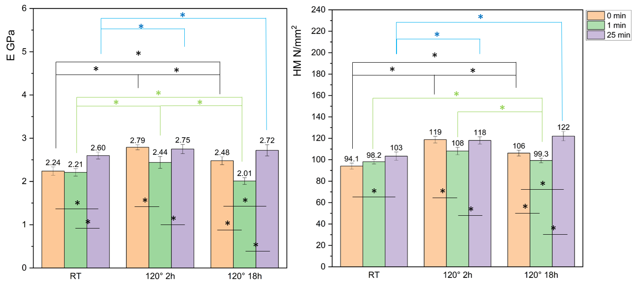

Figure 4.3.: Indentation modulus and Martens hardness of the batch 10.3 wt.%-sTX mycelium samples with different Turaxx treatment time (0 min, 1 min, 25 min) after heat treatment for different time (0 h, 2 h, 18 h at 120℃). * = significant difference to the two group of samples.

The mechanical properties of the batch 10.3 wt.%-aging-sTX mycelium can be viewed in Figure 4.4. After aging treatment, the mycelium content in the mycelium suspension increased to 20 wt.%. As the weight percent of mycelium in the suspension increased, the samples showed a different trend from the samples with a lower mycelium concentration in the suspension. The indentation modulus of the samples without Turaxx treatment increases from 2.30 ± 0.03 GPa to 2.84 ± 0.1 GPa after 2 h of heat treatment, and then decreases to 2.69 ± 0.06 GPa as the heat-treatment time increases to 18 h. The Martens hardness of this group is significantly improved after heat treatment from 93.4 ± 2.93 N/mm2 to 121 ± 2.45 N/mm2, and there is no difference in the hardness improvement effect produced by heat treatment with longer time and heat treatment with shorter time. The indentation modulus and Martens hardness of the group with 1 min-Turaxx treatment first increased after 2 h of heat treatment and then remained unchanged as the heat treatment time increased to 18 h. That means the indentation modulus increased from 2.38 ± 0.13 GPa in room temperature to 2.71 ± 0.16 GPa after heat treatment and the Martens hardness increased from 97.3 ± 5.04 N/mm2 in room temperature to 118 ± 3.74 N/mm2 after heat treatment. The mechanical properties the group of samples with 25 min Turaxx treatment showed a significant increasing trend with increasing heat treatment time. The indentation modulus and Martens hardness of this group increases from 2.72 ± 0.09 GPa and 97.4 ± 1.26 N/mm2 to 3.45 ± 0.05 GPa and 136 ± 1.46 N/mm2 respectively.

Among the samples without heat treatment, the indentation modulus of the samples with Turaxx treatment was significantly increased than that of the samples without Turaxx treatment, even if it was only 1 min. Only the samples treated with 25min Turaxx have higher Martens hardness than the samples without Turaxx treatment. Among the samples with 2 h-heat treatment, the mechanical properties of the samples with 25 min-Turaxx treatment were the same as those of the samples without Turaxx treatment and both of them were higher than those of the samples with 1 min-Turaxx treatment. For the samples with 18 h-heat treatment, the mechanical properties of the samples with 25 min-Turaxx treatment were higher than the samples without Turaxx treatment and with 1 min-Turaxx treatment and there is no difference between the latter two.

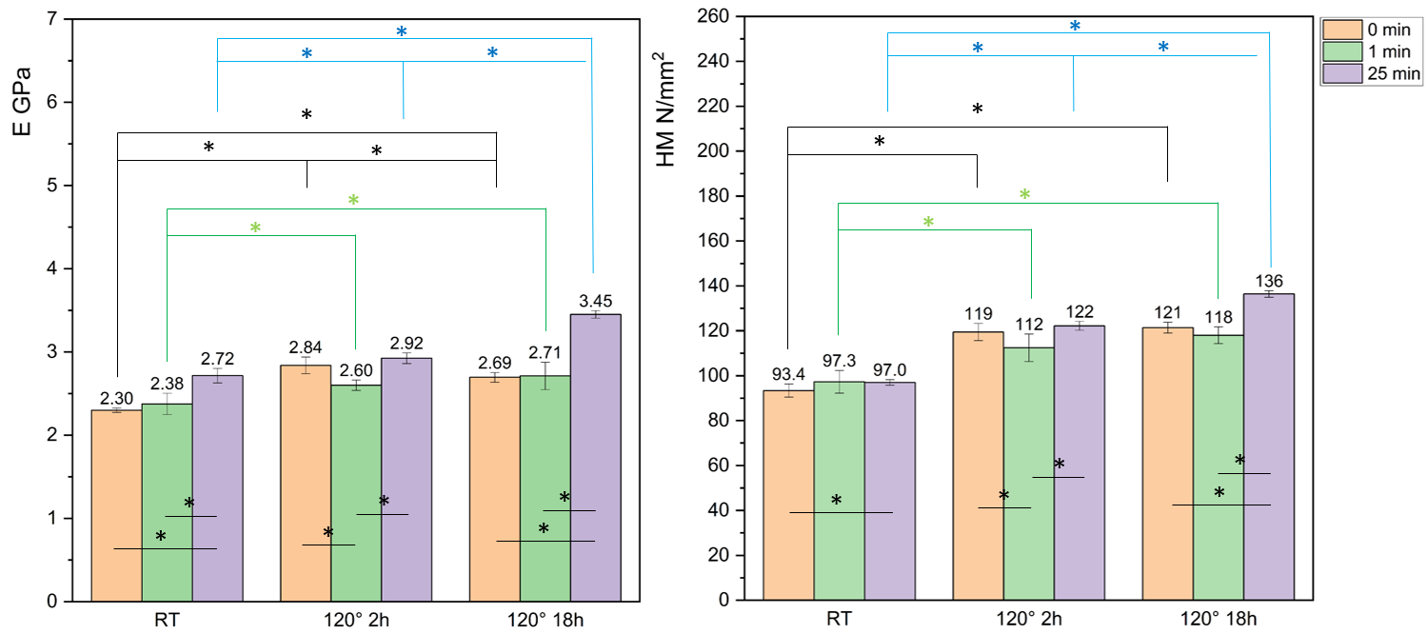

Figure 4.4.: Indentation modulus and Martens hardness of the batch 10.3 wt.%-aging-sTX mycelium samples with different Turaxx treatment time (0 min, 1 min, 25 min) after heat treatment for different time (0 h, 2 h, 18 h at 120℃). * = significant difference to the two group of samples.

The Turaxx used in the batch 10.3 wt.%-aging-bTX has a larger cutter head, in order to compare the effect of the size of the Turaxx cutter head on the experimental results. The indentation modulus of the samples without Turaxx treatment is significantly increased after heat treatment and increases also with the increase of heat treatment time. That means after 2h heat treatment, the elastic module increases from 2.26 ± 0.11 GPa at room temperature to 2.70 ± 0.16 GPa, and then to 3.50 ± 0.08 GPa with 18 h-heat treatment. And the Martens hardness also increases from 94.4 ± 3.4 N/mm2 to 146 ± 4.6 N/mm2 with the increase of heat treatment time. The indentation modulus of the two groups of samples with Turaxx treatment was also significantly improved by increasing the heat treatment time. For the sample with 1 min-Turaxx treatment, its indentation modulus increases from 2.59 ± 0.19 GPa at room temperature to 2.9 ± 0.15 GPa after 2 h-heat treatment and then continues to increases to 3.22 ± 0.03 GPa after 18 h-heat treatment. Its Martens hardness increases from 99.8 ± 6.2 N/mm2 at room temperature to 124 ± 4.45 N/mm2 after 2h-heat treatment and remains at the same performance with 127 ± 2.58 N/mm2 after 18 h-heat treatment. The mechanical properties of the samples with 25 min-Turaxx increased from 2.59 ± 0.16 GPa for indentation modulus and 97.8 ± 2.54 N/mm2 for Martens hardness at room temperature to 3.58 ± 0.06 GPa and 138 ± 3.3 N/mm2 at maximum with increasing heat treatment time to 18 h.

Turaxx treatment significantly increased the indentation modulus of the sample at room temperature but had no effect on the Martens hardness. In the samples with 2 h-heat treatment, Turaxx treatment kept the indentation modulus of the sample unchanged but long-term treatment reduced the hardness. Among the samples with 18 h-heat treatment, the sample treated with Turaxx for a short time has the lowest mechanical properties. There is no difference in the indentation modulus of the remaining two groups, but the hardness of the sample without Turaxx treatment is higher than that of the sample with Turaxx treatment.

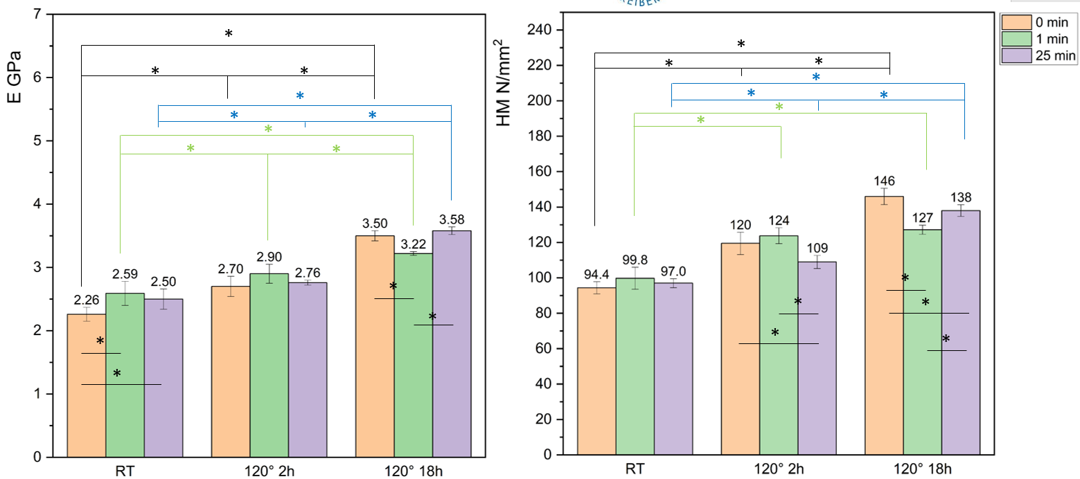

Figure 4.5.: Indentation modulus and Martens hardness of the batch 10.3 %-aging-bTX mycelium samples with different Turaxx treatment time (0 min, 1 min, 25 min) after heat treatment for different time (0 h, 2 h, 18 h at 120℃). * = significant difference to the two group of samples..

In order to see the effects of different mycelium contents in suspension and Turaxx sizes on the mechanical properties, all the data of mechanical properties for pure *A. niger* mycelium samples obtained were grouped according to the heat treatment time and plotted into figure 4.6. For samples with 1 min-Turaxx treatment at room temperature, the indentation modulus of samples with high mycelium weight percent through aging treatment is higher than that of samples with low weight percent. This indicates that the 1 min-Turaxx treatment can moderately destroy the pellet-structure, and many mycelium fragments of moderate size appear to fill the gaps among the pellet-structure. At the same time, as the concentration of mycelium in the suspension increases, more mycelium can be tightly packed. These two reasons promote the reduction of porosity and improve mechanical properties. It can also be seen that the indentation modulus can be more effectively improved when using large-caliber Turaxx, but there is no obvious effect on hardness. When the Turaxx treatment time was increased to 25 min, the particle structure was further broken down into smaller structures or even hyphae. From Batch 7.4 wt%-sTX to 10.3 wt.%-aging-bTX, the increase in the density of small-structured mycelium or hyphae in the suspension made the connection between the mycelium tighter, which increased the indentation modulus. However, because the effect of large Turaxx was more intense, a lot of air was brought into the mycelium suspension, making the structure of the material loose or unevenly distributed, the porosity increased, and the mechanical properties decreased slightly. There is a significant difference in the shear force exerted on the sample by large and small Turaxx when they are processing the samples, which results in different indentation modulus of samples processed for the same time. Large Turaxx caused a greater degree of damage to the pellet-structure when processing times are shorter and produces more small structures. Both types of Turaxx can destroy the particle structure to the greatest extent when the treatment time is long, but the greater shear force generated by the large Turaxx brought in more air and creates more loose structures. Furthermore the porosity was then increased. This could explain the different effects of the indentation modulus in the samples with high mycelium weight percent in the suspension. In the samples with low weight percent, the indentation modulus and hardness of the samples mainly depend on the properties of the material and the changes in the structure during the treatment process. As the treatment time increases, the structure of the mycelium is gradually destroyed, and the uniformity and deformation resistance of the material are slightly improved.

After 2 hours of heat treatment, the indentation modulus of the sample without Turaxx treatment decreased as the concentration of mycelium in the suspension increased. This is because some water evaporated from the sample after heat treatment, and the greater the concentration of mycelium in the suspension, the more internal pores or voids were formed, which reduced the indentation modulus. Hardness is sensitive to the surface properties of the material, but not to the internal structure. Therefore, the hardness did not change. The indentation modulus and hardness of the samples with 1min-Turaxx treatment increased with the increase of mycelium concentration in the suspension. This is because through the Turaxx treatment the gaps between the pellet-structures could be filled, making the overall structure of the sample denser, thereby improving the mechanical properties. And large-diameter Turaxx will enhance this effect. The same reason can also explain the phenomenon that the mechanical properties of the samples treated with 25 min-Turaxx in small-diameter increased with the increase of mycelium concentration in suspension. As described above, the treatment of large Turaxx brings a lot of air into the mycelium suspension, generating a lot of bubbles in the suspension. These bubbles can easily overflow in a low mycelium content e.g.Batch 7.4 wt. %-sTX, but it is more difficult for them to overflow when the mycelium content is high. On the one hand, part of the water is evaporated by the heat treatment, and the cavities and pored caused by these bubbles are enlarged. On the other hand, the water remaining in the structure can support the plastic deformation of the structure, resulting in the shrinkage of the structure and pores. The results caused by these two aspects are opposite, and their antagonistic results will determine the changes in the mechanical properties of the mycelium material.

After the samples were heat treated for 18 hours, the mechanical properties of the samples without Turaxx treatment and the samples with 1-minute Turaxx treatment showed a trend of decreasing first and then increasing with the increase of the concentration of mycelium in the suspension. Because in the sample with low mycelium concentration, long-term heat treatment causes more water to evaporate, which continuously expands the pores. The water is getting less and less, which is not enough to support the hyphae or mycelium to continue to undergo plastic deformation to shrink and reduce the pores. Finally, the pores are enlarged. When the mycelium concentration increases, the pellet-structure in the material is more tightly arranged and the pores and voids caused by the evaporation of water are filled with small-structure mycelium, which leads to an improvement in mechanical properties. The mechanical properties of the samples with 25 min-Turaxx treatment increased with the increase in the concentration of mycelium in the suspension. Because in the samples after heat treatment for 18 hours, the degree to which the pores become larger due to water evaporation is smaller than which the pores become smaller due to the shrinkage of the mycelium structure. There are more such small-structured mycelium or hyphae in the samples with 25min-Turaxx treatment than in other samples, and the number increases with the increase of mycelium concentration. They allow defects like micropores in the sample to be repaired, and the mechanical properties are therefore improved.

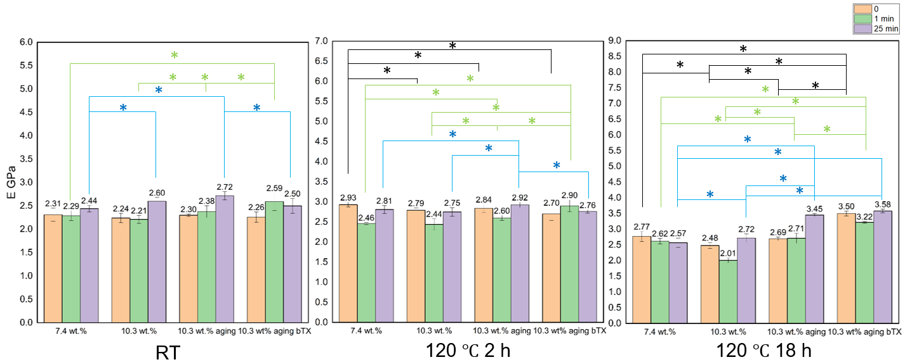

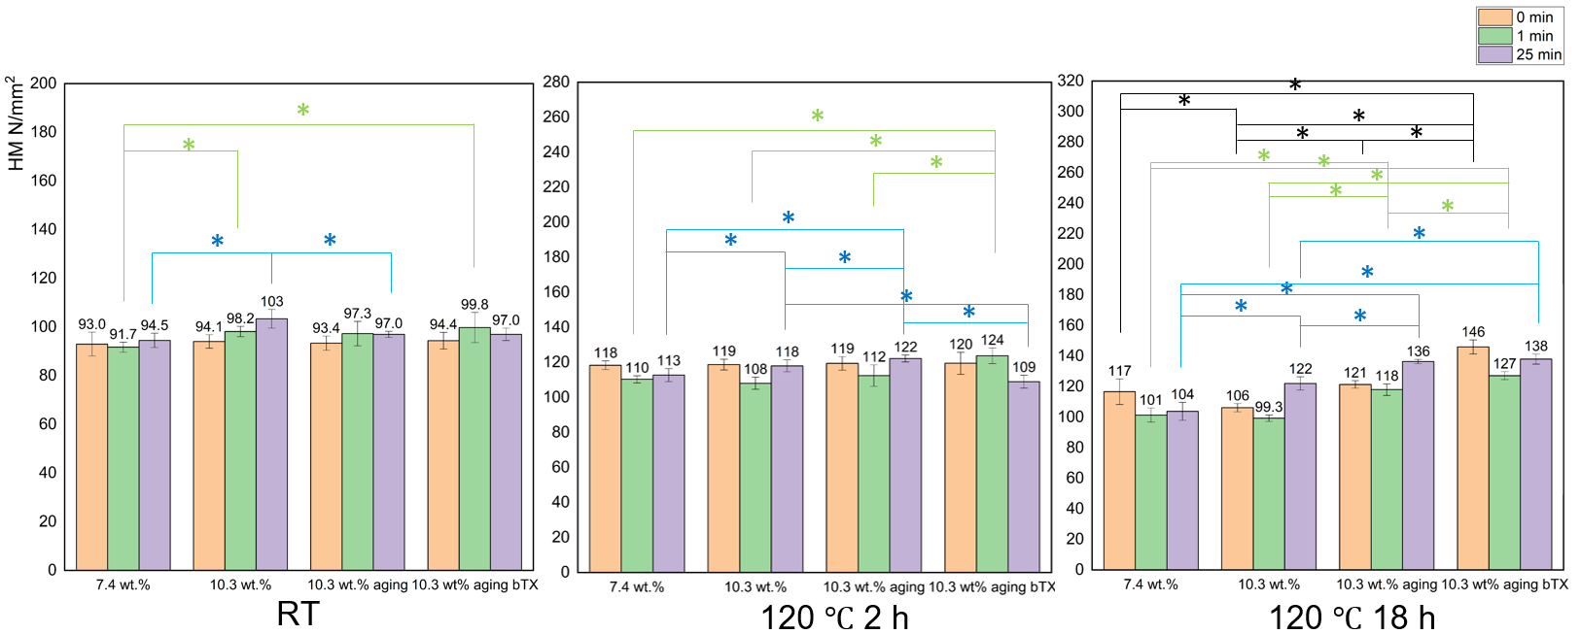

Figure 4.6.: Indentation modulus and Martens hardness of all the pure mycelium samples mycelium with different Turaxx treatment time (0 min, 1 min, 25 min) and different aging treatment after heat treatment for different time (0 h, 2 h, 18 h). All the date are grouped according to the mycelium weight precent in initial suspension. *= significant difference to the two group of samples. Yellow Column= no Turaxx treatment. Green Column= 1 min-Turaxx treatment. Purple Column= 25 min-Turaxx treatment.

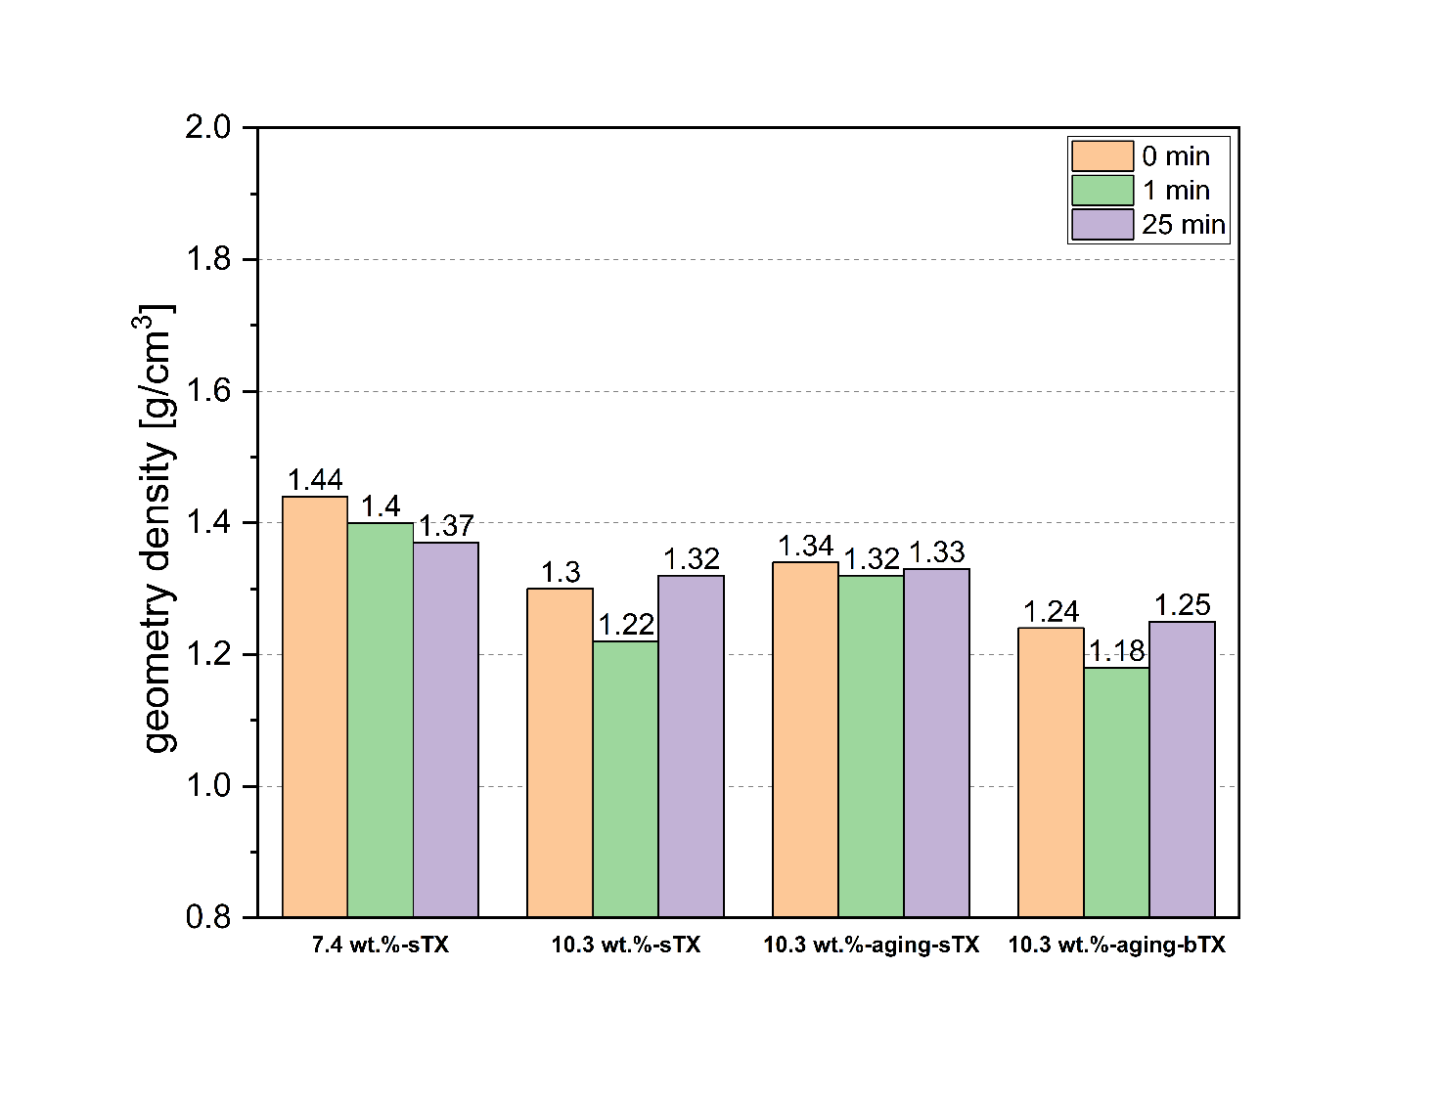

Figure 4.7 shows the geometric density of all samples after 18h heat treatment. The samples used for geometric density measurements were the same as those subjected to nanoindentation.

Figure 4.7 shows the geometric density of all samples after 18h heat treatment. The sample with Batch 7.4 wt.%-sTX has the highest geometry density. This proves the viewpoint described above that the lower the density of mycelium in the suspension, the easier it is for bubbles to overflow. The geometric density of Batch 10.3 wt.% with the same density and volume treated with small Turaxx was increased after aging treatment. The geometric density of the sample without Turaxx treatment and with 1 min- and 25 min-Turaxx treatment increased from 1.30 to 1.32, 1.20 to 1.32 and 1.32 to 1.33 g/cm3, respectively. It was confirmed that under the treatment of small Turaxx, when the mycelium concentration was increased by aging treatment, the density of the sample also increased. The geometric density of the Batch 10.3 wt. %-aging-bTX sample decreased compared to the 10.3 wt. % samples. This indicates that the heat treatment caused the mycelium structure to shrink and fill the micropores and other defects. However, the bubbles introduced into the sample due to the vigorous stirring of the large Turaxx caused more macropores. As described above, these pores became larger due to the heat treatment.

#### 4.1.2.2 Mechanical characterization using compression test.

The compressive stress-strain curve of the batch 10.3 wt.%-aging-sTX samples with different heat treatment (0 h, 2 h, 18 h at 120 ℃) is shown in Figure 4.8. A total of 5 cylindrical specimens were tested in each set of compression tests, and their production process was described in section 3.2.5. The compression modulus was calculated by curve fitting, and the fitting interval was 16 %-20 % compressive strain in all samples. The calculated results do not include data from samples that failed prematurely.

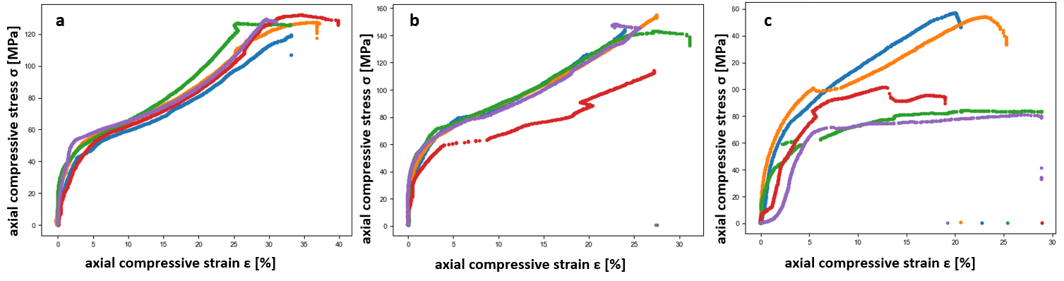

Figure 4.8.: compressive stress-strain curve of the batch 10.3 wt.%-aging-sTX samples with different heat treatment (0 h, 2 h, 18 h at 120 ℃). a. RT. b. 120 ℃ 2 h. c. 120 ℃ 18h.

Table 4.1 lists the properties of batch 10.3 wt.%-aging-sTX samples obtained through compression experiments.

Table 4.1: Mechanical properties of batch 10.3 wt.%-aging-sTX samples with different heat treatment measured by compression test.

|  |  |  |  |  |
| --- | --- | --- | --- | --- |
| ***Sample*** | ***Compression at break [%]*** | ***Compressive strength [MPa]*** | ***Compressive modulus [GPa]*** | ***Toughness [kj/m2]*** |
| ***RT*** | 31.8 ± 3.9 | 127.0 ± 4.18 | 2.9 ± 0.34 | 76.1 ± 12.1 |
| ***120°C_2h*** | 29.8 ± 2.0 | 147.7 ± 4.71 | 3.93 ± 0.24 | 71.9 ± 8.6 |
| ***120°C_18h*** | 20.6 ± 4.6 | 124.3 ± 31.91 | 4.2 ± 0.31 | 63.3 ± 13.4 |

As the heat treatment time increases, the compression modulus of the sample also increases significantly. This trend is consistent with the results of the indentation test of the same sample. The indentation modulus of the RT samples is consistent with the compression modulus. However, the indentation modulus is significantly smaller than the compression modulus in samples with heat treatment. The nanoindentation mainly measures local mechanical properties, and the test results reflect more the properties near the sample surface. The compression test reflects more the overall mechanical properties of the sample. This shows that the structure of the mycelium sample is complex and unique. When a large amount of mycelium in the sample is subjected to force, the structure of the sample changes so that it can withstand more pressure.

### **4.1.3 FTIR Spectroscopy of pure A. niger mycelium samples**

ATR-FTIR spectra of 7.4 wt.%-sTX samples without Turaxx treatment and heat treatment are shown in Fig. 4.9. The spectra were normalized against the band at around 1027 cm−1 assigned as a polysaccharide representative signal for standardized comparison. The bands in the zone of 3700–3000 cm−1 are attributed to the O–H stretching vibration caused by water, polysaccharides, glycerol molecules and the N–H stretching vibration of secondary amines [101,102]. The infrared absorption around 3263 cm–1 is due to the N–H stretching vibration of secondary amines or amides bound to proteins and chitin [103,104]. Because the cell wall of *A. niger* contains approximately 9-13% hexosamine [105]. Amine and carboxylate groups were identified as the main functional groups for metal biosorption in *A. niger* biomass [105]. The absorption band in the region around 3000–2800 cm−1 corresponded to different stretching modes of CH2 (2922 cm−1) and CH3 (2855 cm−1) associated with lipids [101,106]. The small peak around 1741 cm−1 is attributed to the C = O stretching vibration caused by the presence of lipids [101,106]. Two distinct peaks at approximately 1650 and 1555 cm−1 show amide vibrations associated with proteins and chitin, corresponding to amide I and amide II, respectively [101,107]. The amide I peaks are from the stretching of the C=O and C–N groups and N–H bending, respectively. The absorption of amide I is mainly caused by the C=O stretching vibration of the amide group, and the contributions of amide C–N stretching and N–H bending are weaker [101]. For the amide II band, the absorption is mainly caused by N–H bending and C–N stretching [101]. Absorption at band around 1627 cm–1 is associated with vibrations of aromatic rings and the presence of melanin pigments in fungal biomass [108]. Kalra *et al.* reviewed information on the synthesis of various pigments by filamentous fungi, including *A. niger* [109]. The interval between 1500 and 1300 cm−1 is often considered as a “mixed” region that includes vibration associated with lipids, proteins (amide III), functional groups bound in polysaccharides, chitin, nucleic acids, and phospholipids [110]. The peak between 1453 and 1423 cm-1 is associated with the vibration of CH groups in lipids [111]. A distinct peak at 1372 cm–1 can be attributed to the symmetric bending of aliphatic CH3. Another sharp peak next to it is at 1311 cm –1, which may be caused by the C–O stretching of carboxylic acids and/or the asymmetric C–N–C stretching of aromatic amines [108]. The peak at 1251 cm-1 can be associated with the amide III band in both cases, where the absorption is related to CN stretching, NH bending and CO in-plane bending. The absorption in this region may be also partially caused by asymmetric P=O stretching in nucleic acids and phospholipid substances [112,113]. The absorption in *A. niger* is mainly caused by proteins and partly by phospholipids substances, because the proportion of proteins in its biomass is higher. The sharpest infrared absorption occurs between 1200 and 800 cm–1, with most of the absorption detected arising from vibrations of carbohydrates. Specific functional groups and associated frequencies include stretching vibrations of COC (1153 cm–1), CO (1105 cm–1), and CC (1068 or 1027 cm–1) groups [111,114]. The frequencies of all the above peaks and their corresponding functional groups are listed in Table 4.1.

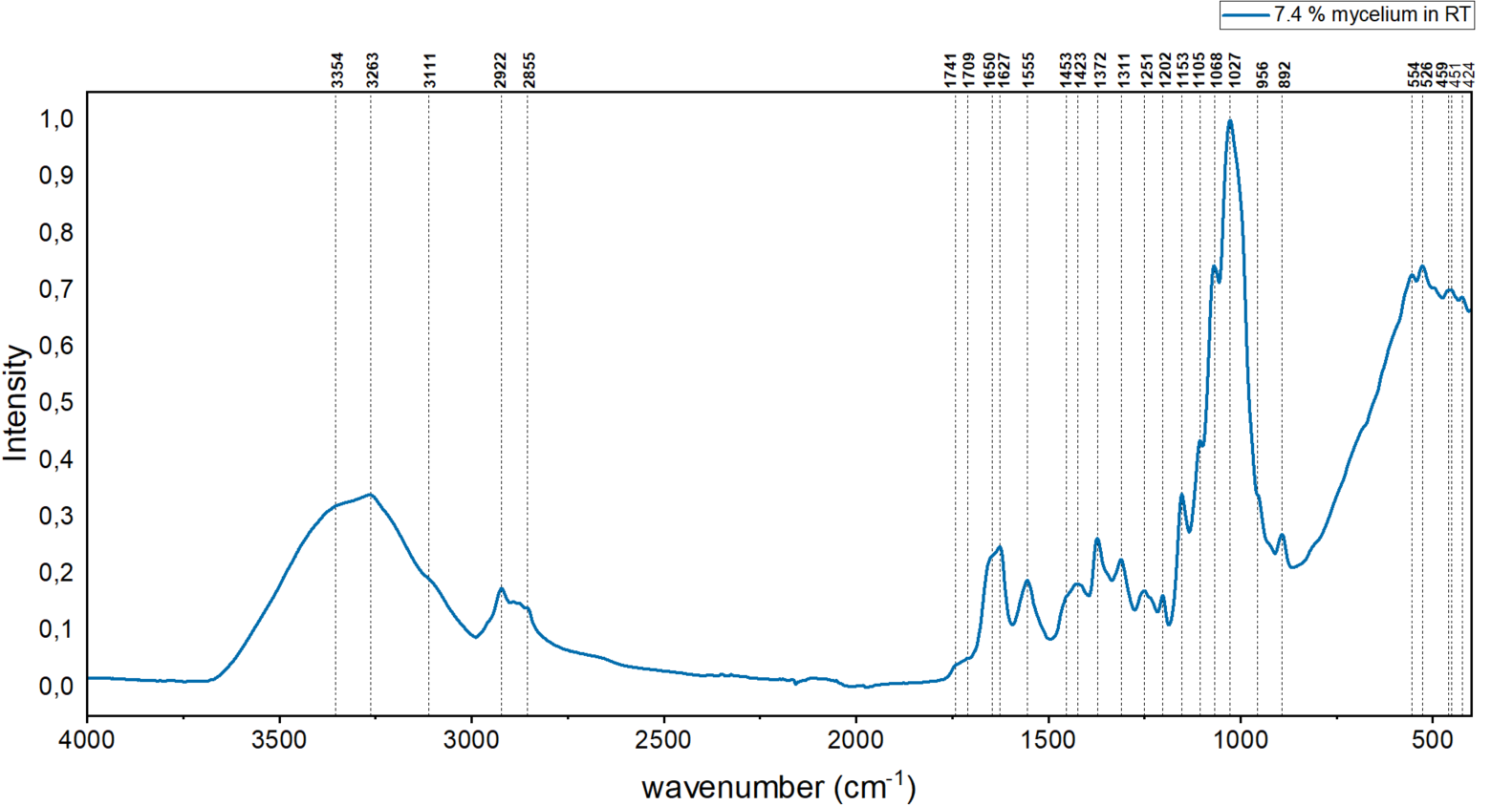

Figure 4.9.: FTIR spectrum of A. niger mycelium, 7.4 wt.%-sTX samples without Turaxx treatment and heat treatment.

Table 4.1.: FTIR spectra and peaks of *A. niger* mycelium, 7.4 wt.%-sTX samples without Turaxx treatment and heat treatment.

|  |  |  |  |  |  |  |  |  |  |  |  |
| --- | --- | --- | --- | --- | --- | --- | --- | --- | --- | --- | --- |
| 0  RT | 1minRT | 25min  RT | 0min 2h | 1min  2h | 25min  2h | 0min  18h | 1min  18h | 25min  18h | Assigned | Mycelium comp. | Ref. |
| 3354 |  |  |  |  |  |  |  |  | $$ν_{OH}^{}$$ | polysaccharides, water, protein, lipid | [103][104] |
| 3265 | 3264 | 3264 | 3265 | 3263 | 3265 | 3264 | 3263 | 3264 |  | 2o amine | [103][104] |
| 3111 |  |  |  |  |  |  |  |  | $$ν_{NH}^{s}$$ |  |  |
| 2922 | 2922 | 2922 | 2923 | 2922 | 2923 | 2923 | 2923 | 2922 | $$ν_{CH}^{2}$$ | lipid | [101][106] |
| 2855 |  |  |  |  |  |  |  |  | $$ν_{CH}^{3}$$ | lipid | [101][106] |
| 1741 |  |  |  |  |  |  |  |  | $$ν_{C=O}$$ | lipid | [101][106] |
| 1709 |  |  |  |  |  |  |  |  | $$ν_{C=O}$$ | citric acid |  |
| 1650 |  |  |  |  |  |  |  |  | $$ν_{C=O}+ν_{CN}+ν_{NH}\left(Amide I\right)$$ | Protein, chitin | [101][107] |
| 1626 | 1625 | 1626 | 1626 | 1625 | 1626 | 1626 | 1625 | 1625 | $$ν_{C-C}$$ $$\left(aromatic ring\right)$$ | pigments | [108] |
| 1555 | 1555 | 1555 | 1555 | 1555 | 1555 | 1555 | 1555 | 1555 | $$ν_{CN}+ν_{NH}$$ $$\left(Amide II\right)$$ | Protein, chitin | [101][107] |
| 1453 |  |  |  |  |  |  |  |  | $$δ_{CH}$$ | lipid | [111] |
| 1425 | 1425 | 1426 | 1428 | 1426 | 1428 | 1426 | 1426 | 1426 | $$δ_{CH}$$ | lipid | [111] |
| 1372 | 1372 | 1372 | 1372 | 1372 | 1372 | 1372 | 1372 | 1372 | $$δ_{C-CH3}$$ | chiitn | [108] |
| 1311 | 1311 | 1311 | 1311 | 1311 | 1311 | 1311 | 1311 | 1309 | $$ν_{C-O}$$ | carbohydrate |  |
| 1251 | 1251 | 1251 | 1251 | 1251 | 1249 | 1252 | 1251 | 1251 | $$ν_{CN}+δ_{NH}+δ_{CO in-plane}$$ $$\left(Amide III\right)$$ | chitin | [101] |
| 1202 | 1202 | 1202 | 1202 | 1202 | 1202 | 1202 | 1202 | 1202 | $$δ_{CH}+δ_{OH in-plane}$$ | α-glucan | [101] |
| 1153 | 1152 | 1152 | 1152 | 1152 | 1152 | 1152 | 1152 | 1152 | $$ν_{C-O-C}^{as}(ring)$$ | carbohydrate | [111][114] |
| 1105 | 1105 | 1105 |  | 1105 |  |  | 1105 |  | $$ν_{C-O}$$ | carbohydrate | [111][114] |
| 1068 |  |  | 1070 | 1068 | 1070 | 1068 | 1070 |  | $$ν_{C=C}$$ | carbohydrate | [111][114] |
| 1027 | 1025 | 1027 | 1025 | 1025 | 1027 | 1024 | 1025 | 1024 | $$ν_{C=C}$$ | carbohydrate | [111][114] |
| 956 |  |  |  |  |  |  |  |  | $$γ_{CH3}$$ | - | [101] |
| 891 | 891 | 891 | 891 | 891 | 891 | 891 | 891 | 891 | $$γ_{CH3}$$ $$(C1 axial)$$ | - | [101] |
| 554 |  |  |  |  |  |  |  |  | $$γ_{C-C}$$ | - | [101] |
| 526 |  |  |  |  |  |  |  |  | - |  | - |

In order to compare the changes in the chemical composition of the samples after heat treatment or Turaxx treatment, the FTIR spectra of samples obtained from batch 7.4 wt.%-sTX samples with different Turaxx treatment (0 min, 1 min, 25 min) and heat treatment (0 h, 2 h, 18 h at 120℃) in suspension are plotted in Figure 4.10. All data were normalized according to the peak 1027 cm-1. All peaks involved in the intensity change analysis are listed in Table 4.1. Based on the comparison of the intensity changes of the peaks at the same position of each group of samples, it was found that there was no difference between the mycelium samples without Turaxx treatment and the samples with Turaxx treatment of samples dried at room temperature. The intensity changes of all peaks at the same position of the three groups were negligible. After heat treatment and Turaxx treatment, the peak positions of all mycelium samples shifted slightly. Compared with the standard sample (0min, 0h), the absorption peaks at 2922, 1426 cm-1 of the 0min-2h and 25min-2h samples shifted to the left by 1 cm-1, and the absorption peak at 1425 cm-1 shifted to the left by 3 cm-1. Their absorption peak at 1068 cm-1 shifted to the right by 2 cm-1. The absorption peaks of 1min-RT, 25min-RT and 0min-18h samples at 3265 cm-1 shifted to the right by 1 cm-1 relative to the standard sample. The absorption peaks of 1min-2h and 1min-18h samples shifted by 3 cm-1 here. The absorption peaks of 0min-18h and 1min-18h at 2923 cm-1 shifted to the left by 1 cm-1 compared with the standard sample. The peaks of 25min-RT, 1min-2h, 0min18h and 1min-18h samples at 1425 cm-1 shifted to the left by 1 cm-1. The absorption peaks of the other samples shifted to the right here. At 1311 cm-1, only the absorption peak of the 25min-18h sample shifted to the right by 2 cm-1. The absorption peaks of the 25min-2h sample and the 0min-18h sample at 1249 and 1252 cm-1 shifted to the left and right by 2 cm-1 respectively. The absorption peaks of all samples at 1152 cm-1 shifted to the left by 1 cm-1. For the 25min-RT, the absorption peaks of the 25min-2h and 1min-18h samples at 1027 cm-1 shifted to the left by 2 cm-1. The absorption peaks of the 0min-18h and 25min-18h samples here shifted to the left by 3m-1. The absorption peaks of all samples at 1555, 1202, 1105 and 891 cm-1 did not shift. No peak signal was disappeared or weakened. The peak intensity increased with the increase of heat treatment time. It can be inferred that the sample has no composition change after Turaxx treatment and heat treatment. However, due to the accelerated evaporation of water during heat treatment, the mass proportion of other components increased and their signals were therefore enhanced.

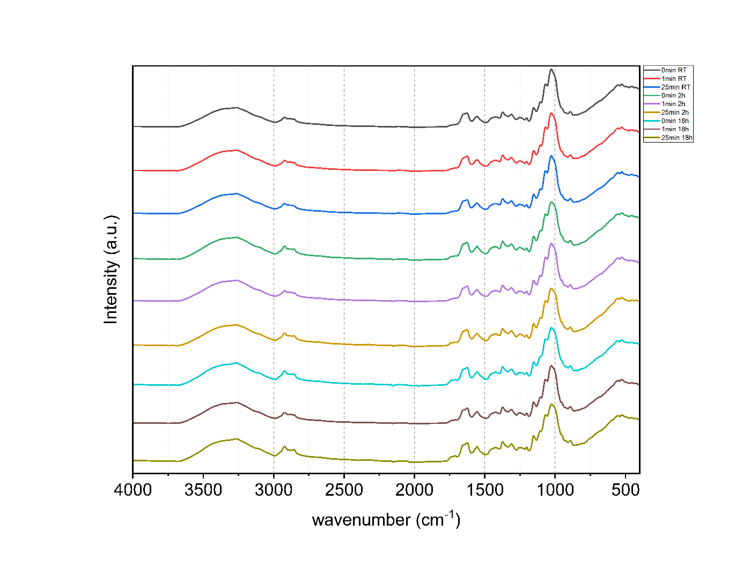

Figure 4.10.: FTIR spectra of samples with 7,4 % A. niger mycelium in suspension after different heat treatment and Turaxx treatment (2h, 18h).

## **4.2 Characterization of composite materials based on *A. niger* mycelium with mineralization**

### **4.2.1 Characterization of morphology and surface of *A. niger* mycelium composite materials**

The macroscopic appearance photos of all samples were taken by mobile phone. In Figure 4.10, mycelium composites mineralized by insitu synthesis and precursor synthesis methods are shown. The silicone mold is a 1×1×1 cm cube. Batch M-ADB/BDA composites mineralized by insitu synthesis are shown in figure 4.11. Similar to the mycelium composite samples produced by insitu synthesis and precursor synthesis, phase separation also occurred. The color of the pure *A. niger* sample is dark yellow. All the sample integrated with CaP begins to turn white. It is obvious that there is a white CaP layer on the surface of the sample. There is a clear phase separation between the white CaP layer and the A. niger mycelium matrix and it is observed in all samples integrated with CaP. These phase separations occur because the water in the samples evaporates from the bottom to the top during drying, transporting CaP to the sample surface. There is also a small amount of white CaP on the side walls of these samples. This appearance may be due to the fact that CaP can easily heterogeneously nucleate on the side walls of silica gel and remain on the side of the sample after drying.

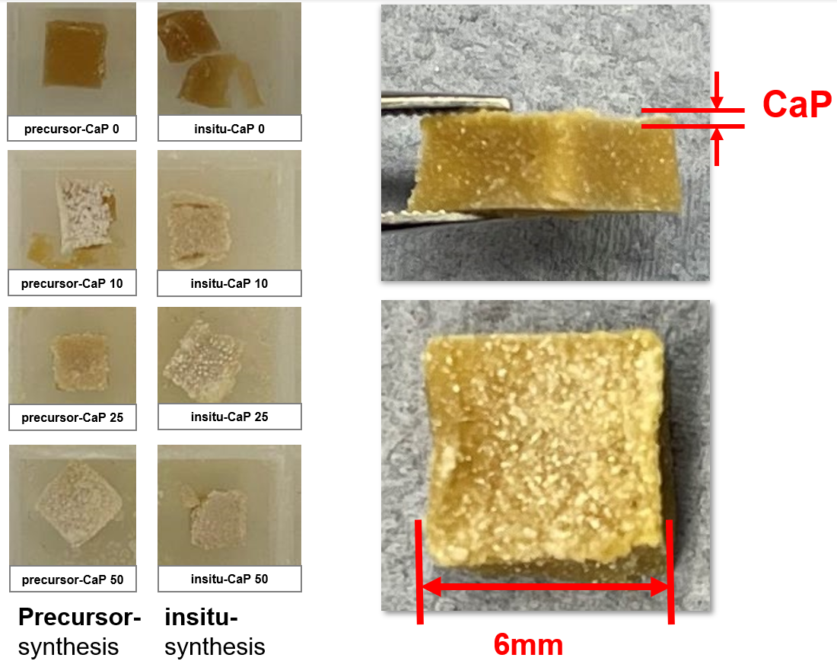

b.

a.

Figure 4.10.: a.Macroscopic appearance of mycelium-CaP composites integrated with different weight percent of CaP. b. Phase separation of the samples.

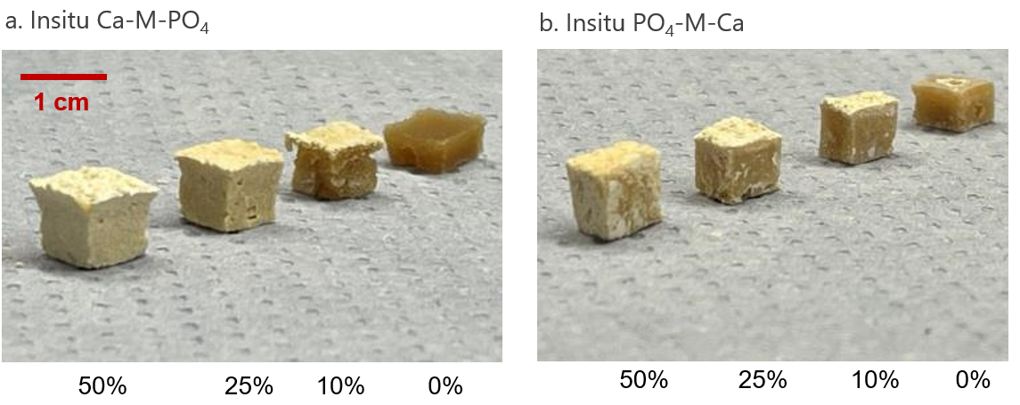

Figure 4.11.: Macroscopic appearance of mycelium-CaP composites with extra drying process. a. ADB. B. BDA. The samples from left to right are 50%, 25%, 10%, and 0% CaP-Mycelium composite.

Figure 4.12 shows the SEM micrograph of the sample, which was gold-coated prior to imaging. The captured area corresponds to the cross-section of the sample.

The pellet-structure of mycelium can be clearly recognized in the cross section of the samples without CaP. The morphology of the pellet-structure is circular or elliptical spherical. The presence of was also observed in the pictures. This is due to the contraction of the mycelium when the sample is dried. In the pictures of the samples with insitu-synthesis method, no visible CaP was observed from the samples incorporating 10% CaP. It may be that most of the CaP is present on the surface of the sample due to phase separation and there is almost no distribution inside the sample. The samples incorporating 25% and 50% CaP showed progressively more mineralization and higher particle deposition density. These CaP show more distinct crystalline features, i.e., a more angular needle-shaped. Their size was statistically determined to be approximately 42 ± 15 µm and not in the nanometer range. The morphology also does not correspond to the spherical shape of ACP. Combined with the PXRD results in figure 4.13, it can be concluded that these calcium phosphates are DCPDs. in the samples with 10% CaP using precursor-synthesis method, some large pieces of CaP were observed that were not stirred well and remained aggregated. In the samples with 25% and 50% CaP, a large amount of spherical CaP was observed to accumulate on the surface of the mycelium. the deposition of CaP on the surface resulted in a large gap between the pellet-structure of mycelium. This morphology suggested that the deposition process had resulted in a large gap between the pellets and the deposition process is looser and inhomogeneous.

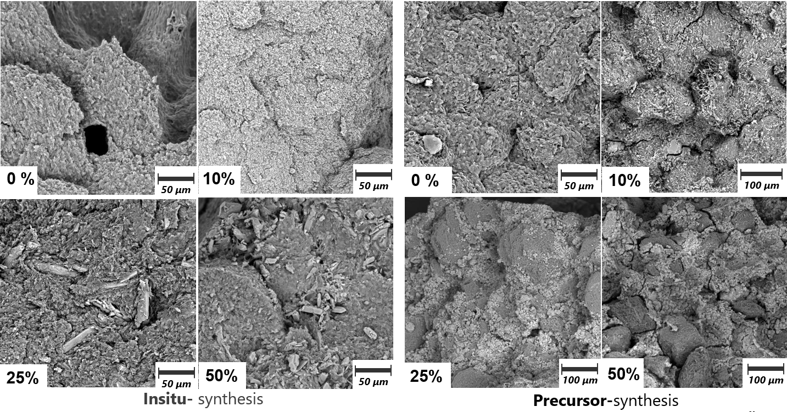

Figure 4.12.: SEM micrographs of cross sections of CaP-mycelium composite samples.

### **4.2.2** **Characterization of calcium phosphate phase in *A. niger* mycelium composite materials**

Figure 4.13 presents the X-ray powder diffractometry patterns of the pure A. niger mycelium, mineralized *A. niger* mycelium composites using insitu-synthesis and precursor-synthesis.

The reflection peaks at 9.4°, 12.8°, 19.3° and 26.3° are assigned to α-chitin contained in *A. niger*. Among them, 9.4° and 19.3° also are assigned to β-chitin. The other peaks assigned to β-chitin are not obvious, such as the peaks at 20.1°, 21.0°, and 23.6°. This shows that the main type of chitin in A. niger is α-chitin. The broad characteristic peak at 19°-20° corresponds to the secondary structure of the protein, α-helix.

Neither the pattern of *A. niger* mycelium nor the pattern of ACP showed obvious peaks, and the peaks in their patterns were generally small and broad. This indicates that no crystalline components appear in these two materials. The M-insitu-CaP 50% and Batch ADB composite showed a clearly different pattern. The comparison with literature data revealed the presence of DCPD in the M-insitu-CaP 50% samples [118,119]. Characteristic peaks appear at 11.6°, 20.9°, 29.2°, 30.4°, 34.1°, 41.5°, 42°, 48.4°, 48.9° and 50.2°. They were assigned to present DCPD. There major peaks at 11.8, 21.1 and 29.5 2θ° were identified as the crystallographic planes $\left(020\right),$ $(1\overline{2}1)$ and $(1\overline{1}2;14\overline{1})$ [120]. This indicates that the desired ACP cannot be synthesized by insitu-synthesis. The reason may be that ACP is very unstable in water, and calcium phosphate that exceeded solubility directly precipitates into a crystalline form. At the same time, the vigorous stirring brings a lot of heat, which further promotes the transformation of ACP into a crystalline form of calcium phosphate. The peak at 26°, 29.2° and 53.4° for Batch ADB-CaP50 were assigned to present OCP [121]. Peaks at 35.6° and 60.1° were also assigned to present OCP although OCP has medium signals here [121]. The peaks around 35.7° and 60° may assigned to calcium acetate crystals and ammoniumphosphat [127]. This indicates that in addition to OPC generated by the reaction of the mineralization solution, there are also undissolved solutes from solution calcium (A) and solution phosphate (B) in the sample. This shows that in the production of Batch ADB or BDA, too little water was added after the drying process. The solutes were not completely dissolved in the sample when the amount of water was too little and remained in the sample. The peaks at 26°, 31.5°, 32.3° and 53.4° for M-prec-CaP50 were assigned to the presence of a small amount of HAP [121]. The CaP phase synthesized by the precursor synthesis method is a mixed phase of amorphous and crystalline, which indicates that the precursor can achieve partial stabilization of ACP and the other part of ACP will be converted into a crystalline phase. This is consistent with the results shown in Figure 4.12 in Section 4.2.1. The morphology of these particles in micrometer scale is consistent with HAP in the literature [121].

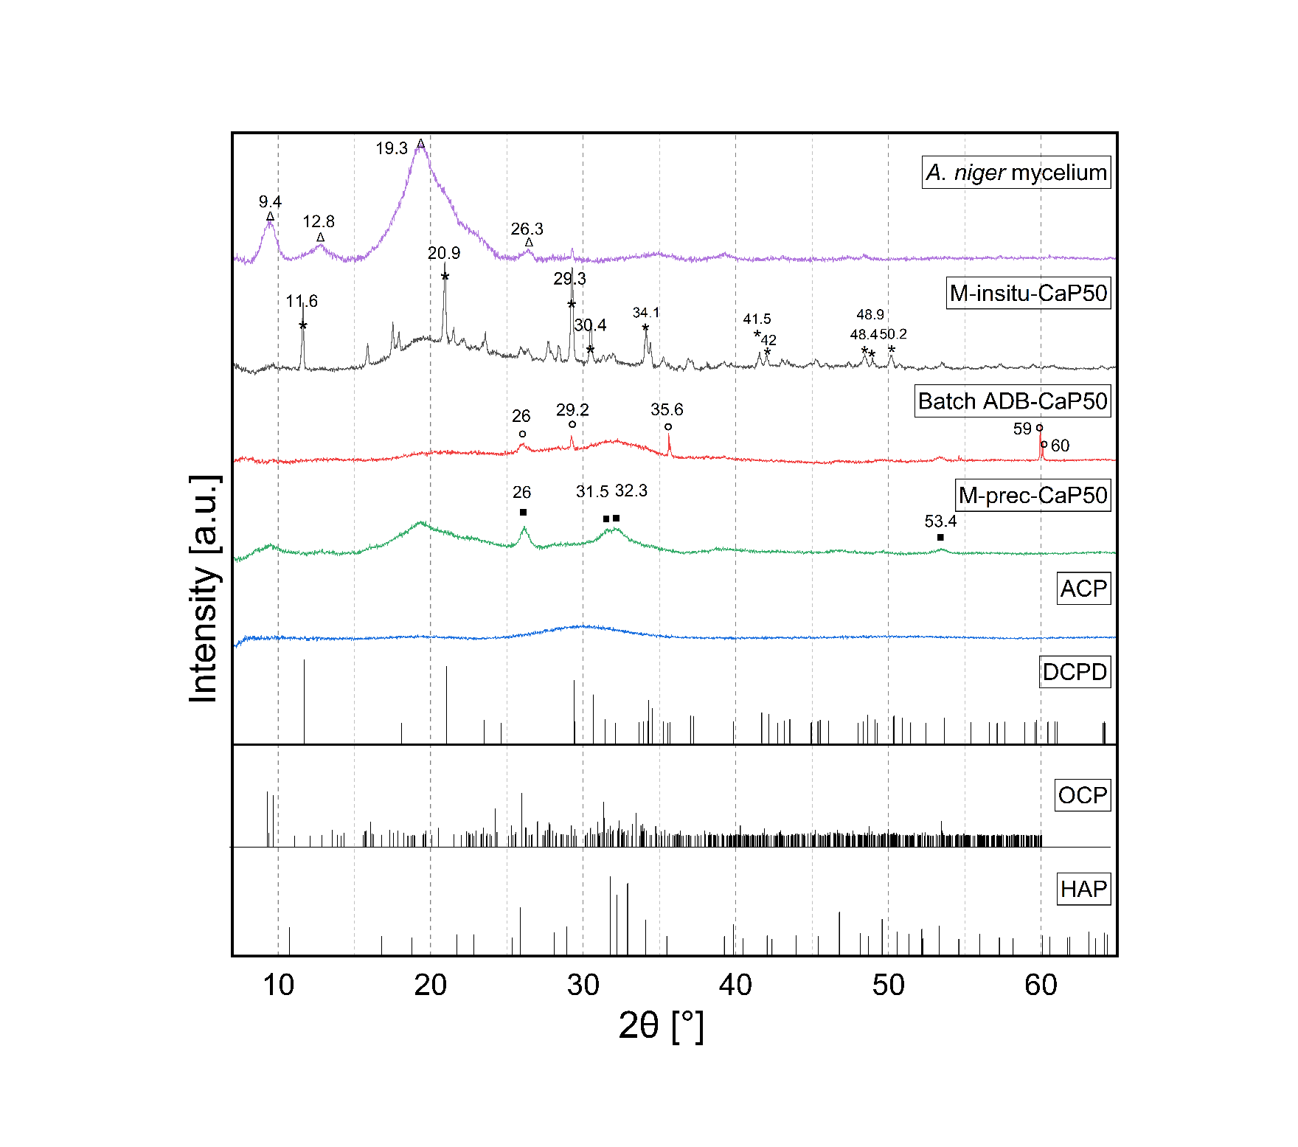

Figure 4.13.: X-ray powder diffractometry patterns of the pure A. niger mycelium, mineralized A. niger mycelium composites using insitu-synthesis and precursor-synthesis. ★ = DCPD. ○= OCP. ▪= HAP. Δ = characteristic peaks in mycelium.

### **4.2.3 Mechanical properties of *A. niger* mycelium composite materials**

Mechanical characterization was done by nanoindentation measurements. All samples were placed in a fume hood to dry for more than 5 days to ensure that the samples were dried to the greatest extent possible. Afterwards, the sample was ground and polished with 320P-4000P sandpaper without water to keep the surface of the sample horizontal. The Martens hardness (HM) and indentation modulus or indentation modulus (EIT), calculated from the Nano-indenter software, are plotted for each sample. Significant differences were tested using a single-factor ANOVA with Bonferroni (p < 0.05).

In the insitu-synthesis method, as Ca2+ source solution A and as PO4- source solution B were added to the mycelium matrix simultaneously in fixed amounts. When 10% weight percent of CaP was integrated to the mycelium matrix, the indentation modulus and Martens hardness of the sample were significantly improved to 3.51 ± 0.11 GPa and 132 ± 10.14 N/mm2. However, when the weight percent of CaP continued to increase to 25 % and 50%, the indentation modulus and Martens hardness of the sample decreased. The indentation modulus and Martens hardness of the samples with precursor synthesis were increased to 3.24 ± 0.43 GPa and 129 ± 11.6 N/mm2, respectively. Statistical analysis revealed a significant difference of the M-insitu-CaP 10 samples in the indentation modulus and Martens hardness to other samples. M-insitu-CaP 0, 25 and 50 samples are not significant different with each other. Combined with the SEM images in Section 4.2.1, it can be seen that the incorporation of a moderate amount of CaP was acting as reinforcing phase, which strengthens the structure of the sample. The presence of CaP allows for deformation in such a way that crack propagation is blocked and more energy is expended. This improves the mechanical properties of the material. However, excess integration of CaP does not diffuse into the pellet-structure of the mycelium and accumulates on the surface, which results in a weaker bonding of the pellet to each other. Then the energy required to be destroyed becomes smaller and the mechanical properties deteriorate.

For the *A. niger* mycelium sample mineralized by the precursor-synthesis method, its indentation modulus and Martens hardness also have the same changing trend. The mechanical properties increase first and then decrease with the increase of CaP amount. Statistical analysis showed that only M-precursor-CaP 10 to other samples had significant differences in indentation modulus and Martens hardness. There were no differences in the other three groups of samples. The reason for the deterioration of the sample performance can also be explained by the SEM photos figure 4.12 in section 4.2.1. the ACP particles did not diffuse well into the pellet-structure of the mycelium. They accumulated in large numbers on the surface of the mycelium pellets and largely prevent inter-pellet contact. At the same time, their bonding to the surface of the mycelium as well as their own bonding is weak, which leads to a weakening of the interfaces and a consequent weakening of the mechanical properties.

In general, increasing the CaP content by these two mineralization methods did not lead to an increase in mechanical properties, but rather a decrease.

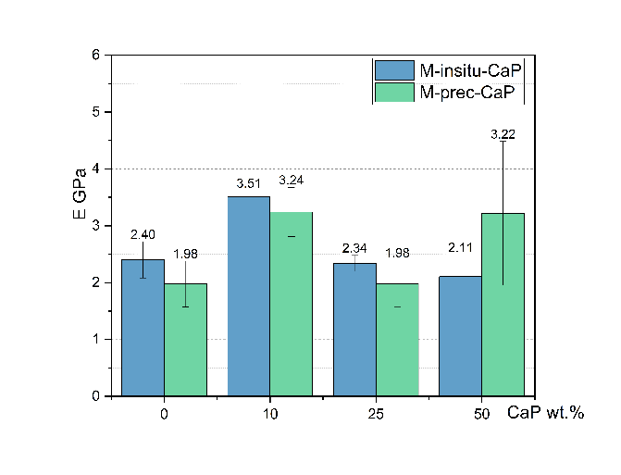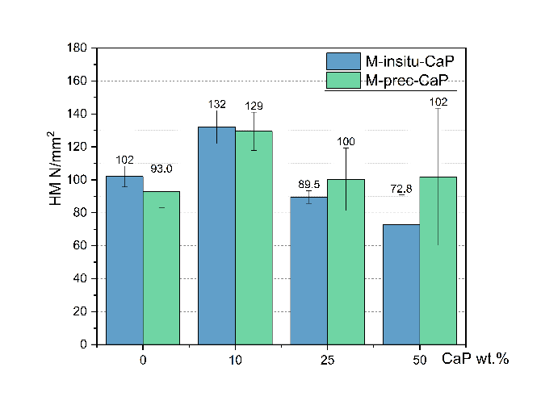Figure 4.14.: Indentation modulus and Martens hardness of A. niger mycelium composites mineralized using insitu synthesis and precursor synthesis methods.

The production process of the Batch ADB and BDA samples included an additional drying step after adding the first mineralizing solution and before adding the second mineralizing solution.

The purpose is to make the first mineralization solution evenly distributed in the mycelium matrix and evenly react with the second mineralization solution to mineralize the matrix and reduce phase separation. The measured indentation modulus and Martens hardness of the samples are presented in Figure 4.16. The results show that both the indentation modulus and the Martens hardness decrease with the increase of mineralization degree. The indentation modulus of Batch ADB samples decreases from 2.9 ± 1.27 GPa without mineralization to 0.65 ± 0.09 GPa incorporating 50 wt.% CaP. Martens hardness of this batch also decreases from the non-mineralized 137 ± 18.3 N/mm2 to the 25 ± 3.2 N/mm2 incorporating 50 wt.% CaP. For Batch BDA samples, their indentation modulus decreases from 3.16 ± 0.21 GPa without mineralization to 1.54 ± 0.22 GPa incorporating 50 wt.% CaP. Martens hardness of this batch also decreases from the non-mineralized 99.4 ± 10.7 N/mm2 to the 36.5 ± 8.3 N/mm2 incorporating 50 wt.% CaP. The experimental results showed that the additional drying step did not lead to a better diffusion of CaP into the mycelium and, as in the case of the samples using insitu-synthesis described above, the mechanical properties were considerably weakened.

 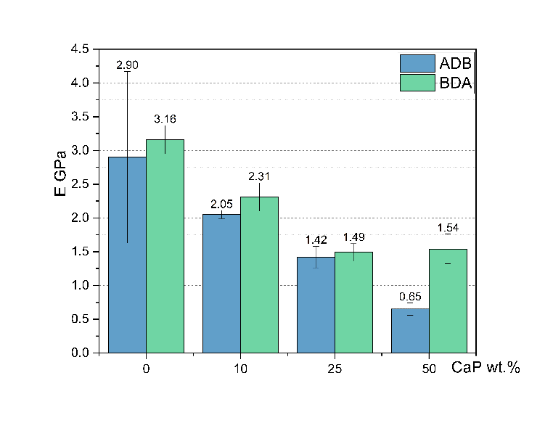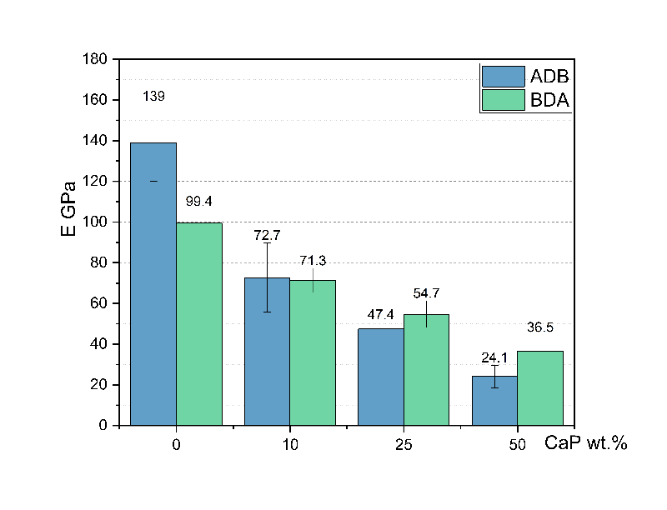

Figure 4.16.: Indentation modulus and Martens hardness of A. niger mycelium composites mineralized using ADB and BDA insitu synthesis methods.

## **4.3 Characterization of composite materials based on CNC with mineralization**

### **4.3.1 Characterization of morphology of the CNC composite material**

The CNC-CaP composite sample fabricated according to the description in Section 3.4.2 is shown in Figure 4.17. All samples were dried in an incubator with 70% RH at 24℃ for 3 days. After characteri-zation experiments were completed, they were stored in a refrigerator.

Due to the excellent film-forming properties of CNC, complete film can also be formed in the composite samples containing CaP after drying. The cracking of some samples can be attributed to the uncleanness of the glass slide. Among them, the composite material integrated with 75 wt.% CaP was block-like in shape after drying and fell off the glass slide. At the same time, it was observed that with the increase of CaP content, the thickness of the film sample increased from 52 ± 3 µm for CNC samples integrated with 20 wt.% CaP to 210 ± 30 µm for CNC samples with 75 wt.% CaP. The diameter of the film decreased from 32 ± 4 mm to 13 ± 4 mm for CNC samples integrated with 20 and 75 wt.% CaP respectively. This indicates that CaP leads to a different drying behavior of CNC.

The CNC-CaC composite sample fabricated according to the description in Section 3.4.3 is shown in Figure 4.18. Composite films can be formed but detach easily from the glass slide. A large number of sample preparation repeat experiments were performed for this purpose. Unlike CNC composite films integrated with CaP, the thickness of CNC composite films integrated with CaC did not vary significantly. It increased form 32 ± 7 µm to 63 ± 11 µm with the increase of CaC content. The composite film could fill the entire silicone mold after formation and did not shrink with increasing CaC content.

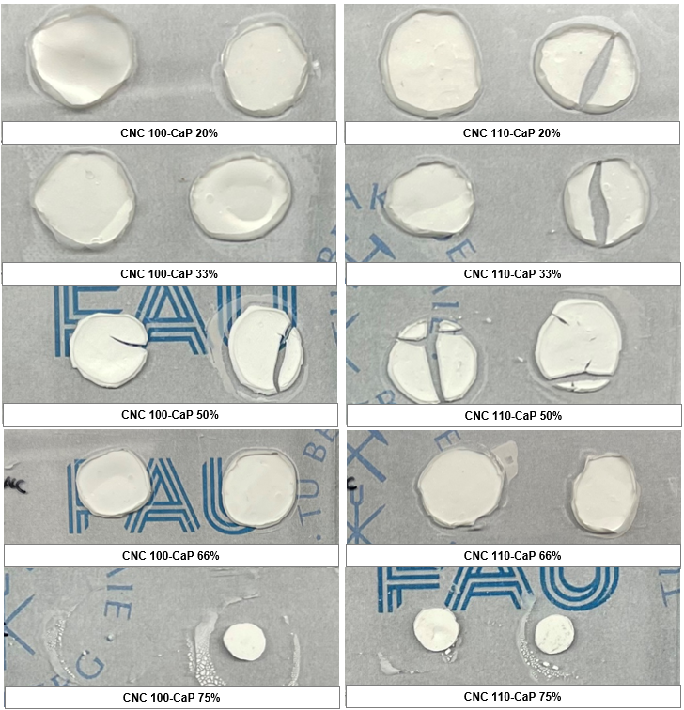

***1cm µm***

***1cm µm***

Figure 4.17.: CNC-CaP composite samples. The background image shows the university logos of FAU and TUBAF.

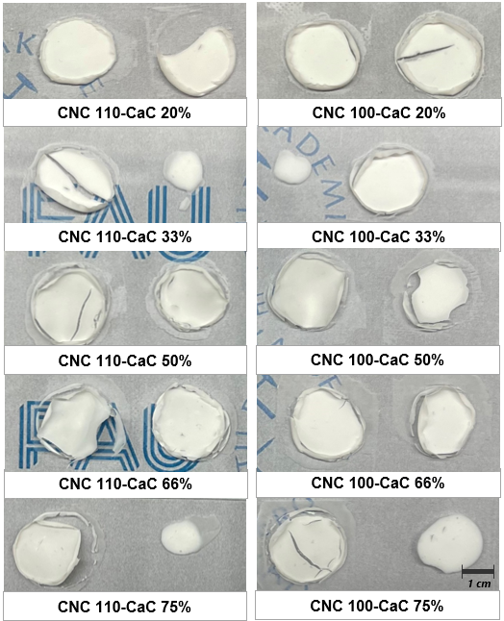

Figure 4.18.: CNC-CaC composite samples. The background image shows the university logos of FAU and TUBAF.

Figure 4.19 shows the SEM microscopic picture of the CNC 110/100 samples. The CNC 110/100 composite samples integrated with CaP are presented in figure 4.20.

It can be observed from the SEM images, that the surfaces of the CNC110/100 film samples that were not mineralized were relatively smooth and there is no obvious difference in the appearance of the both films. Their cross sections showed a layered structure, which was related to the good film-forming properties of CNC. The layers were tightly bonded with each other, and there were a few gaps. However, the formation of these gaps may also be related to the bending and breaking of the films during the preparation of the cross-section samples for SEM. The surface of the CNC composite sample integrated with CaP shows rougher features than that of the pure CNC film. The degree of roughness increases with the increase of CaP content. The shape of CaP in the CNC matrix is ​​mostly flake-shaped. These smaller flake CaP are embedded in the CNC matrix, and it can be observed that they are roughly distributed in the lateral direction in the CNC composite integrated with 20 wt.% CaP. They are well integrated with in the matrix and did not increase the porosity. Combined with the mechanical properties analysis of Figure 4.24 in 4.3.3, it can be confirmed that they can act as a reinforcement phase to increase the indentation modulus of the composite. However, a large number of flaky CaP appeared when the CaP content increased. The length of these flaky CaP is 17.6 ± 8.3 µm for CNC100 composite films and 22.3 ± 4.9 µm for CNC110 composite films. They were oriented differently in the matrix. From figure 4.18.c it can be seen that they left the composite with many voids. These voids reduce the mechanical properties of the material. It is also consistent with the measurements in figure 4.23 and explains the decrease in the mechanical properties of CNC composites with increasing CaP content starting from 50 wt.%.

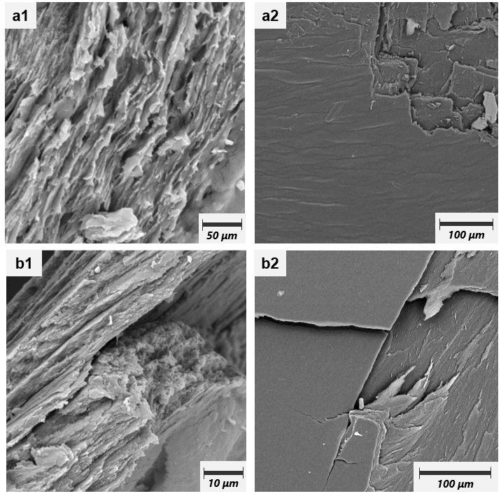Figure 4.19.: SEM micrographs of the cross-section (1) and surface (2) of CNC 110/100 films. a CNC 110 film. b CNC 100 film.

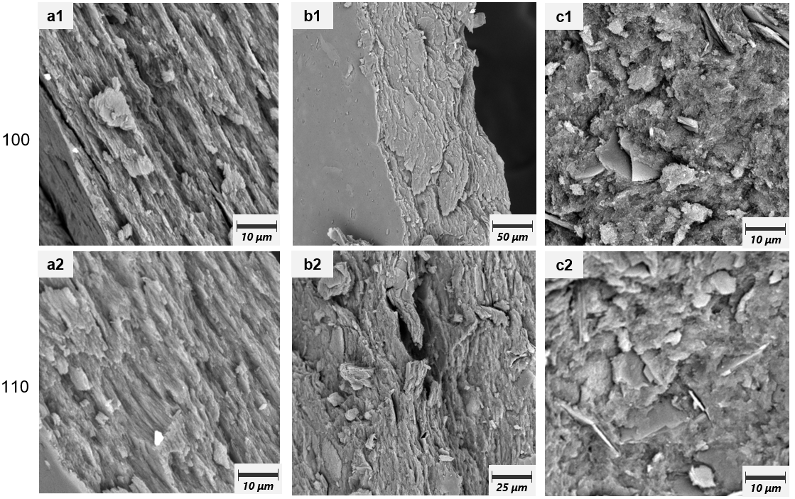

Figure 4.20.: SEM micrographs of the cross-section of CNC 110/100 composite samples integrated with CaP. 1= CNC 100 composite films. 2= CNC 110 composite films. a= 20 wt.% CaP. b= 50 wt.% CaP. c= 75 wt.% CaP.

Figure 4.21 shows the SEM microscopic picture of the CNC 110/100 composite samples integrated with CaC. According to the conclusion of Figure 4.23 from Raman measurement, the calcium carbonate phase in the composite material is calcite. As shown in the SEM photographs, the morphology of calcite is cube-shaped. The surface of the composite material becomes rougher with the integration of CaC. The surface can be compared with a pile of gravel, and the wavy morphology on it is caused by the integration of calcite. At the same time, the incorporation of calcite increases the porosity of the composite material. This is most likely due to the low content of CCO in the gel obtained after centrifugation of the CCO suspension. After the CCO gel was mixed with the CNC matrix and the composites were dried, a large number of cavities were left due to the evaporation of ethanol. These cavities will affect the mechanical properties of the composite material. This microstructure can also explain the phenomenon of decreased mechanical properties of the composite material. As the content of CaC increases, the porosity may decrease. Thereby the mechanical properties of the composites could be improved. In general, both CNCs can also stabilize calcium carbonate. This is reflected in the smaller size and uniform distribution of calcium carbonate in the CNC matrix. The side length of the cube-shaped calcite is about 1.7 ± 0.28 µm for CNC110 composite films and 2.5 ± 0.66 µm for CNC100 composite films. The size of calcite in the CNC110 composite film is significantly larger than that in the CNC100 composite film.

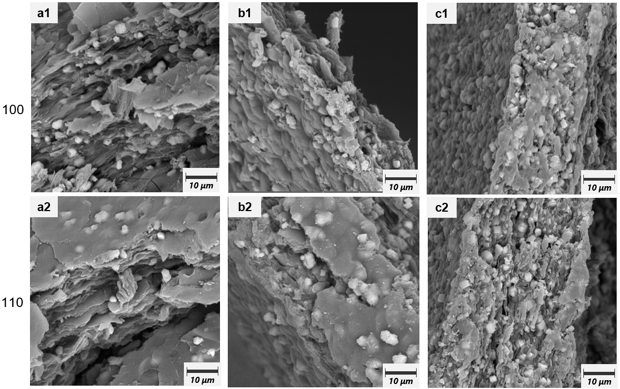

Figure 4.21.: SEM micrographs of the cross-section of CNC 110/100 composite samples integrated with CaC. a CNC 110 film. b CNC 100 film. 1= CNC 100 composite films. 2= CNC 110 composite films. a= 20 wt.% CaC. b= 50 wt.% CaC. c= 75 wt.% CaC.

### **4.3.2 Characterization of calcium phosphate phases contained in the CaP-CNC composite material**

For the analysis of the calcium phosphate phase formed in the CaP-CNC composite material, Raman spectroscopy were conducted. Figure 4.22 presents the recorded spectra of composites from CNC-CaP 0% (pure CNC) to CNC-CaP 75%. In Table 4.2 the strong peaks according to literatures [115,116,117] are displayed and used for the evaluation of this work. Since the peaks of the FTIR spectra of CNC and ACP overlap to a large extent, they are not suitable for component analysis.

There are 4 typical absorption bands in CNC and CNC-CaP composite samples. The absorption band in 1480 cm−1 is corresponded to the ring stretching and NH. Also, the absorption band of HCC, HCO and HOC bending can be found at 1383 cm−1. The absorption band of COC bending at 1122 cm-1 are associated with the characteristic glycosidic in cellulose. OH bending or asymmetric stretching of ring can be found in the absorption band at 1096 cm-1. The comparison of the measured Raman peaks (Figure 4.22) with literature data (Table 4.2) revealed the presence of HAP in the CNC-CaP samples (peaks at 959-960, 578-579, 428-429 cm-1 for all mineralized samples). No ACP was found, as the typical strong peak at 951 cm-1 was not seen in any of the composites.

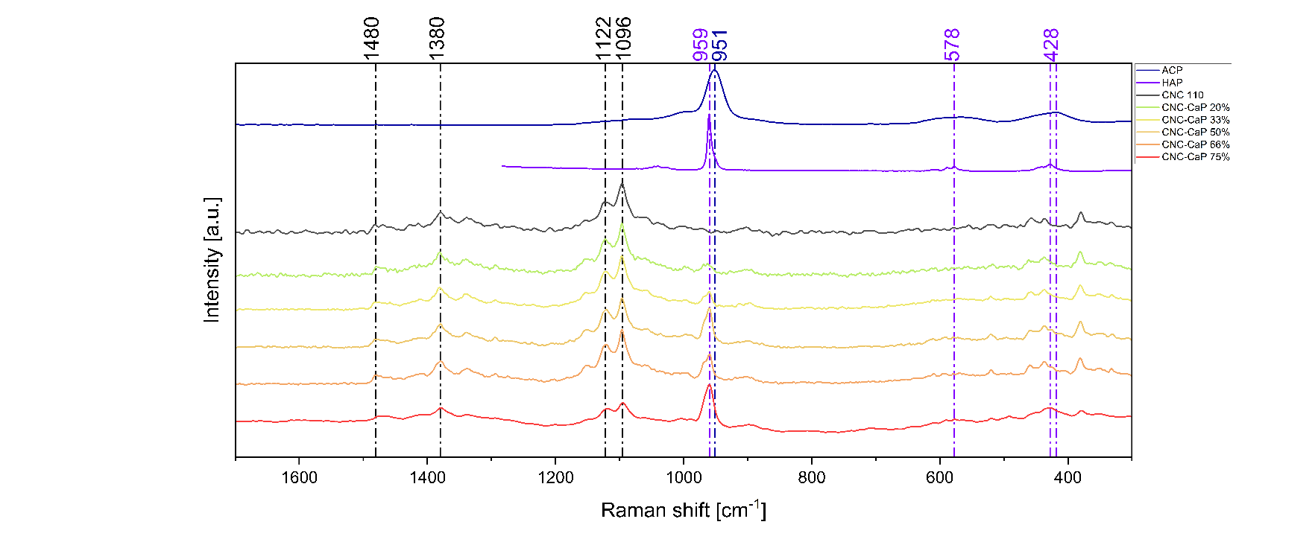

Figure 4.22.: Raman spectra of CNC 110, ACP and all CNC-CaP composite materials. The blue indicator line indicates the characteristic peak of ACP. The purple indicator line indicates the characteristic peak of HAP. The black indicator line indicates the characteristic peak of CNC.

Table 4.2.: Peaks in Raman spectra of CNC 110, ACP and all CNC-CaP composite materials.

|  |  |  |  |
| --- | --- | --- | --- |
| Wavenumber (cm-1) | Assignment | Comp. | Ref. |
| 951 |  | ACP | [116] |
| 959 |  | HAP | [116] |
| 1096 | δOH or νas(ring), νC-O-C glycosidic | Cellulose | [115][117] |
| 1122 | νCOC glycosidic | Cellulose | [115] |
| 1380 | δHCC, δHCO, δCOH | Cellulose | [115][117] |
| 1480 | ν(ring), δNH | Cellulose | [115] |
|  |  |  |  |

Figure 4.23 presents the Raman spectra of the CNC composites integrated with CaC. The characteristic peaks in the CNC pattern have been described in the previous paragraph and in table 4.2. The characteristic peaks were found in all CNC composite samples integrated with CaC. The Raman spectra of all calcium carbonates have a strong peak at 1087 cm−1 which is assigned to the symmetric stretching of C–O bonds [122]. The peak for C–O in-plane bending was found in the 713 cm−1. It can be effectively used to distinguish between calcite and aragonite [123,124]. The peaks at 1087 and 713 cm-1 are called “internal modes” because they originate from vibrations between the C and O of carbonate (CO3) [122]. The Raman spectrum of calcite contains "lattice modes" (or "external modes") at 282 and 156 cm-1 caused by vibrations between molecules in the crystal lattice, which are also unique to the mineral. In addition, no obvious peak was found in the 205-220 cm-1 region on the pattern of the CNC composite. Therefore, it can be determined that the calcium carbonate phase in the CNC composite is calcite. This conclusion is consistent with the cube-like morphology of calcium carbonate found in SEM micrographs. The cube-like structure is also consistent with the morphology of calcite described in the literature [125,126].

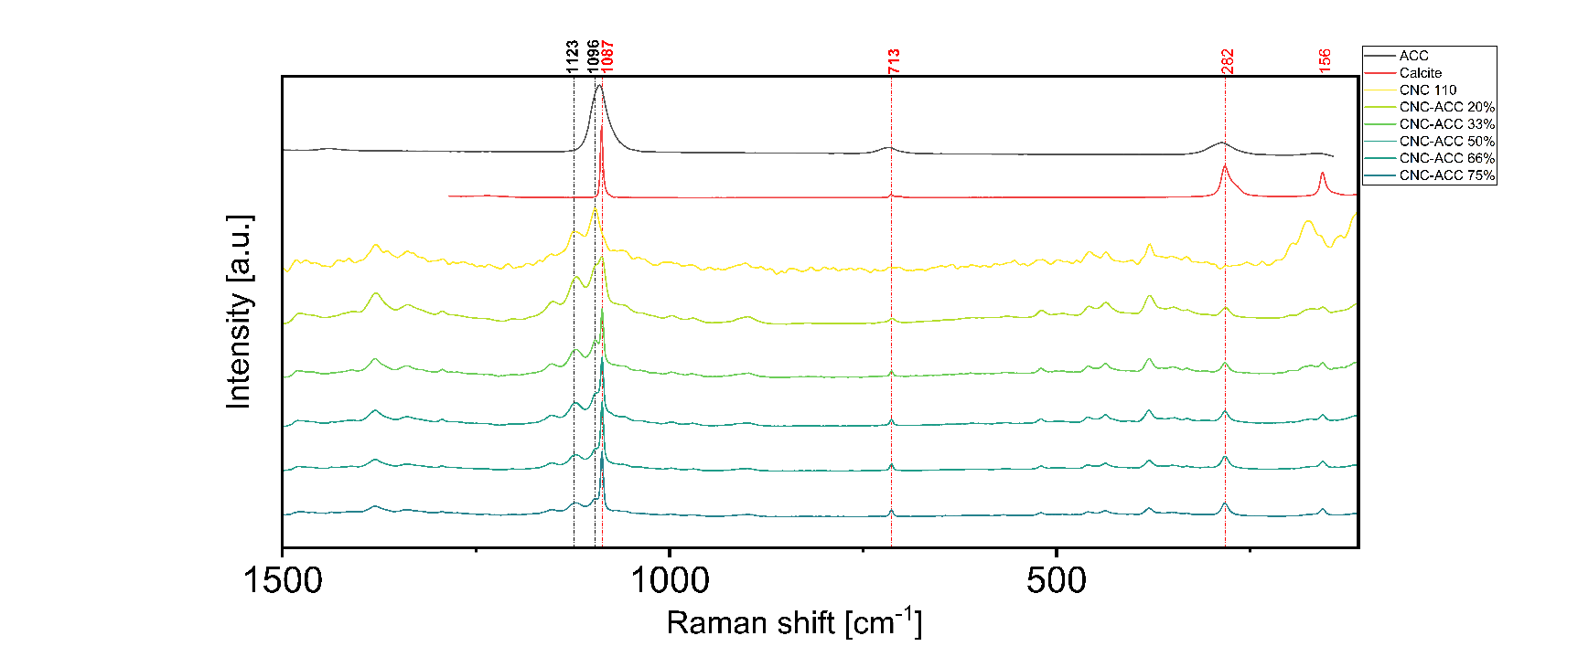

Figure 4.23.: Raman spectra of CNC 110, ACP and all CNC-CaP composite materials.

### **4.3.2 Mechanical properties calcium phosphate mineralized CNC composite material**

For the evaluation of the mechanical properties of CNC composites, the nanoindentation measure-ments were performed on the samples as compression tests are not suitable for films. The results for the indentation modulus and Martens hardness of the CNC-CaP composites are presented in Figure 4.24. The comparison between the data was analyzed using single-factor ANOVA with Bonferroni (p < 0.05).

The indentation modulus of the CNC film is significantly increased after integrating with CaP. The indentation modulus of the CNC film without integration of CaP is 2.13 ± 0.13 GPa for CNC 110 and 2.33 ± 0.21 GPa for CNC 100. There is no significant difference in the indentation modulus of the two CNC films. After the integration of CaP, the indentation modulus of CNC increases to 3.06 ± 0.09 GPa for CNC 110 and 4.34 ± 0.11 GPa for CNC 100. As the CaP content increases up to 50 wt.%, the indentation modulus increases to a maximum value of 4.78 ± 0.28 GPa for CNC 110 and 5.80 ± 0.28 GPa for CNC 100. Then, with the increase of CaP content, the elastic moduli of the two CNCs began to decrease. The indentation modulus of CNC with 75 wt.% CaP decreased to 4.06 ± 0.52 GPa for CNC 110 and 4.73 ± 0.22 GPa for CNC 100. In general, the trend in the change of the indentation modulus is the same for both CNC, but the increase is more obvious for CNC 100. The indentation modulus of CNC 100-CaP composites is always higher than that of CNC 110-CaP. The variation of the Martens hardness of the composites is quite different from that of the indentation modulus. For CNC 110, the Martens hardness increases from 121.18 ± 11 N/mm2 to 138.5 ± 7.6 N/mm2 only when 20 wt.% and 33 wt.% CaP were integrated. When 50 wt.% and 66 wt.% CaP were integrated into CNC 110 matrix, the Martens hardness does not change. Even when the content of CaP increases to 75 wt.%, the Martens hardness is lower than that of CNC 110 film. For CNC 100, the Martens hardness increases from 109.84 ± 10 N/mm2 to 151 ± 4.9 N/mm2 when 20 wt.% CaP were integrated. And the Martens hardness of CNC 100 composite with 33 and 50 wt.% CaP had no significant difference to the composite with 20 wt.% CaP. The Martens hardness of CNC 100 composite with 66 and 75 wt.% CaP was then decreased.

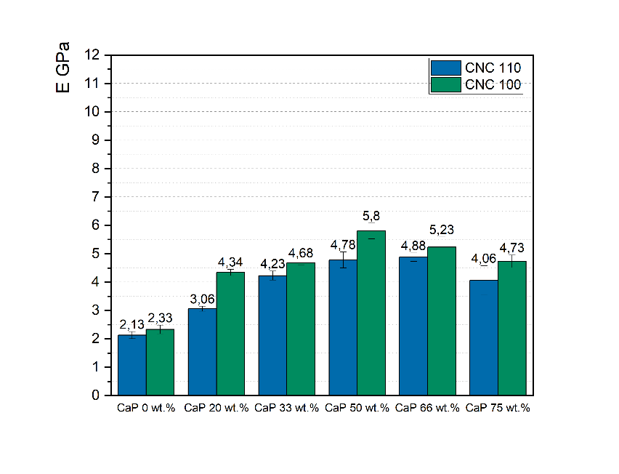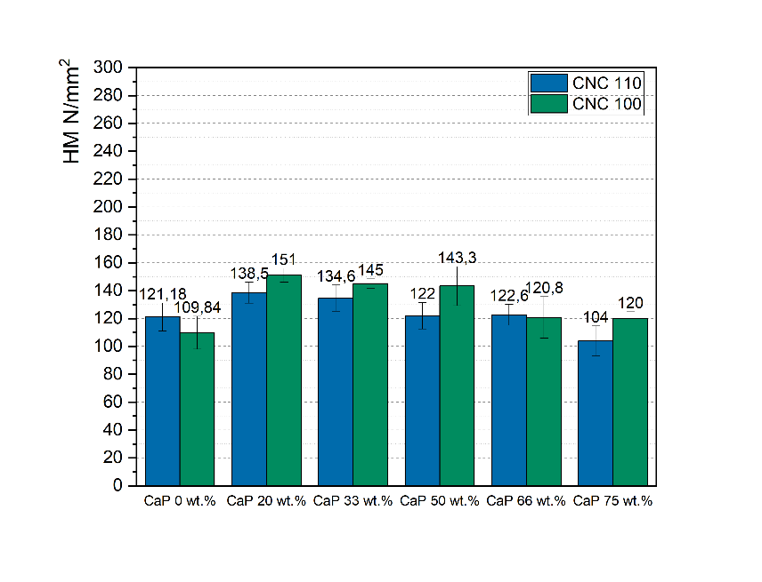

Figure.4.24.: Indentation modulus and Martens hardness of CNC film and CNC-CaP composite materials.

The indentation modulus and Martens hardness measured from nanoindentation for the CNC composites integrated with CaC are presented in Figure 4.25. The comparison between data was also analyzed using single-factor ANOVA with Bonferroni (p < 0.05).

Compared with CaP, CaC also has the effect of increasing the indentation modulus of composite materials and reducing the Martens hardness. The indentation modulus of all CNC composite samples with integration of CaC was improved. The sample with the largest improvement was CNC composite integrated with 75 wt.% CaC, whose indentation modulus increased from 2.25 ± 0.39 GPa for CNC 110 and 2.13 ± 0.52 GPa for CNC 100 to 4.4 ± 0.29 GPa and 4.3 ± 0.35 GPa respectively. The indentation modulus of the other CNC composites integrated with 20-66 wt.% CaP did not change significantly. Different from the CNC-CaP composites, only the CNC 100 composite incorporating with 33 wt.% CaC has a higher indentation modulus than that of the CNC 110 composite. In general, the voids in the CNC-CaP composite films have a significant impact on the indentation modulus and caused a larger standard deviation, even though the size of CaC in the CNC110 composite film is larger than that in the CNC100 composite film.

There is no significant change in the Martens hardness of the CNC 110 and 100 composites integrated with 20% CaC and the Martens hardness of the CNC 110 and 100 film. However, the Martens hardness of other CNC composites integrated with CaC is lower than that of both pure CNC film. This is also due to the voids in the structure.

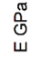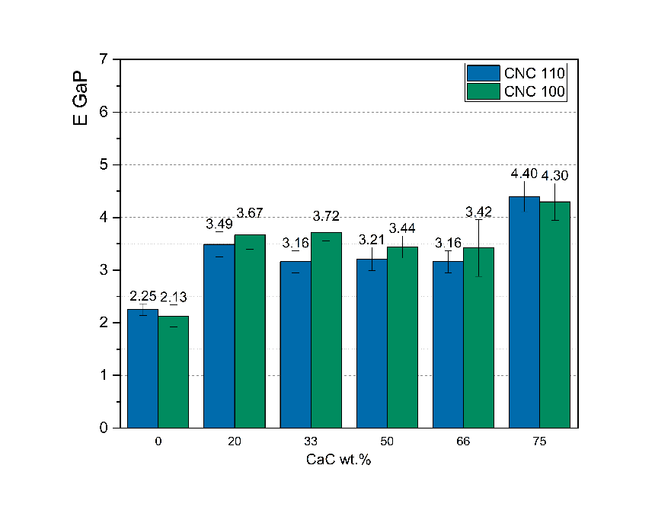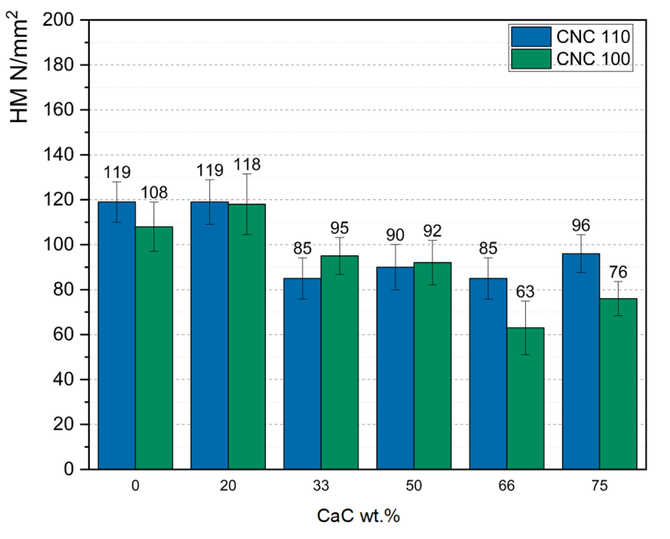

Figure.4.25.: Indentation modulus and Martens hardness of CNC film and CNC-CaC composite materials.

# **Conclusion**

In this work, due to the complexity of *A. niger* mycelium, we first characterized the samples made from mycelium. The effects of different mycelium contents, heat treatments, and disperser usage time on their mechanical properties were studied. Precursor-synthesis and insitu-synthesis were then used to mineralize the mycelium matrix with calcium phosphate. The mineralization effect was analyzed and the phase of the calcium phosphate formed was characterized. The mechanical properties of the composite material after mineralization were characterized using nanoindentation. In addition, the precursor synthesis was then used to mineralize the CNC matrix with calcium phosphate and calcium carbonate. The mechanical properties of the composite film were characterized as well as the phase of the minerals formed.

#### The characterization of A. niger mycelium samples.

Both the use of the disperser Turaxx and heat treatment have a significant influence on the mechanical properties of the mycelium. For the batch 7.4 wt.% and 10.3 wt.%-sTX mycelium samples the indentation modulus of the sample with 1 min-Turaxx treatment was not significantly different from that of the mycelium sample without Turaxx treatment. After using the disperser for 25 minutes, since the pellet-structure of the mycelium was destroyed to a large extent, these mycelium fragments or hyphae generated by the destruction filled the gaps between the pellet structures in the sample, the indentation modulus is increased 5.6 % from 2.31 ± 0.14 GPa to 2.44 ± 0.07 GPa and 16.1 % from 2.24 ± 0.10 GPa to 2.60 ± 0.08 GPa respectively at as a result. For batch 10.3 wt.%-aging-sTX/bTXsamples, both 1 min-Turaxx treatment and 25 min-Turaxx treatment can significantly increase the indentation modulus of mycelium samples. However, Turaxx treatment generally has little effect on the hardness of samples. Among the heat-treated samples, the changes in mechanical properties were different between the batch 7.4 wt.% and 10.3 wt.%-sTX samples without aging treatment to the batch 10.3 wt.% samples with aging treatment. The indentation modulus and Martens hardness of batch 7.4 wt.% and 10.3 wt.%-sTX samples without aging treatment mostly reach their maximum values after 2 h-heat treatment. Compared to their RT samples, the indentation modulus increased 15.1 ± 9.5 %, 8.9 ± 1.5 %, 10.5 ± 4.7 % for samples with 0, 1, 25 min-Turaxx treatment. The mechanical properties of samples with aging treatment increased significantly with increasing heat treatment time in opposite. The geometric density measurement results indicate that after 2 h-heat treatment, the presence of water allows the mycelium to plastically deform and shrink. Then more micropores are filled. After 18 h-heat treatment, the macropores expand due to the shrinkage of the mycelium structure.

The mechanical properties of the mineralized mycelium samples with calcium phosphate were not improved. Many samples showed a decrease in mechanical properties. In the samples M-insitu-CaP and Batch ADB/BDA composite samples, this was due to the formation of calcium phosphate, which caused the porosity of the mycelium matrix to increase when drying. In the M-prec-CaP composite sample, a large amount of calcium phosphate adhered to the surface of the pellet structure due to poor diffusivity, which made the bonding between the pellet structures of the mycelium worse and the mechanical properties decreased. In addition, due to the driving effect of water evaporation and the inability of the mycelium matrix to stabilize calcium phosphate, the samples all showed phase separation. Raman spectroscopy and PXRD were used to characterize the calcium phosphate phase formed in the samples. Many characteristic peaks of DCPD were found in the samples M-insitu-CaP and Batch ADB/BDA composite samples, indicating that ACP cannot be formed through insitu synthesis, but DCPD. It is worth noticing that incompletely dissolved ammonium phosphate and calcium acetate crystals were also found in the sample Batch ADB. This is due to the addition of too little water and too short stirring time. In the PXRD pattern of the M-prec-CaP composite sample, the presence of HAP. In general, the two methods cannot synthesize ACP in the mycelium matrix.

#### The characterization of CNC composite samples.

CNC composite films were produced by using precursor-synthesis in CNC matrix. In the CNC-CaP samples, the thickness of the composite film increases with the increase of CaP content. And when the glass slide is highly sanitary, all CaP contents can be firmly attached to the glass slide. In contrast, the thickness of the CNC-CaC composite films increased slightly with increasing CaC content and showed no shrinkage, but the film samples often detached from the glass slide. Thermal stress cracking can also be reduced by drying the both CNC composite films in an incubator.

The mechanical properties of the composite film were characterized and it was found that the indentation modulus of the CNC-CaP sample first increased to 4.78 ± 0.28 GPa for CNC 110 (maximum 224 % and 249 %) and 5.80 ± 0.28 GPa for CNC 100. Then indentation modulus decreased to 4.06 ± 0.52 GPa for CNC 110 and 4.73 ± 0.22 GPa for CNC 100 (15.1 % and 18.5 %) with the increase of CaP content. This may be due to the voids generated by the integration of CaP. When the CaP content increased more than 50 wt.%, the effect of the voids on the indentation modulus after drying caused by the continued increase of CaP content was greater than the enhancement effect of CaP on the indentation modulus. The strengthening effect of CaP on Martens hardness is not as strong as that on indentation modulus. The Martens hardness of CNC-CaP is higher than that of pure CNC film only when it contains 20 wt.%-50 wt.% CaP. The indentation modulus of the CNC-CaC composite films was also enhanced by integration of CaC, with the best enhancement being achieved in CNC-CaC75. The indentation modulus measurement data for the samples had a high standard deviation. Because the CaC suspension was centrifuged to form a CaC gel containing CCO and ethanol, it was then added to the CNC matrix and stirred. The ethanol evaporated when the sample was dried, leaving a large number of voids at the corresponding locations. These voids would cause uneven mechanical energy in the sample. Compared with CaP, CaC has no strengthening effect on Martens hardness. And the presence of voids significantly reduces the Martens hardness of CNC-CaC composite films.

# **Reference**

[1] Morgan EF, Unnikrisnan GU, Hussein AI. Bone Mechanical Properties in Healthy and Diseased States. Annu Rev Biomed Eng. 2018;20:119-143. doi: 10.1146/annurev-bioeng-062117-121139.

[2] Luz GM, Mano JF. Mineralized structures in nature: Examples and inspirations for the design of new composite materials and biomaterials. Composites Science and Technology. 2010;70(13):1777-1788. doi: 10.1016/j.compscitech.2010.05.013.

[3] Estroff LA. Introduction: biomineralization. Chemical Reviews. 2008;108(11):4329-4331. doi: 10.1021/cr8004789.

[4] Ritchie RO. The Conflicts between Strength and Toughness. Nat Mater. 2011;10:817-822. doi: 10.1038/nmat3115.

[5] Naleway SE, Porter MM, McKittrick J, Meyers MA. Structural Design Elements in Biological Materials: Application to Bioinspiration. Adv Mater. 2015;27:5455-5476. doi: 10.1002/adma.201502403.

[6] Barthelat F, Yin Z, Buehler MJ. Structure and Mechanics of Interfaces in Biological Materials. Nat Rev Mater. 2016;1:16007. doi: 10.1038/natrevmats.2016.7.

[7] Lowenstam H, Weiner S. On Biomineralization. Oxford University Press, USA; 1989.

[8] Qin K, Zheng Z, Wang J, Pan H, Tang R. Biomineralization strategy: from material manufacturing to biological regulation. Giant. 2024;100317. doi: 10.1016/j.giant.2024.100317.

[9] Chen Y, Feng Y, Deveaux JG, Masoud MA, Chandra FS, Chen H, Zhang D, Feng L. Biomineralization Forming Process and Bio-inspired Nanomaterials for Biomedical Application: A Review. Minerals. 2019;9(68). doi: 10.3390/min9020068.

[10] Arockiasamy FS, Muthukrishnan M, Kumar P, Ramesh M, Kannan M. PLA based Bio Composite reinforced with natural fibers: Review. IOP Conference Series Materials Science and Engineering. 2021;1145(1):012069. doi: 10.1088/1757-899X/1145/1/012069.

[11] Bakhori S, Hassan M, Bakhori N, Jamaludin K, Daud MY, Abdul Aziz S. Physical, Mechanical and Perforation Resistance of Natural-Synthetic Fiber Interply Laminate Hybrid Composites. Polymers. 2022;14(1322). doi: 10.3390/polym14071322.

[12] Faruk O, Bledzki AK, Fink H-P, Sain M. Progress Report on Natural Fiber Reinforced Composites. Macromol Mater Eng. 2014;299:9-26. doi: 10.1002/mame.201300008.

[13] Pan H, Jiang S, Zhang T, Tang R. In Situ Solution Study of Calcium Phosphate Crystallization Kinetics. Methods in Enzymology. Academic Press; 2013;532:129-144. doi: 10.1016/B978-0-12-416617-2.00006-0.

[14] Amjad Z, et al. The growth of hydroxyapatite from solution: A new constant composition method. Journal of Dental Research. 1979;58(4):1431-1432.

[15] Kniep J, Graupner N, Reimer JJ, Müssig J. Mycelium-based biomimetic composite structures as a sustainable leather alternative. Materials Today Communications. 2024;39:109100. doi: 10.1016/j.mtcomm.2024.109100.

[16] Lupu BI, Beznea EF, Chirica I. Buckling and Ultimate Strength Assessment of Ship Hull Layered Composite Panels. Advanced Materials Research. Doi:10.4028/www.scientific.net/amr.1143.145

[17] X. Wang, Y. Zhang, J. Luo, T. Xu, C. Si, A.J.C. Oscanoa, D. Tang, L. Zhu, P. Wang, C. Huang Printability of hybridized composite from maleic acid-treated bacterial cellulose with gelatin for bone tissue regeneration Adv. Compos. Hybrid Mater., 6 (2023), p. 134, 10.1007/s42114-023-00711-7.

[18] Askeland, Donald R.; Fulay, Pradeep P.; Wright, Wendelin J. (2010-06-21). The Science and Engineering of Materials (6th ed.). Cengage Learning. ISBN 9780495296027.

[19] D.K.Y. Tam, S. Ruan, P. Gao, T. Yu. High-performance ballistic protection using polymer nanocomposites, Editor(s): E. Sparks, In Woodhead Publishing Series in Textiles, Advances in Military Textiles and Personal Equipment, Woodhead Publishing, 2012, Pages 213-237, ISBN 9781845696993, <https://doi.org/10.1533/9780857095572.2.213>.

[20] M.W. HYER, A.M. WAAS, 1.12 - Micromechanics of Linear Elastic Continuous Fiber Composites, Editor(s): Anthony Kelly, Carl Zweben. Comprehensive Composite Materials, Pergamon, 2000, Pages 345-375, ISBN 9780080429939, <https://doi.org/10.1016/B0-08-042993-9/00049-8>.

[21] Asrar Rafiq Bhat, Rajiv Kumar, Prasanna Kumar S. Mural. Natural fiber reinforced polymer composites: A comprehensive review of Tribo‐Mechanical properties, Tribology International, Volume 189, 2023, 108978, ISSN 0301-679X, <https://doi.org/10.1016/j.triboint.2023.108978>.

[22] J.W. Martin. 6 - Composite materials. Editor(s): J.W. Martin, Materials for Engineering (Third Edition). Woodhead Publishing, 2006. Pages 185-215, ISBN 9781845691578. <https://doi.org/10.1533/9781845691608.2.185>.

[23] Angelo G. Facca, Mark T. Kortschot, Ning Yan, Predicting the elastic modulus of natural fibre reinforced thermoplastics, Composites Part A: Applied Science and Manufacturing, Volume 37, Issue 10, 2006, Pages 1660-1671, ISSN 1359-835X, https://doi.org/10.1016/j.compositesa.2005.10.006.

[24] Voigt, W. (1889). "Ueber die Beziehung zwischen den beiden Elasticitätsconstanten isotroper Körper". Annalen der Physik. 274 (12): 573–587. Bibcode:1889AnP...274..573V. doi:10.1002/andp.18892741206.

[25] Reuss, A. (1929). "Berechnung der Fließgrenze von Mischkristallen auf Grund der Plastizitätsbedingung für Einkristalle". Zeitschrift für Angewandte Mathematik und Mechanik. 9 (1): 49–58. Bibcode:1929ZaMM....9...49R. doi:10.1002/zamm.19290090104.

[26] A. P. Jackson, J. F. V. Vincent, R. M. Turner, and R. M. Alexander. “The mechanical design of nacre.” Proceedings of the Royal Society of London. Series B. Biological Sciences. vol. 234, no. 1277. pp. 415–440. Sep. 1988.

[27] H. Dai, W. Dai, Z. Hu, W. Zhang, G. Zhang, R. Guo, Advanced Composites Inspired by Biological Structures and Functions in Nature: Architecture Design, Strengthening Mechanisms, and Mechanical-Functional Responses. Adv. Sci. 2023, 10, 2207192. https://doi.org/10.1002/advs.202207192

[28] Jones, R.M. (1999). Mechanics Of Composite Materials (2nd ed.). CRC Press. p. 86. https://doi.org/10.1201/9781498711067

[29] Dorozhkin SV. Calcium orthophosphates: occurrence, properties, biomineralization, pathological calcification and biomimetic applications. Biomatter. 2011 Oct-Dec;1(2):121-64. doi: 10.4161/biom.18790. PMID: 23507744; PMCID: PMC3549886.

[30] Cameron F.K., Seidell A. The phosphates of calcium. I. J. Am. Chem. Soc. 1905;27:1503–1512. doi: 10.1021/ja01990a005.

[31] Cameron F.K., Bell J.M. The phosphates of calcium. II. J. Am. Chem. Soc. 1905;27:1512–1514. doi: 10.1021/ja01990a006.

[32] Cameron F.K., Bell J.M. The phosphates of calcium, III; Superphosphate. J. Am. Chem. Soc. 1906;28:1222–1229. doi: 10.1021/ja01975a016.

[33] Cameron F.K., Bell J.M. The phosphates of calcium. IV. J. Am. Chem. Soc. 1910;32:869–873. doi: 10.1021/ja01925a003.

[34] Bassett H., Jr. Beiträge zum Studium der Calciumphosphate. I. Die Hydrate der Calcium-Hydroorthophosphate. Z. Anorg. Chem. 1907;53:34–48. doi: 10.1002/zaac.19070530104.

[35] Bassett H., Jr. Beiträge zum Studium der Calciumphosphate. II. Die Einwirkung von Ammoniakgas auf Calcium-Hydroorthophosphate. Z. Anorg. Chem. 1907;53:49–62. doi: 10.1002/zaac.19070530105.

[36] Bassett H., Jr. Beiträge zum Studium der Calciumphosphate. III. Das System CaO – P2O5 – H2O. Z. Anorg. Chem. 1908;59:1–55. doi: 10.1002/zaac.19080590102.

[37] Bassett H., Jr. The phosphates of calcium. Part IV. The basic phosphates. J. Chem. Soc. 1917;111:620–642. doi: 10.1039/ct9171100620.

[38] Jie Zhao, Yu Liu, Wei-bin Sun, Xuebin Yang, First detection, characterization, and application of amorphous calcium phosphate in dentistry, Journal of Dental Sciences, Volume 7, Issue 4, 2012, Pages 316-323, ISSN 1991-7902, <https://doi.org/10.1016/j.jds.2012.09.001>.

[39] J.C. Elliott. Structure and chemistry of the apatites and other calcium ortho-phosphates, Elsevier, Amsterdam, 1994.

[40] S.V. Dorozhkin. Calcium orthophosphates. J Mater Sci. 42 (2007) 1061–1095. <https://doi.org/10.1007/s10853-006-1467-8>.

[41] Zhao J, Liu Y, Sun WB, Zhang H. Amorphous calcium phosphate and its application in dentistry. Chem Cent J. 2011 Jul 8;5:40. doi: 10.1186/1752-153X-5-40. PMID: 21740535; PMCID: PMC3143077.

[42] Ce Bian, Yiman Guo, Mengyao Zhu, Miao Liu, Xianju Xie, Michael D. Weir, Thomas W. Oates, Radi Masri, Hockin H.K. Xu, Ke Zhang, Yuxing Bai, Ning Zhang, New generation of orthodontic devices and materials with bioactive capacities to improve enamel demineralization, Journal of Dentistry, Volume 142, 2024, 104844, ISSN 0300-5712, https://doi.org/10.1016/j.jdent.2024.104844.

[43] Feenstra TP, De Bruyn PL. Formation of Calcium Phosphates in Moderately Supersaturated Solutions. J Phys Chem. 1979;83:475–479. doi: 10.1021/j100467a010.

[44] Dorozhkin SV. Amorphous calcium (ortho) phosphates. Acta Biomater. 2010;6:4457–4475. doi: 10.1016/j.actbio.2010.06.031.

[45] Harries JE, Hukins DW, Holt C, Hasnain SS. Conversion of Amorphous Calcium Phosphate into Hydroxyapatite. J Cryst Growth. 1987;84:563–570. doi: 10.1016/0022-0248(87)90046-7.

[46] Boskey AL, Posner AS. Magnesium Stabilization of Amorphous Calcium Phosphate: A Kinetic Study. Mater Res Bull. 1974;9:907–916. doi: 10.1016/0025-5408(74)90169-X.

[47] Posner AS, Betts F, Blumenthal NC. Role of ATP and Mg in the stabilization of biological and synthetic amorphous calcium phosphates. Calcif Tissue Res. 1977;22:208–212.

[48] Li YB, Weng WJ. In vitro synthesis and characterization of amorphous calcium phosphates with various Ca/P atomic ratios. J Mater Sci Mater Med. 2007;18:2303–2308. doi: 10.1007/s10856-007-3132-4.

[49] Lowenstam, Heinz Adolf, and Stephen Weiner. On biomineralization. Oxford University Press, USA, 1989.

[50] M. Katsikini, E. Proiou, N. Vouroutzis, F. Pinakidou, E.C. Paloura, D. Smirnov, M. Brzhezinskaya, S. Ves, Crystalline and amorphous calcium carbonate as structural components of the Calappa granulata exoskeleton, Journal of Structural Biology, Volume 211, Issue 3, 2020, 107557, ISSN 1047-8477, https://doi.org/10.1016/j.jsb.2020.107557.

[51] C. Shao, B. Jin, Z. Mu, H. Lu, Y. Zhao, Z. Wu, L. Yan, Z. Zhang, Y. Zhou, H. Pan, Z. Liu, R. Tang, Repair of tooth enamel by a biomimetic mineralization fron-tier ensuring epitaxial growth, Sci. Adv. 5 (2019). https://doi.org/10.1126/sciadv.aaw9569.

[52] Y. Yu, Y. He, Z. Mu, Y. Zhao, K. Kong, Z. Liu, R. Tang. Biomimetic Mineralized Organic–Inorganic Hybrid Macrofiber with Spider Silk‐Like Supertoughness. Adv. Funct. Mater. 30 (2020). <https://doi.org/10.1002/adfm.201908556>.

[53] M. J. Olszta, X. Cheng, S. S. Jee, R. Kumar, Y.-Y. Kim, M. J. Kaufman, E. P. Douglas, L. B. Gower, Bone structure and formation: A new perspective. Mater. Sci. Eng. R Rep. 58, 77–116 (2007).

[54] S. T. Sun, D. Gebauer, H. Cölfen, A general strategy for colloidal stable ultrasmall amorphous mineral clusters in organic solvents. Chem. Sci. 8, 1400–1405 (2017).

[55] Wolfgang F. Tegethoff: Calciumcarbonat Von der Kreidezeit ins 21. Jahrhundert. Springer-Verlag, 2013, ISBN 978-3-0348-8259-0, S. 3.

[56] Rodriguez-Navarro, Carlos & Kudlacz, Krzysztof & Cizer, Özlem & Ruiz-Agudo, Encarnación. (2014). Formation of amorphous calcium carbonate and its transformation into mesostructured calcite. CrystEngComm. 17. 10.1039/C4CE01562B.

[57] Markus Neumann: Synthese und Charakterisierung von Calciumcarbonat-Phasen und Calciumphosphat-basierter Knochenersatzmaterialien. Dissertation. Uni Duisburg-Essen. abgerufen am 1. Januar 2016.

[58] Holger Nebel, Dissertation, Kontrollierte Fällung von CaCO3 in einem modular aufgebauten Kristallisationsreaktor, 2008, urn:nbn:de:hbz:465-20081222-080244-7.

[59] Zsombor Molnár, István Dódony, Mihály Pósfai. Transformation of amorphous calcium carbonate in the presence of magnesium, phosphate, and mineral surfaces. Geochimica et Cosmochimica Acta. Volume 345, 2023, Pages 90-101. ISSN 0016-7037. <https://doi.org/10.1016/j.gca.2023.01.028>.

[60] K. Ishikawa, K. Hayashi Carbonate apatite artificial bone Sci. Technol. Adv. Mater., 22 (1) (2021), pp. 683-694, 10.1080/14686996.2021.1947120

[61] C.J.S. Ibsen, D. Chernyshov, H. Birkedal Apatite formation from amorphous calcium phosphate and mixed amorphous calcium phosphate/amorphous calcium carbonate Eur. J. Chem., 22 (35) (2016), pp. 12347-12357, 10.1002/chem.201601280.

[62] C. Combes, C. Rey Amorphous calcium phosphates: synthesis, properties and uses in biomaterials Acta Biomater., 6 (2010), pp. 3362-3378, 10.1016/j.actbio.2010.02.017.

[63] Chow E.K.-H., Ho D. AUTHOR FULL NAMES: Chow, Edward Kai-Hua (56657179500); Ho, Dean (35272071300) 56657179500; 35272071300 Cancer nanomedicine: From drug delivery to imaging (2013) Science Translational Medicine, 5 (216), art. no. 216rv4, Cited 412 times. DOI: 10.1126/scitranslmed.3005872.

[64] Orit Ecker Cohen, Sara Neuman, Yehudit Natan, Almog Levy, Yigal Dov Blum, Shimon Amselem, Danny Bavli, Yossi Ben, Amorphous calcium carbonate enhances osteogenic differentiation and myotube formation of human bone marrow derived mesenchymal stem cells and primary skeletal muscle cells under microgravity conditions, Life Sciences in Space Research, Volume 41, 2024, Pages 146-157, ISSN 2214-5524, https://doi.org/10.1016/j.lssr.2024.02.007.

[65] Yoreo, James J. De; Gilbert, Pupa U. P. A.; Sommerdijk, Nico A. J. M.; Penn, R. Lee; Whitelam, Stephen; Joester, Derk; Zhang, Hengzhong; Rimer, Jeffrey D.; Navrotsky, Alexandra (2015-07-31). "Crystallization by particle attachment in synthetic, biogenic, and geologic environments". Science. 349 (6247): aaa6760. doi:10.1126/science.aaa6760. ISSN 0036-8075. PMID 26228157. S2CID 14742194.

[66] Blue, Christina R.; Rimstidt, J. Donald; Dove, Patricia M. (2013-01-01). "A Mixed Flow Reactor Method to Synthesize Amorphous Calcium Carbonate Under Controlled Chemical Conditions". Research Methods in Biomineralization Science. Methods in Enzymology. Vol. 532. pp. 557–568. doi:10.1016/B978-0-12-416617-2.00023-0. ISBN 9780124166172. PMID 24188782.

[67] Cobourne, G.; Mountjoy, G.; Rodriguez-Blanco, J.D.; Benning, L.G.; Hannon, A.C.; Plaisier, J.R. (2014). "Neutron and X-ray Diffraction and Empirical Potential Structure Refinement Modelling of Magnesium Stabilised Amorphous Calcium Carbonate". Journal of Non-Crystalline Solids. 401: 154–158. Bibcode:2014JNCS..401..154C. doi:10.1016/j.jnoncrysol.2013.12.023. hdl:2262/89859.

[68] Liu, Z., Shao, C., Jin, B. et al. Crosslinking ionic oligomers as conformable precursors to calcium carbonate. Nature 574, 394–398 (2019). <https://doi.org/10.1038/s41586-019-1645-x>.

[69] M.L. Smith, J.N. Bruhn, J.B. Anderson.The fungus Armillaria bulbosa is among the largest and oldest living organisms Nature, 356 (1992), pp. 428-431.

[70] G. Vidal-Diez de Ulzurrun, J.M. Baetens, J. van den Bulcke, B. De Baets. Modelling three-dimensional fungal growth in response to environmental stimuli. J. Theor. Biol., 414 (2017), pp. 35-49.

[71] G. Vidal-Diez de Ulzurrun, J. M. Baetens, J. Van den Bulcke, und B. De Baets, „Modelling three-dimensional fungal growth in response to environmental stimuli“, J. Theor. Biol., Bd. 414, S. 35–49, Feb. 2017, doi: 10.1016/j.jtbi.2016.11.020.

[72] van Leeuwe, T.M.; Arentshorst, M.; Forn-Cuní, G.; Geoffrion, N.; Tsang, A.; Delvigne, F.; Meijer, A.H.; Ram, A.F.J.; Punt, P.J. Deletion of the Aspergillus niger Pro-Protein Processing Protease Gene kexB Results in a pH-Dependent Morphological Transition during Submerged Cultivations and Increases Cell Wall Chitin Content. Microorganisms 2020, 8, 1918. https://doi.org/10.3390/microorganisms8121918

[73] I. R. Johnston. The composition of the cell wall of aspergillus niger. The Biochemical journal, 96(3):651–658, 1965. ISSN 0264-6021. doi: 10.1042/bj0960651.

[74] K. N. Madhusudhan. Extraction and characterization of chitin and chitosan from aspergillus niger, synthesis of silver-chitosan nanocomposites and evaluation of their antimicrobial potential. JOURNAL OF ADVANCES IN BIOTECHNOLOGY, 6(3): 939–945, 2017. doi: 10.24297/jbt.v6i3.6598.

[75] Yury A. Skorik, Alexander V. Pestov, and Yury G. Yatluk. Evaluation of various chitin-glucan derivatives from aspergillus niger as transition metal adsorbents. Bioresource technology, 101(6):1769–1775, 2010. doi: 10.1016/j.biortech.2009.10.033.

[76] Fernando Alvarez-Vasquez, Carlos Gonzalez-Alcon, and N´estor Torres. Metabolism of citric acid production by aspergillus niger: Model definition, steady-state analysis and constrained optimization of citric acid production rate. Biotechnology and bioengineering, 70:82–108, 11 2000. doi: 10.1002/1097-0290(20001005)70:1<82::AIDBIT10> 3.0.CO;2-V.

[77] Levente Karaffa and Christian P. Kubicek. Aspergillus niger citric acid accumulation: do we understand this well working black box? Applied microbiology and biotechnology, 61(3):189–196, 2003. ISSN 0175-7598. doi: 10.1007/s00253-002-1201-7.

[78] Timothy C. Cairns, Corrado Nai, and Vera Meyer. How a fungus shapes biotechnology: 100 years of aspergillus niger research. Fungal biology and biotechnology, 5:13, 2018. doi: 10.1186/s40694-018-0054-5.

[79] Mao S, Liu Y, Yang J, Ma X, Zeng F, Zhang Z, et al. (July 2019). "Cloning, expression and characterization of a novel fructosyltransferase from Aspergillus niger and its application in the synthesis of fructooligosaccharides". RSC Advances. 9 (41): 23856–23863. Bibcode:2019RSCAd...923856M. doi:10.1039/C9RA02520K. PMC 9069702. PMID 35530578.

[80] Channab BE, El Idrissi A, Essamlali Y, Zahouily M. Nanocellulose: Structure, modification, biodegradation and applications in agriculture as slow/controlled release fertilizer, superabsorbent, and crop protection: A review. J Environ Manage. 2024;352:119928. doi: 10.1016/j.jenvman.2023.119928.

[81] Ansell MP, Mwaikambo LY. The structure of cotton and other plant fibres. In: Handbook of Textile Fibre Structure. Elsevier; 2009. p. 62-94. doi: 10.1533/9781845697310.1.62.

[82] Wiles JL, Vergano PJ, Barron FH, Bunn JM, Testin RF. Water Vapor Transmission Rates and Sorption Behavior of Chitosan Films. J Food Sci. 2000;65(7):1175-9. doi: 10.1111/j.1365-2621.2000.tb10261.x.

[83] Hynninen V, Patrakka J, Nonappa. Methylcellulose–Cellulose Nanocrystal Composites for Optomechanically Tunable Hydrogels and Fibers. Materials (Basel). 2021;14(18):5137. doi: 10.3390/ma14185137.

[84] Lahiji RR, Xu X, Reifenberger R, Raman A, Rudie A, Moon RJ. Atomic Force Microscopy Characterization of Cellulose Nanocrystals. Langmuir. 2010;26(6):4480-8. doi: 10.1021/la903111j.

[85] Peng BL, Dhar N, Liu HL, Tam KC. Chemistry and applications of nanocrystalline cellulose and its derivatives: A nanotechnology perspective. Can J Chem Eng. 2011;89(5):1191-206. doi: 10.1002/cjce.20554.

[86] Zhang X, Ni H, Xu X, Li L, Kang H, Li D. Recent Advancements in the Synthesis, Functionalization, and Utilization of Cellulose Nanocrystals. Resources Chemicals and Materials. 2024. doi: 10.1016/j.recm.2024.05.003.

[87] Hu C, Li Z. A review on the mechanical properties of cement-based materials measured by nanoindentation. Constr Build Mater. 2015;90:80-90. doi: 10.1016/j.conbuildmat.2015.05.008.

[88] Mokhtari A, Tala-Ighil N, Masmoudi YA. Nanoindentation to Determine Young’s Modulus for Thermoplastic Polymers. J Mater Eng Perform. 2022;31:2715-22. doi: 10.1007/s11665-021-06386-9.

[89] Bhushan B, Li X. Nanomechanical characterisation of solid surfaces and thin films. Int Mater Rev. 2003;48(3):125-64. doi: 10.1179/095066003225010227.

[90] Wang H, Zhu L, Xu B. Principle and methods of nanoindentation test. In: Wang H, Zhu L, Xu B, editors. Residual Stresses and Nanoindentation Testing of Films and Coatings. Singapore: Springer; 2018. p. 21-36. doi: 10.1007/978-981-10-7841-5_2.

[91] Esmaeili N, Alves JL, Teodosiu C. Simulation of Vickers Micro-Indentation Tests on Dual-Phase Steel utilizing VCAD-based Software. 2009.

[92] Ladani L, Harvey E, Choudhury SF, Taylor CR. Effect of varying test parameters on elastic–plastic properties extracted by nanoindentation tests. Exp Mech. 2013;53(8):1299-309. doi: 10.1007/s11340-013-9732-7.

[93] Xu W, Tang Z, Xie Y, Long G, Luo Z, Kai M, et al. Recent advances and insights in nanoindentation technique in the characterization of cement-based materials. J Build Eng. 2023;80:108022. doi: 10.1016/j.jobe.2023.108022.

[94] Lu Y, Li Y, Wu Y, Luo S, Jin Y, Zhang G. Characterization of Shale Softening by Large Volume-Based Nanoindentation. Rock Mech Rock Eng. 2020;53:451-64. doi: 10.1007/s00603-019-01981-8.

[95] Klapálek P, Prošek Z, Jíra A, Melzerová L. Evaluation of micromechanical properties of carbon fiber fabric using nanoindentation. Acta Polytech CTU Proc. 2017;13:66. doi: 10.14311/APP.2017.13.0066.

[96] Sneddon IN. The relation between load and penetration in the axisymmetric Boussinesq problem for a punch of arbitrary profile. Int J Eng Sci. 1965;3:47.

[97] Oliver WC, Pharr GM. Measurement of Hardness and Elastic Modulus by Instrumented Indentation: Advances in Understanding and Refinements to Methodology. J Mater Res. 2004;19:3.

[98] Zhang Q. Multi-scale instrumented indentation of hydrogels. In: Li H, Silberschmidt V, editors. The Mechanics of Hydrogels. Elsevier; 2022. p. 91-118. doi: 10.1016/B978-0-08-102862-9.00001-4.

[99] Ramamurty U, Jang JI. Nanoindentation for probing the mechanical behavior of molecular crystals–a review of the technique and how to use it. CrystEngComm. 2014;16(1):12-23. doi: 10.1039/C3CE41266K.

[100] Wang H, Zhu L, Xu B. Principle and methods of nanoindentation test. In: Wang H, Zhu L, Xu B, editors. Residual Stresses and Nanoindentation Testing of Films and Coatings. Singapore: Springer; 2018. p. 21-36. doi: 10.1007/978-981-10-7841-5_2.

[101] Wilde HR, Wehrstedt A. Martens hardness hm — an international accepted designation for “hardness under test force”. Materialwiss Werkstofftech. 2000;31:937-40. doi: 10.1002/1521-4052(200010)31:103.0.CO;2-1.

[102] Briscoe BJ, Fiori L, Pelillo E. Nano-indentation of polymeric surfaces. J Phys D Appl Phys. 1998;31:2395. doi: 10.1088/0022-3727/31/19/002.

[103] Fischer-Cripps AC. The IBIS handbook of nanoindentation. Forestville, NSW: Fischer-Cripps Laboratories; 2009.

[104] Haneef M, Ceseracciu L, Canale C, Bayer IS, Heredia-Guerrero JA, Athanassiou A. Advanced materials from fungal mycelium: fabrication and tuning of physical properties. Sci Rep. 2017;7:41292. doi: 10.1016/j.bej.2008.10.006.

[105] Ramírez Tapias YA, Di Monte MV, Peltzer MA, Salvay AG. Bacterial cellulose films production by Kombucha symbiotic community cultured on different herbal infusions. Food Chem. 2022;372:131346. doi: 10.1016/j.foodchem.2021.131346.

[106] Forfang K, Zimmermann B, Kosa G, Kohler A, Shapaval V. FTIR spectroscopy for evaluation and monitoring of lipid extraction efficiency for oleaginous fungi. PLoS One. 2017;12. doi: 10.1371/journal.pone.0170611.

[107] Saif FA, Yaseen SA, Alameen AS, Mane SB, Undre PB. Identification and characterization of Aspergillus species of fruit rot fungi using microscopy, FT-IR, Raman and UV-Vis spectroscopy. Spectrochim Acta A Mol Biomol Spectrosc. 2021;246:119010. doi: 10.1016/j.saa.2020.119010.

[108] Cai CX, Xu J, Deng NF, Dong XW, Tang H, Liang Y, et al. A novel approach of utilization of the fungal conidia biomass to remove heavy metals from the aqueous solution through immobilization. Sci Rep. 2016;6:36546. doi: 10.1038/srep36546.

[109] Dzurendova S, Zimmermann B, Kohler A, Tafintseva V, Slany O, Certik M. Microcultivation and FTIR spectroscopy-based screening revealed a nutrient-induced coproduction of high-value metabolites in oleaginous Mucoromycota fungi. PLoS One. 2020;15(6)

. doi: 10.1371/journal.pone.0234870.

[110] Lecellier A, Gaydou V, Mounier J, Hermet A, Castrec L, Barbier G, et al. Implementation of an FTIR spectral library of 486 filamentous fungi strains for rapid identification of molds. Food Microbiol. 2015;45(Pt A):126-34. doi: 10.1016/j.fm.2014.01.002.

[111] Meenu M, Xu B. Application of vibrational spectroscopy for classification, authentication and quality analysis of mushroom: a concise review. Food Chem. 2019;289:545-57. doi: 10.1016/j.foodchem.2019.03.091.

[112] Kalra R, Conlan XA, Goel M. Fungi as a potential source of pigments: harnessing filamentous fungi. Front Chem. 2020;8:369. doi: 10.3389/fchem.2020.00369.

[113] Sanchez-Díaz MR, Lazarte MS, Moavro A, et al. Naturally multicomponent materials obtained from filamentous fungi: impact of different cell rupture treatment on film properties. J Polym Environ. 2023;31:2347-63. doi: 10.1007/s10924-023-02766-5.

[114] Šimonovicová A, Takácová A, Šimkovic I, Nosalj S. Experimental treatment of hazardous ash waste by microbial consortium Aspergillus niger and Chlorella sp.: decrease of the Ni content and identification of adsorption sites by Fourier-transform infrared spectroscopy. Front Microbiol. 2021;12:792987. doi: 10.3389/fmicb.2021.792987.

[115] Haneef M, Ceseracciu L, Canale C, Bayer IS, Heredia-Guerrero JA, Athanassiou A. Advanced materials from fungal mycelium: fabrication and tuning of physical properties. Sci Rep. 2017;7:41292. doi: 10.1038/srep41292.

[116] Kosa G, Zimmermann B, Kohler A, Ekeberg D, Afseth NK, Mounier J, et al. High-throughput screening of Mucoromycota fungi for production of low- and high-value lipids. Biotechnol Biofuels. 2018;11:66. doi: 10.1186/s13068-018-1070-7.

[117] Baeva E, Bleha R, Lavrova E, Sushytskyi L, Čopíková J, Jablonsky I, et al. Polysaccharides from basidiocarps of cultivating mushroom Pleurotus ostreatus: isolation and structural characterization. Molecules. 2019;24:2740. doi: 10.3390/molecules24152740.

[118] Danyliv O, Strach M, Nechyporchuk O, Nypelö T, Martinelli A. Self-standing, robust membranes made of cellulose nanocrystals (CNCs) and a protic ionic liquid: toward sustainable electrolytes for fuel cells. ACS Appl Energy Mater. 2021;4(7):6474-85. doi: 10.1021/acsaem.1c00452.

[119] Olympio KPK, Huila MFG, de Almeida Baldini Cardoso C, et al. Can in vivo surface dental enamel microbiopsies be used to measure remote lead exposure? Environ Sci Pollut Res. 2018;25:9322-9. doi: 10.1007/s11356-017-0988-9.

[120] Juárez-Méndez ME, Palma-Ramírez D, Brachetti-Sibaja SB, et al. CNCs extraction from single-use cups: effects of grafting it onto MMA monomer. J Chem Technol Biotechnol. 2023;98:1847-62. doi: 10.1002/jctb.7360.

[121] Schofield PF, Knight KS, van der Houwen JAM, Valsami-Jones E. The role of hydrogen bonding in the thermal expansion and dehydration of brushite, di-calcium phosphate dihydrate. Phys Chem Minerals. 2004;31:606-24. doi: 10.1007/s00269-004-0419-6.

[122] Brown WE, Smith JP, Lehr JR, Frazier AW. Octacalcium phosphate and hydroxyapatite: crystallographic and chemical relations between octacalcium phosphate and hydroxyapatite. Nature. 1962;196:1050-5. doi: 10.1038/1961050a0.

[123] Rafeek AD, Choi G, Evans LA. Controlled synthesis of dicalcium phosphate dihydrate (DCPD) from metastable solutions: insights into pathogenic calcification. J Mater Sci Mater Med. 2021;32:142. doi: 10.1007/s10856-021-06617-4.

[124] Murata M, Hino J, Kabir MA, Yokozeki K, Sakamoto M, Nakajima T, et al. Osteoinduction in novel micropores of partially dissolved and precipitated hydroxyapatite block in scalp of young rats. Materials (Basel). 2021;14:196. doi: 10.3390/ma14010196.

[125] DeCarlo TM. Characterizing coral skeleton mineralogy with Raman spectroscopy. Nat Commun. 2018;9:5325. doi: 10.1038/s41467-018-07601-3.

[126] Dandeu A, Humbert B, Carteret C, Muhr H, Plasari E, Bossoutrot JM. Raman spectroscopy–a powerful tool for the quantitative determination of the composition of polymorph mixtures: application to CaCO3 polymorph mixtures. Chem Eng Technol. 2006;29:221-5. doi: 10.1002/ceat.200500318.

[127] De La Pierre M, Andrè E, Maschio L, Kuo I-W, Rega N, Ugliengo P, et al. The Raman spectrum of CaCO3 polymorphs calcite and aragonite: a combined experimental and computational study. J Chem Phys. 2014;140:164509. doi: 10.1063/1.4870339.

# **Appendix**

Figure A1. 3D-printed stample printed with a PLA filament.

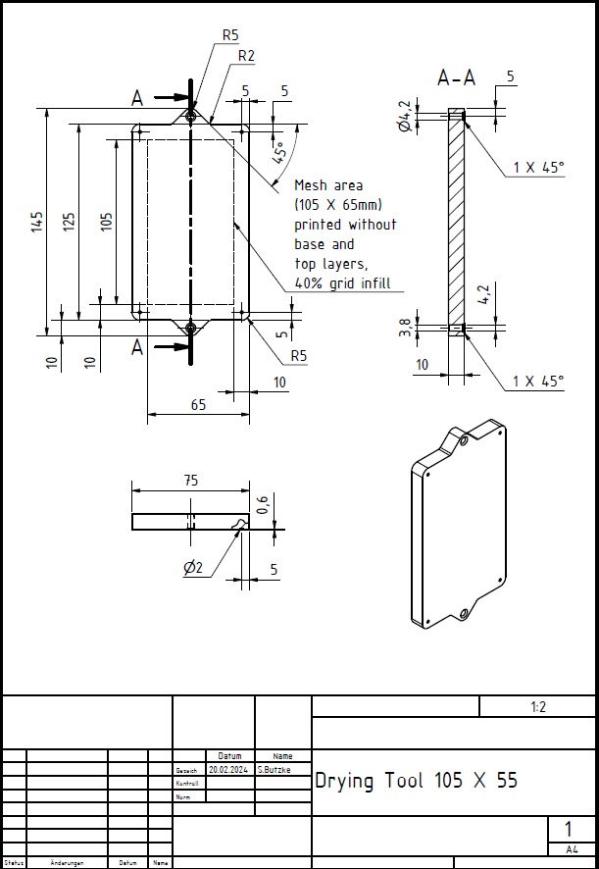 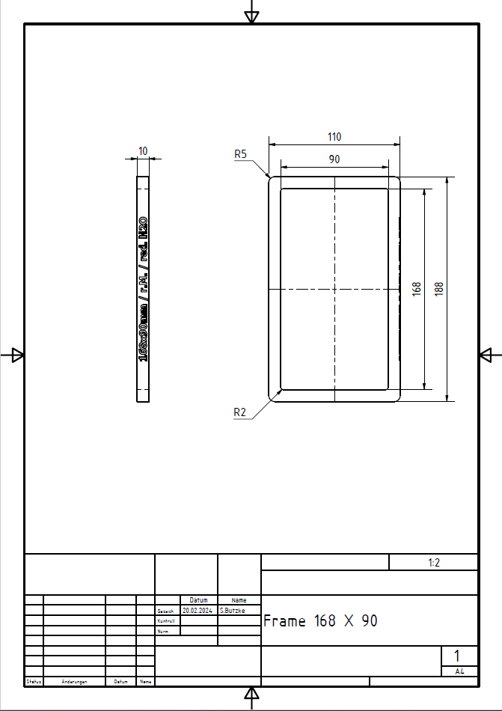

Figure A2: Technical drawing of 3D-printed frame printed with a PLA filament. The writing on the edge says ‘16.8 cm × 9 cm /r.M./red. H2O’ explaining the dimensions and the usage: pure mycelium with reduced water content.

Table A1.: some other insitu synthesis methods to mineralize *A. niger* mycelium matrix.

|  |  |  |  |  |  |  |
| --- | --- | --- | --- | --- | --- | --- |
| Batch | MaT. | Amount [mg] | water [mL] | Swelling time [h] | stirring time [min] | Drying [day] |
| insitu | Powder 600 µm | 1250 | 2000 | - | 1 | 3 |
| insitu | Powder 600 µm | 1250 | 2500 | - | 1 | 3 |
| insitu | Powder 600 µm | 1250 | 3000 | - | 1 | 3 |
| insitu | Powder 180 µm | 1250 | 2000 | - | 1 | 3 |
| insitu | Powder 180 µm | 1250 | 2500 | - | 1 | 3 |
| insitu | Powder 180 µm | 1250 | 3000 | - | 1 | 3 |
| ADB | suspension | 1600 | 1.to 500 µL 2. 1000 µL | 1:1 h(A) 2:0.5 h(B) | 1 | 3 |
| BDA | suspension | 1600 | 1.to 500 µL 2. 1000 µL | 1: 1 h(B) 2: 0.5 h(A) | 1 | 3 |
| ADB | suspension | 3200 | 1.to 500 µL 2. 2500 µL | 1:1 h(A) 2:0 h(B) | 1 | 3 |
| BDA | suspension | 3200 | 1.to 500 µL 2. 2500 µL | 1:1 h(B) 2:0 h(A) | 1 | 3 |

Table A2. The parameters of pre-experiment of disperser treatment.

|  |  |
| --- | --- |
| **Rotation speed** | **duration** |
| 20 000 | 1 min |
| 30 000 | 5 min |

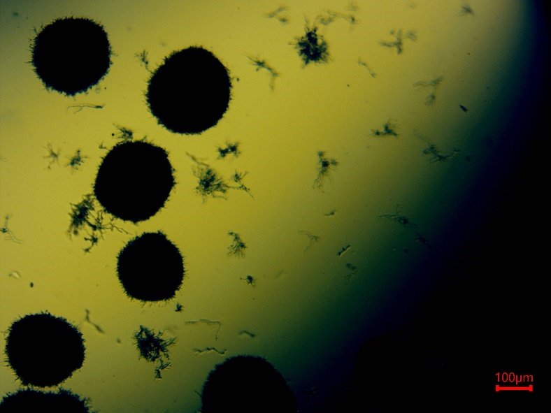

Figure A2. Pellet-structure of *A. niger* mycelium.

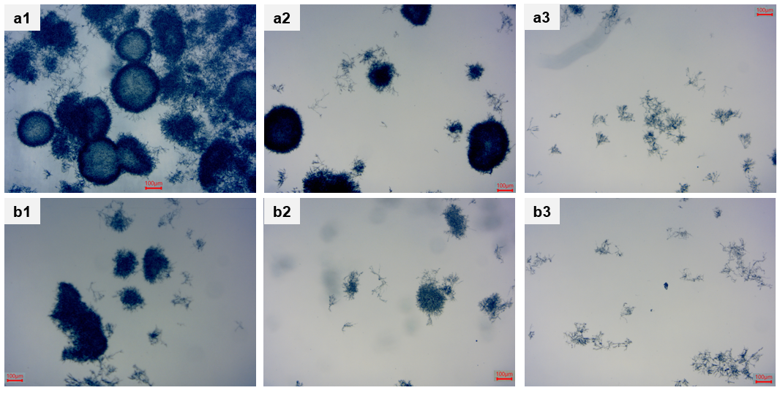

Figure A3.: Microscopic photographs of mycelium suspensions treated with a disperser at different times and speeds. a. rotation speed is 20 000 rpm. b. roration speed is 30 000 rpm. 1. Duration of 1 min. 2. Duration of 5 min. 3. Duration of 25 min.

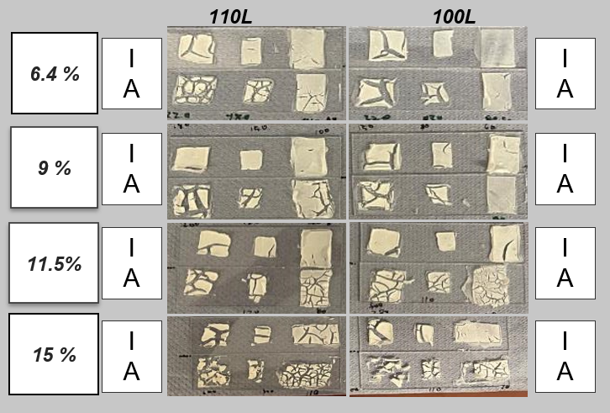

Figure A4.: Pre-experiment of CNC-CaP composite films with different CNC wt.% in suspension and CaP is 33 wt.%

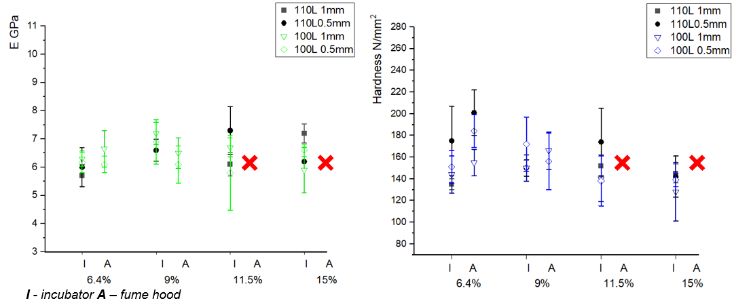

Figure A5.: Indentation performance of CNC-CaP composite films with different mold thickness and CNC wt.% in suspension (CaP is 33 wt.%).

Table A3.: Indentation performance of CNC-CaP composite films with different mold thickness and CNC wt.% in suspension (CaP is 33 wt.%).I= drying in incubator. A= drying in fume hood.

|  |  |  |  |  |  |  |  |
| --- | --- | --- | --- | --- | --- | --- | --- |
| E (GPa) | | 110L | | | 100L | | |
| ***1mm*** | ***500µm*** | ***200µm*** | ***1mm*** | ***500µm*** | ***200µm*** |
| 6.4 wt.% | I | 5.7 ± 0.40 | 6,0 ± 0.69 | 5.0 ± 1.36 | 6.3 ± 0.27 | 6.2 ± 0.35 | 5.2 ± 0.47 |
| A | x | 9.5 ± 0.66 | 8.7 ± 0.82 | 6.7 ± 0.65 | 6.1 ± 0.29 | 6.9 ± 0.41 |
| 9.0 wt.% | I | x | 6.6 ± 0.39 | 6.6 ± 0.85 | 7.2 ± 0.4 | 6.9 ± 0.79 | 5.7 ± 0.48 |
| A | 10.3 ± 1.39 | x | x | 6.5 ± 0.54 | 6.1 ± 0.66 | 6.9 ± 1.2 |
| 11.5 wt.% | I | 6.1 ± 0.41 | 7.3 ± 0.84 | 6.1 ± 0.43 | 6.7 ± 0.34 | 5.8 ± 1.33 | 6.2 ± 0.50 |
| A | x | x | x | x | x | x |
| 15 wt.% | I | 7.2 ± 0.34 | 6.2 ± 0.03 | 6.7 ± 0.41 | 5.9 ± 0.81 | 6.6 ± 0.22 | 5.9 ± 0.38 |
| A | x | x | x | x | x | x |

Table A4.: Thickness of CNC-CaP composite films with different mold thickness and CNC wt.% in suspension (CaP is 33 wt.%).

|  |  |  |  |  |  |  |  |
| --- | --- | --- | --- | --- | --- | --- | --- |
|  | | 110L | | | 100L | | |
| ***1mm*** | ***500µm*** | ***200µm*** | ***1mm*** | ***500µm*** | ***200µm*** |
| 6,40% | **I** | *160* | *90* | *60* | *120* | *100* | *30* |
| **A** | *200* | *110* | *50* | *120* | *60* | *50* |
| 9,00% | **I** | *180* | *90* | *70* | *160* | *90* | *70* |
| **A** | *200* | *120* | *40* | *180* | *100* | *30* |
| 11,50% | **I** | *200* | *120* | *80* | *200* | *110* | *100* |
| **A** | *200* | *120* | *60* | *240* | *110* | *100* |
| 15,00% | **I** | *280* | *160* | *70* | *240* | *110* | *50* |
| **A** | *600* | *300* | *110* | *600* | *110* | *70* |

Table A5.: Validation of mineral phase content in CNC composites was performed by EDX.

|  |  |  |  |  |  |  |  |  |  |  |  |  |  |
| --- | --- | --- | --- | --- | --- | --- | --- | --- | --- | --- | --- | --- | --- |
| CNC 100-CaC | | | | | | | CNC 110-CaC | | | | | | |
| target | **actual** | Element | Mass [%] | Atom [%] | abs. Errors [%] | rel. Errors [%] | **target** | **actual** | Element | Mass [%] | Atom [%] | abs. Errors [%] | rel. Errors [%] |
| 20 | **20**.**3** | C | 54.35 | 64.15 | 6.93 | 11.25 | **20** | **11.5** | C | 52.47 | 61.13 | 5.98 | 11.39 |
| O | 36.81 | 32.62 | 4.18 | 12.49 | O | 42.15 | 36.87 | 5.08 | 12.06 |
| Na | 0.29 | 0.18 | 0.05 | 14.76 | Na | 0.36 | 0.22 | 0.05 | 14.07 |
| S | 0.43 | 0.19 | 0.04 | 9.33 | S | 0.37 | 0.16 | 0.04 | 10.75 |
| Ca | 9.12 | 2.87 | 0.15 | 3.61 | Ca | 4.64 | 1.62 | 0.16 | 3.53 |
| 50 | **40.2** | C | 46.95 | 59.05 | 8.04 | 11.72 | **50** | **42.5** | C | 32.1 | 44.66 | 5.79 | 14.27 |
| O | 36.7 | 34.65 | 6.87 | 12.81 | O | 40.79 | 42.76 | 7.22 | 13.94 |
| Na | 0.37 | 0.24 | 0.07 | 12.23 | Na | 0.35 | 0.25 | 0.07 | 14.96 |
| S | 0.38 | 0.18 | 0.05 | 8.82 | S | 0.22 | 0.11 | 0.44 | 15.41 |
| Ca | 15.61 | 5.88 | 0.7 | 3.05 | Ca | 17.16 | 7.15 | 0.67 | 3.1 |
| 75 | **78.1** | C | 35.65 | 41.94 | 7.34 | 9.32 | **75** | **80.3** | C | 34.78 | 40.9 | 5.62 | 12.2 |
| O | 37.4 | 33.39 | 3.21 | 10.23 | O | 38.1 | 33.72 | 6.78 | 12.6 |
| Na | 0.12 | 0.08 | 0.04 | 7.52 | Na | 0.08 | 0.06 | 0.08 | 11 |
| S | 0.48 | 0.21 | 0.03 | 5.3 | S | 0.23 | 0.11 | 0.06 | 7.37 |
| Ca | 31.21 | 9.81 | 0.21 | 3.4 | Ca | 32.1 | 11.22 | 0.7 | 3.05 |
| CNC 100-CaP | | | | | | | CNC 110-CaP | | | | | | |
| target | **actual** | Element | Mass [%] | Atom [%] | abs. Errors [%] | rel. Errors [%] | **target** | **actual** | Element | Mass [%] | Atom [%] | abs. Errors [%] | rel. Errors [%] |
| 20 | **24.8** | C | 46.7 | 58.02 | 8.42 | 15.45 | **20** | **21.5** | C | 49.74 | 60.54 | 8.95 | 11.81 |
| O | 38.57 | 35.97 | 7.66 | 17.02 | O | 37.65 | 34.41 | 7.17 | 12.5 |
| P | 4.35 | 2.1 | 0.25 | 4.85 | P | 3.73 | 1.76 | 0.25 | 4.38 |
| S | 0.48 | 0.22 | 0.06 | 11.12 | S | 0.52 | 0.24 | 0.06 | 7.27 |
| Ca | 9.9 | 3.69 | 0.4 | 3.5 | Ca | 8.37 | 3.05 | 0.4 | 3.17 |
| 50 | **55** | C | 20.51 | 31.07 | 3.27 | 14.51 | **50** | **58.6** | C | 22.5 | 34.16 | 3.44 | 14.4 |
| O | 45.7 | 51.98 | 6.42 | 12.78 | O | 42.22 | 48.11 | 5.83 | 12.98 |
| Na | 0.18 | 0.14 | 0.04 | 22.25 | Na | 0.3 | 0.24 | 0.05 | 16.44 |
| S | 11.35 | 6.67 | 0.04 | 13.19 | S | 0.42 | 0.24 | 0.05 | 4.12 |
| Ca | 21.99 | 0.16 | 0.74 | 3.05 | Ca | 22.72 | 10.34 | 0.74 | 3.05 |
| 75 | **76.3** | C | 13.6 | 22.34 | 2.37 | 16.28 | **75** | **79.3** | C | 15.01 | 25.15 | 2.33 | 16.17 |
| O | 45 | 55.52 | 6.3 | 13.06 | O | 39.27 | 49.97 | 5.15 | 13.49 |
| P | 12.3 | 7.84 | 0.54 | 4.09 | p | 14.01 | 9.1 | 0.44 | 34.55 |
| Cd | 0.09 | 0.02 | 0.03 | 33.98 | S | 0.28 | 0.18 | 0.04 | 4.09 |
| Ca | 29.01 | 14.29 | 0.94 | 3.02 | Ca | 30.86 | 15.5 | 0.9 | 14.34 |

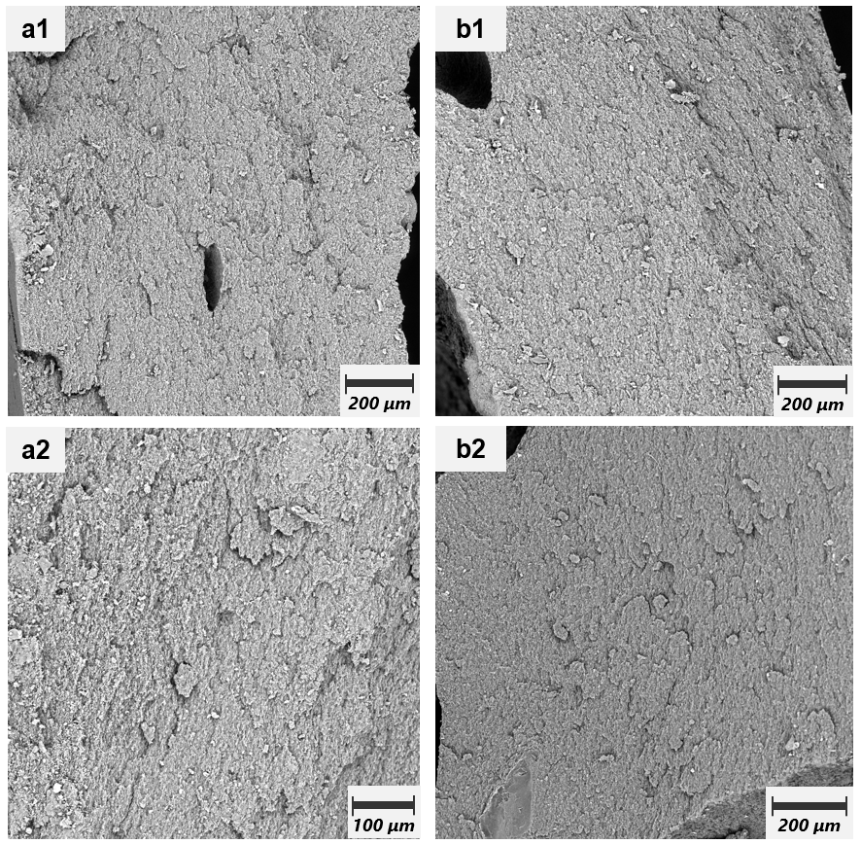

Figure A6. Scanning electron micrographs of cross sections of mycelium samples with disperser treatment. a. rotation speed was 20 000 rpm. b. rotation speed was 30 000 rpm. 1. 1 min disperser treatment. 2. 25 min disperser treatment.

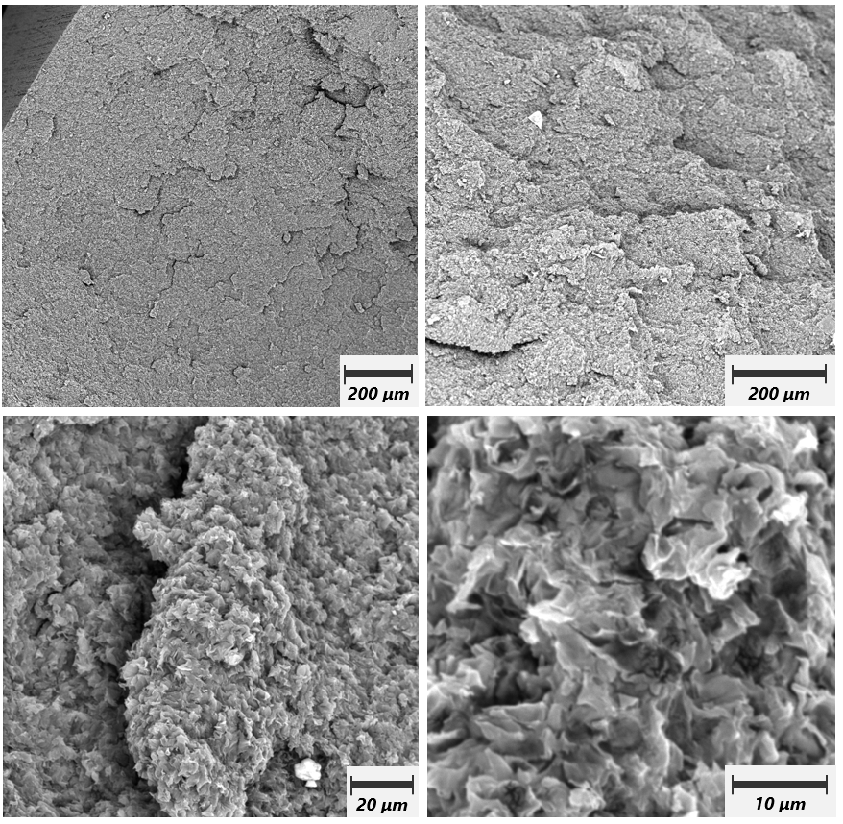

Figure A6. Scanning electron micrographs of cross sections of mycelium samples without disperser treatment.